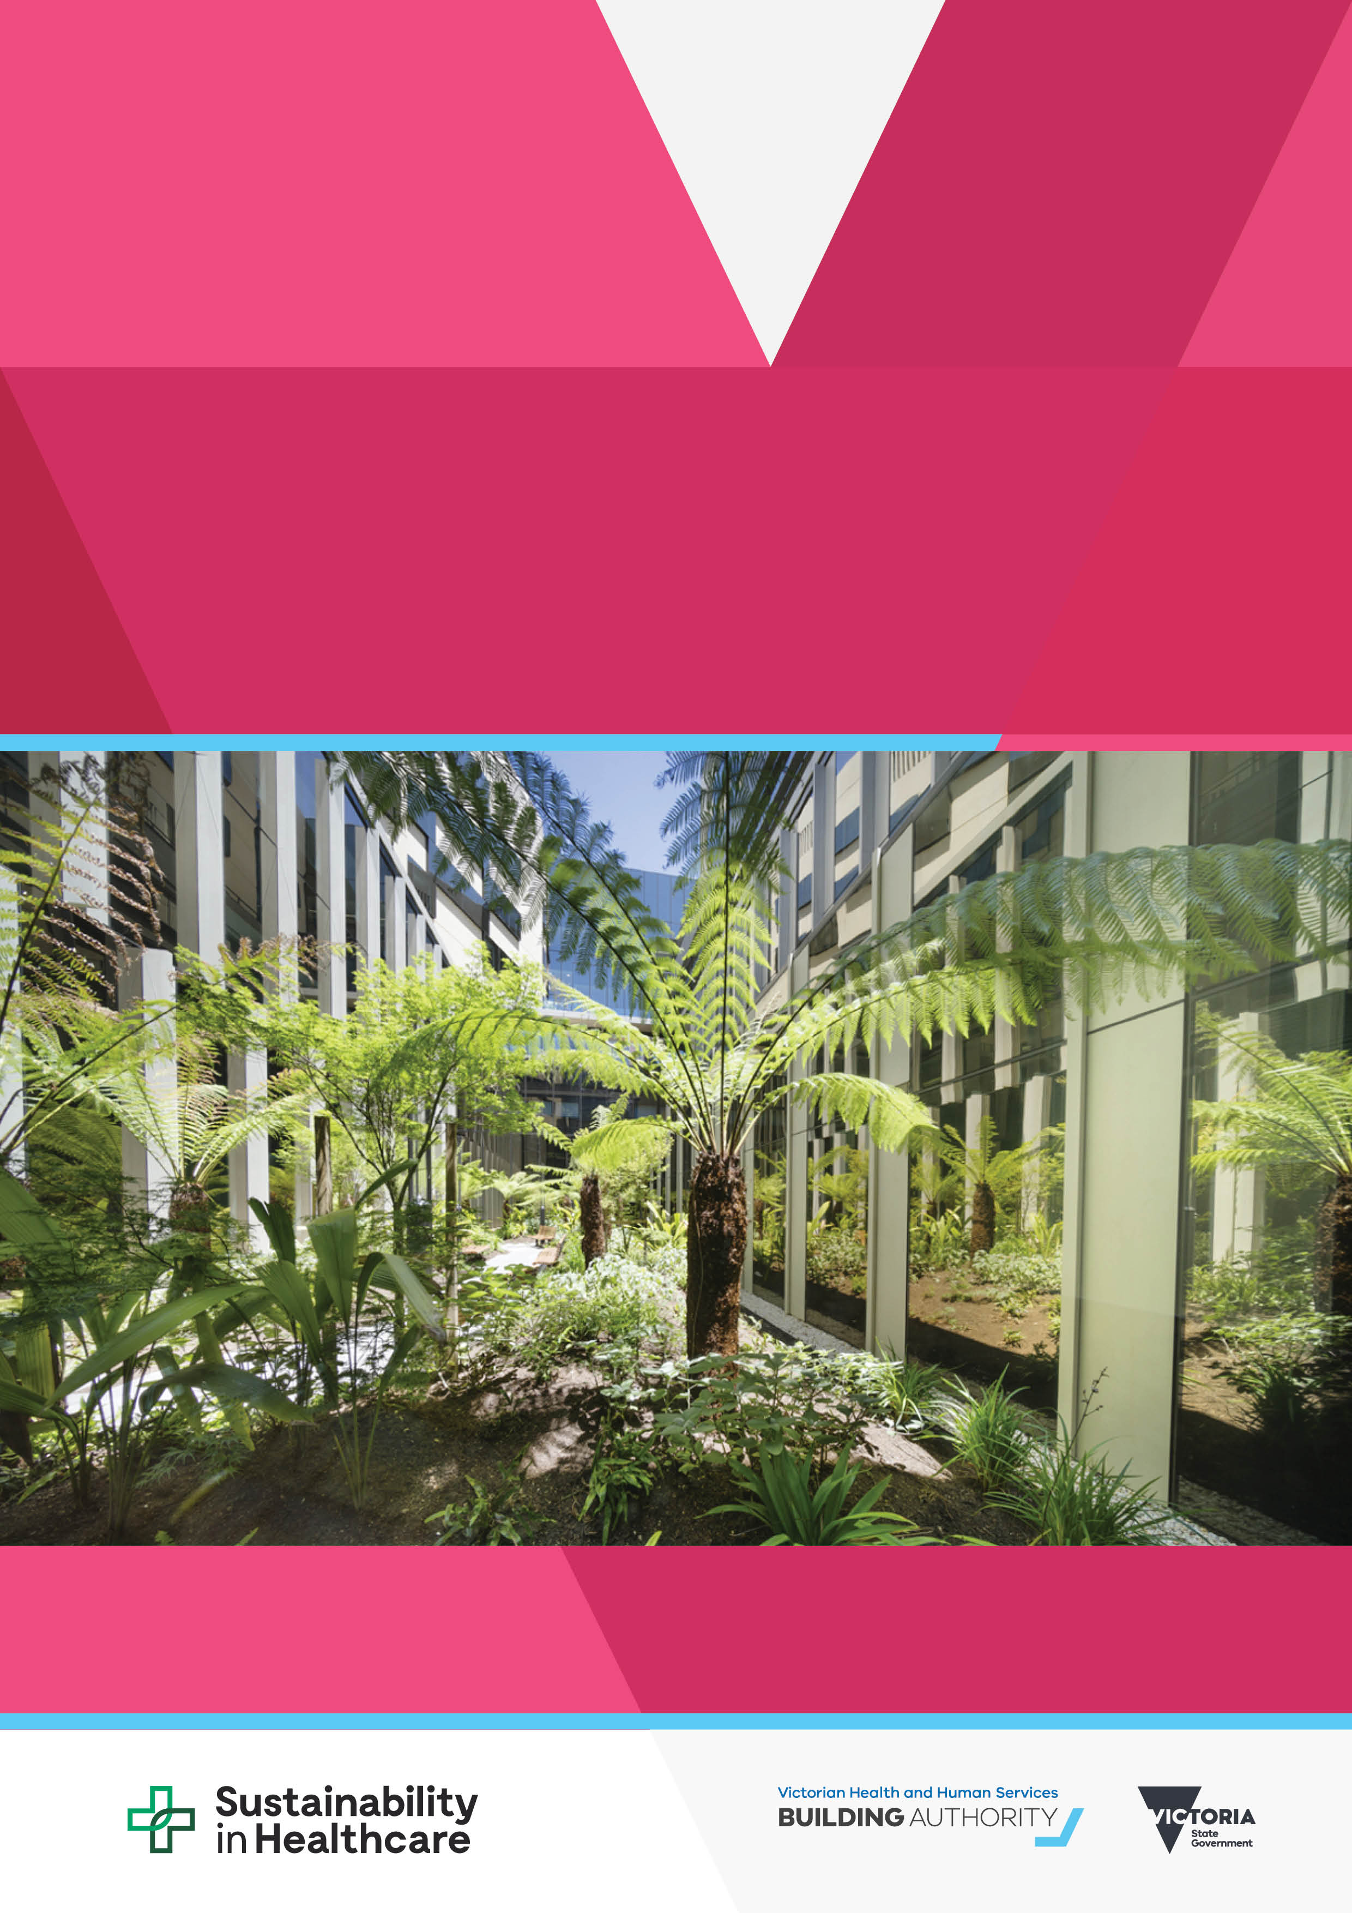

|  |
| --- |
| Environmental sustainability strategy  Progress report, 28 February 2019 |
|  |

|  |
| --- |
| Environmental sustainability strategy  Progress report, 28 February 2019 |
|  |

|  |
| --- |
|  |
| To receive this publication in an accessible format phone 03 9096 2119, using the National Relay Service 13 36 77 if required, or [email Environmental Sustainability](mailto:sustainability@dhhs.vic.gov.au) <sustainability@dhhs.vic.gov.au>.  Authorised and published by the Victorian Government, 1 Treasury Place, Melbourne.  © State of Victoria, Australia, Victorian Health and Human Services Building Authority, March 2019.  ISSN 2652-0672 – Online (pdf / word)  Available from [the department’s website](http://www.health.vic.gov.au/sustainability) <www.health.vic.gov.au/sustainability>. |
|  |

# Overview

The *Environmental sustainability strategy 2018–19 to 2022–23* sets out the department’s commitment to further improve the environmental performance of the health system and to adapt the health system so it is resilient in the face of climate change.

The strategy contains three strategic directions, with each direction having a series of key objectives and high-level actions from 2018–19 to 2022–23. The strategic directions are:

* provide leadership and engage with the sector
* improve the environmental performance of the health system
* adapt to a changing climate.

This progress report outlines progress to date in implementing the actions identified in the 2018–19 action plan as of 28 February 2019. A full progress report for the 2018–19 year will be published in October 2019, including an assessment against the key reporting metrics identified in the strategy.

# Status

The status of projects is expressed in terms of a basic traffic light assessment.

Red indicates a performance that is significantly below target, yellow indicates a performance that is at risk of being below target, and green indicates a performance that is as expected or better than expected.

Projects that are complete are marked green and indicated as ‘complete’. There are no projects that are significantly below target (red).

# Strategic direction 1: Provide leadership and engage with the sector

| **2018–19 action** | **Progress as of 28 February 2019** | **Risks** | **Target completion** | **Status** |
| --- | --- | --- | --- | --- |
| Establish a research and innovation program to allow public hospitals and health services to implement local sustainability solutions | Twenty-three submissions were received, and VHHSBA has funded 11 projects including greening external spaces, life cycle assessment of pathology testing, specialist recycling, reducing waste in food services, carbon foot-printing of services, climate adaptation and energy use of medical equipment. | Risk: Projects not delivered  Mitigation: Continued engagement with health services | Complete | Complete |
| Health Purchasing Victoria (HPV) will develop a formal social procurement plan for collective procurement to implement the *Social procurement framework* | HPV has endorsed an interim *Social procurement strategy* for 2018–19 that includes actions to implement social procurement measures into HPV collective procurement and provide training and support to health services. | Risk: Resourcing  Mitigation: Recruited a project officer to assist specifically with the social procurement framework | Complete | Complete |
| Join the Global Green and Healthy Hospitals network and encourage public hospitals and health services to join | VHHSBA has joined the Global Green and Healthy Hospitals network on behalf of the Department of Health and Human Services.  VHHSBA actively participates in network meetings and presented our Waste Education in Healthcare project to the Australasian members of the network. | Risk: Health services do not join up  Mitigation: Continue to encourage health services to join | Complete: VHHSBA has joined  Encouraging others to join (ongoing) | Ongoing |
| Establish an annual professional development and webinar program for public hospitals and health services, and communicate sustainability messages to the sector through sustainability updates and our website | Held a webinar on e-waste in October 2018 and participated in a sustainability in health forum in February 2019. Sustainability updates issued in September and December 2018. | Risk: Availability of appropriate software to deliver webinars  Mitigation: Continue to work with the department’s IT branch | Ongoing | Expected |
| Report on the health system’s 2018–19 emissions in the department’s annual report, including for the first time on transport emissions | A consultant has established the 2017–18 carbon emissions baseline of the metropolitan hospital vehicle fleet. The project team is engaging with health services to identify opportunities, and the project is due for completion in April 2019. | Risk: 2018–19 data not collected in time for reporting  Mitigation: Report to FTB reporting year (May to April) | June 2019 | Expected |
| Work with Sustainability Victoria to educate public hospitals and health services on the requirements of the e-waste ban commencing on 1 July 2019 | A webinar on the e-waste ban has been made available to all Victorian public health services. To date there has been 125 views of the webinar.  As further information becomes available updates will be provided to health services. | Risk: Health services are unsure of what to do with e-waste  Mitigation: Continue to liaise with partners and provide updates to health services | Ongoing | Expected |
| Update the environmental management plan template to align with the strategy | VHHSBA is engaging with health services to understand barriers and opportunities and how they can be addressed through environmental management planning.  VHHSBA is working with the Department of Environment, Land, Water and Planning to ensure alignment with obligations under proposed climate change regulations for larger health services. | Risk: Health services update EMPs prior to the template being released  Mitigation: Allow gradual adoption of the new EMP template | Mid-2019 | At risk |
| Establish a waste mentoring program for public hospitals and health services staff | A facilitator has been engaged to host six workshops to support health service staff to develop a waste management implementation plan for a single waste stream in a ward or department. | Risk: Low interest for workshops  Mitigation: Communicate about the benefits of the workshop | September 2019 | Expected |

# Strategic direction 2: Improve the environmental performance of the health system

| **2018–19 action** | **Progress as of 28 February 2019** | **Risks** | **Target completion** | **Status** |
| --- | --- | --- | --- | --- |
| Pilot methodologies to implement sustainable travel opportunities in two metropolitan hospitals | Discussions are ongoing with selected metropolitan health services on defining the scope and location of the pilot projects. | Risk: Definition of scope and health service engagement  Mitigation: Continued collaboration with health services | Late 2019 | At risk |
| HPV will source a food organics recycling service offer for metropolitan hospitals | HPV is working with the existing waste contractor to establish a pilot across a number of metropolitan hospitals. | Risk: Probity with respect to new waste procurement activities  Mitigation: Follow probity requirements | Mid-2019 | At risk |
| Prepare guidance for public hospitals and health services to improve the efficiency of their vehicle fleets | A consultant has been engaged to prepare guidance to improve the efficiency of hospital vehicle fleets. The project team is engaging with health services, and the project is due for completion in April 2019. | Risk: Fleet managers do not support efficiency initiatives  Mitigation: Early engagement with fleet managers | June 2019 | Expected |
| Deliver the Regional Health Solar Program in the Barwon South Western, Grampians, Loddon Mallee and Hume regions, and progress energy performance contracts at Northern Health and Peninsula Health | A tender has been awarded to install 2.2 megawatt-peak of solar across 15 sites in the Barwon South Western region.  A tender for 1.4 megawatt-peak of solar across 19 sites in the Hume region closed on 24 January 2019. Tenders for the Loddon Mallee and Grampians regions closed on 26 February 2019.  Practical completion of the Peninsula Health energy performance contract is due in mid-2019.  The Northern Health detailed facility study has begun and is due for completion in the first quarter of 2019. Works are expected to start on site in mid–late 2019. | Risk: Insufficient funding to deliver all identified opportunities  Mitigation: Collect data to build the business case and continue to engage with Treasury to secure funding | Late 2020 | Expected |
| Pilot single-use metal recycling and behavioural change programs to improve waste segregation in hospitals | Behaviour Works has been engaged to conduct research into behavioural barriers and potential interventions regarding waste management in theatre departments. Ethics approval for the research is nearing finalisation.  An expression of interest document has been released to select a pilot site for single-use metal recycling. | Risk: Delays in securing ethics  Mitigation: Original project timeline allows for delays in delivery | October 2019 | At risk |
| Work with the Vinyl Council of Australia to increase PVC recycling in metropolitan public hospitals | A memorandum of understanding between the department and the Vinyl Council of Australia was signed on 22 January 2019. The project seeks to increase the quantity of PVC recovered from 32 public hospitals in Melbourne by establishing PVC collections in theatre, renal and intensive care departments. | Risks: Difficulties in building PVC recycling into departmental practices  Mitigation: Collaboration with health services and communication of the benefits | October 2019 | Expected |
| Prepare new sustainability guidelines for capital works delivered by the Victorian Health and Human Services Building Authority | A consultant has been engaged to update VHHSBA’s sustainability guidelines for capital works. The specification includes requirements to integrate methodologies to assist with delivering carbon-neutral and climate-resilient buildings. | Risks: Delivering desired outcomes within capital project budgets  Mitigation: Engage independent quantity surveyor to advise on whole-of-life costs and benefits | Late 2019 | At risk |
| HPV will review opportunities to reduce greenhouse gas emissions from anaesthetic gases | Discussions are underway with the pharmaceutical sourcing team on impacts, benefits and evidence and how to engage with hospital pharmacy customers. | Risks: Resourcing | Mid-2019 | At risk |
| Develop waste audit guidelines for public hospitals and health services | Waste audit guidelines have been prepared and are available from [the department’s website](http://www.health.vic.gov.au/sustainability) <www.health.vic.gov.au/sustainability>. | Risks: Guidelines not used  Mitigation: Communicate the benefit of waste audits | March 2019 | Expected |
| Work with the Environment Protection Authority to update the *Clinical and related waste operational guidance* (EPA publication IWRG612.1) | Recommendations for changes have been submitted to the EPA for consideration. The EPA will assess these recommendations, with an updated document expected to be available in late 2019.  A supplementary booklet is being developed, providing step-by-step guidance for clinical staff to establish whether items are clinical waste. | Risk: The EPA does not support recommendations  Mitigation: Continued engagement with the EPA on need for changes | Late 2019 | Expected |

# Strategic direction 3: Adapt to a changing climate

| **2018–19 action** | **Progress as of 28 February 2019** | **Risk** | **Target completion** | **Status** |
| --- | --- | --- | --- | --- |
| Contribute to the Department of Health and Human Services *Climate change strategy* | The department is considering a draft *Adaptation action plan* before publication.  A draft *Emissions reduction plan* is in development and will be finalised following release of the state interim targets. | Risk: Delays in finalising the strategy given the scope and extent of stakeholders  Mitigation: Governance through the Climate Change Reference Group | Late 2019 | Expected |
| Map the climate risk to health infrastructure including health services, ambulance stations and public hospital helipads | VHHSBA has engaged a consultant to map the climate risk of public health facilities across the state. The study found that heat risk was a factor at all sites, bushfire, flooding and inundation (sea level rise) posed a future risk at some sites, while wind and soil contraction posed a marginal risk across the portfolio.  VHHSBA is assessing how best to integrate future climate risks into its planning and capital delivery program. | Risk: Climate risks not considered in infrastructure program  Mitigation: Integrate into Asset Management Establishment project and sustainability and engineering guidelines | June 2019 | Expected |
| Collect and analyse data on the energy security of public health facilities | VHHSBA is commissioning an independent emergency generator assessment of the public healthcare system, building on data collected for the 2018 and 2019 summers. | Risk: None identified to date | June 2019 | Expected |
| Integrate climate resilience into guidelines on essential engineering services and sustainability in capital works | Climate resilience was integrated into the request for tenders to update VHHSBA’s sustainability guidelines for capital works and the hospital engineering design guidelines. | Risk: Consultants do not have the requisite expertise to integrate climate resilience into guidelines  Mitigation: Actively consider in tender evaluation | Late 2019 | Expected |
| Prepare guidance on the design and operation of emergency generators in a wider range of climate conditions | The need for a Technical Practice Note on the design and installation of emergency generators will be considered as part of the independent emergency generator assessment.  Engineering design guidelines will incorporate fundamental design principles on the design and operation of emergency generators in a wider range of climate conditions. | Risk: None identified to date | Late 2019 | Expected |