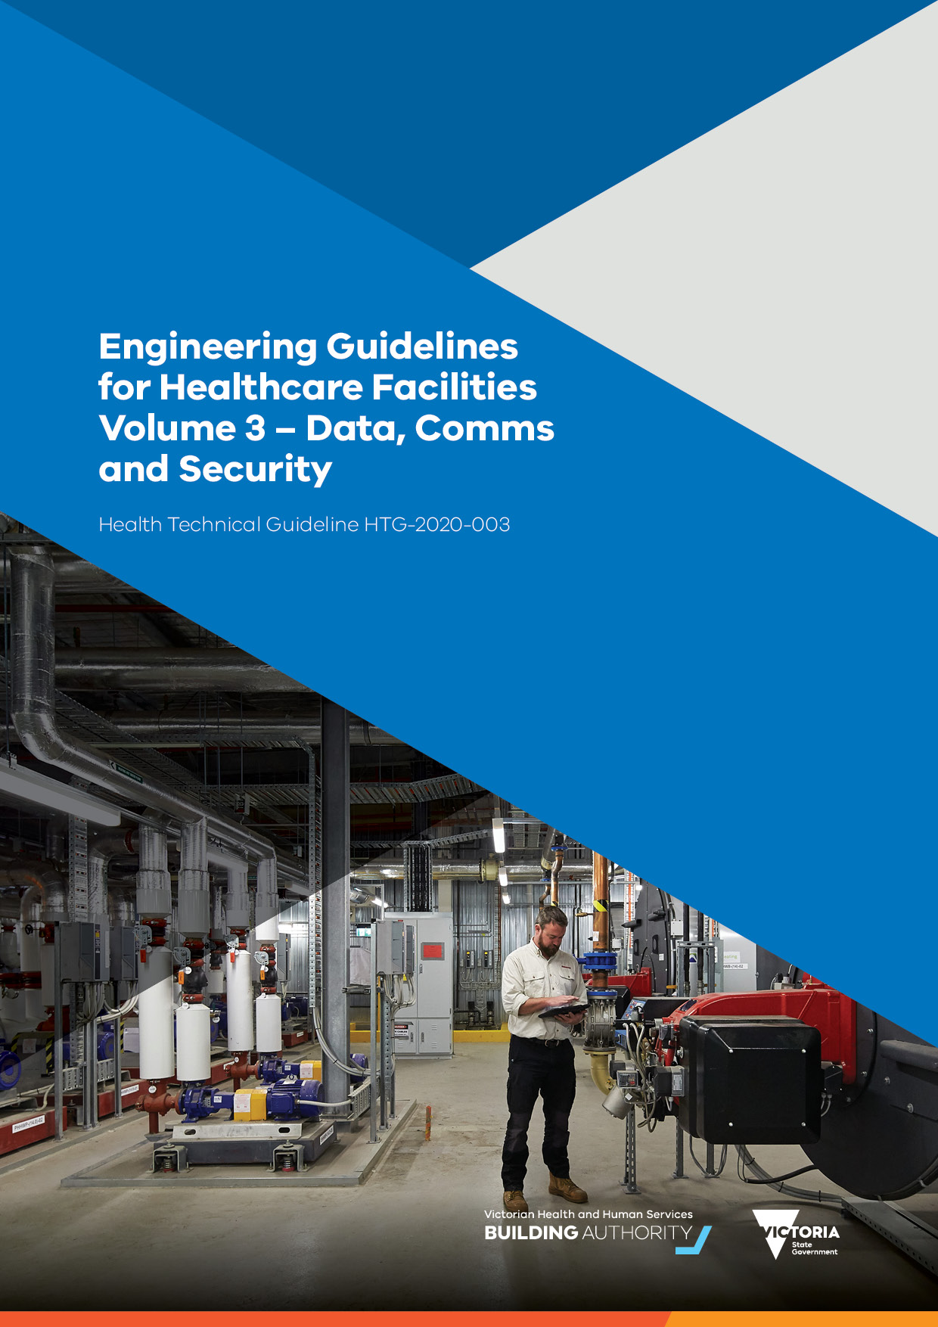

|  |
| --- |
| Engineering guidelines for healthcare facilities:  Volume 3 – Data, comms and security  Health technical guideline HTG-2020-003 |

|  |
| --- |
| To receive this publication in an accessible format phone (03) 8644 5966, using the National Relay Service 13 36 77 if required, or email the [Engineering and Technical Services team](mailto:assetmanagement@dhhs.vic.gov.au) <assetmanagement@dhhs.vic.gov.au>  Authorised and published by the Victorian Government, 1 Treasury Place, Melbourne.  © State of Victoria, Australia, Victorian Health and Human Services Building Authority, May 2020.  Except where otherwise indicated, the images in this publication show models and illustrative settings only, and do not necessarily depict actual services, facilities or recipients of services.  **ISBN** 978-1-76069-437-1 **(pdf/online/MS word)**  Available at the [Victorian Health and Human Services Building Authority website](https://www.vhhsba.vic.gov.au/) <https://www.vhhsba.vic.gov.au> |

Contents

Introduction 6

Scope 7

Objectives 8

Data 9

Infrastructure 9

Communications rooms 10

Wireless technology 10

Building systems 11

Nurse call 11

Interfacing of alarms 11

Public address 11

Paging systems 11

Audio induction loop systems 11

Security 12

Introduction 12

Scope 12

General requirements 12

Planning and context 13

Design criteria 13

Security lighting 13

CCTV 13

Security, access, control, patient location 14

Duress 14

Wayfinding 14

Security intercommunication system 15

# Introduction

These Engineering guidelines are a guide for the development of design and specification documentation for health care facilities. For glossary of terms and common abbreviations used in the guide refer to Volume 1.

A key objective for delivery of healthcare facility projects is the provision of facilities that provide for:

achievement of optimal patient care utilising a model of care for the patient

contemporary approaches to design

practical and easy usage

fitness for purpose

value for money

It is expected that all projects will be delivered in line with the requirements of all relevant codes and regulations, and all designers are be aware of these obligations.

Any engineered deviations from relevant statutory requirements and other standards due to unique project circumstances need to be thoroughly and holistically assessed, proved, clearly articulated or documented, and signed off by the relevant authority.

All designers will assess the provisions of standards, such as the *Australasian Health Facility Guidelines* (AusHFGs), and determine an appropriate application of these to their project. In new, major hospital developments it is envisaged the requirements of AusHFGs and these guidelines will be closely adhered to, except where deviations are associated with new models of care, operational policies or procedures or innovative approaches to the delivery of health services.

On smaller projects and projects where substantial refurbishment is envisaged, designers will critically evaluate the AusHFGs to determine their applicability and suitability to the project during planning. Deviations will be clearly articulated or documented, and signed off by the relevant authority.

Volume 3 – Data, comms and security, forms part of a suite of documents in the *Engineering guidelines for healthcare facilities*. Other documents in this series are:

Volume 1 – Fundamentals

Volume 2 – Electrical and lighting

Volume 3 – Data, comms and security

Volume 4 - Heating, ventilation and air-conditioning

Volume 5 – Fire and hydraulics

Volume 6 – Specialist healthcare engineering and provisions

Reference table 1 – Design parameters

Reference table 2 - Acoustic design parameters

Reference table 3 - Required noise reductions for room adjacencies

## Scope

1. The purpose of data, comms and security in healthcare buildings is to provide safe, reliable and flexible solutions and systems to support clinical and building operation. It is the designer’s responsibility to deliver best practice designs while focusing on cost effective solutions, encourage energy efficiency through innovation and provide a catalyst for future flexibility and improvement.
2. Significant aspects of the electrical services design are governed by statutory requirements contained principally in the codes and standards including:

NCC

AS/ANZ 3000: Electrical installations

AS/NZS 3080: Telecommunications installations

AS/NZS 3084: Telecommunications installations – Pathways and spaces for commercial buildings

AS/NZS 2384: Computer accommodation.

AS/ACIF S008: Requirements for authorised cabling products

AS/ACIF S009: Installation requirements for customer cabling (wiring rules)

AS 1170

AS 3811: Nurse call standard

workplace health and safety

Environment Protection Act and Authority

AS/NZS ISO/IEC 18028.1: Information technology – Security techniques – IT network security - Network security management

AS4485: Security for health facilities

Other areas of the data, comms and security systems will be influenced by the following criteria:

recommendations of Australian standards

specific project briefing process

cyber security requirements

reliability, maintainability, business continuity, redundancy, disaster recovery

best engineering practice from similar projects.

The following services are considered part of data, comms and security systems:

communications cabling infrastructure

wireless access points

paging system

queuing system

FM messaging

nurse call system

wayfinding integration

RTLS tracking system interfaces

patient entertainment systems

access control system

intruder detection system

cyber security

master clock system

electronic medical records (EMR)

## Objectives

1. The design team will provide backbone telecommunications with the following requirements:

incoming telecommunications services access pathways to include diverse entry points for redundancy from the property boundary

main telecommunications equipment rooms (primary and redundancy) to house ‘incoming carrier’ equipment

main primary data centre to accommodate both ICT main computing system and security system equipment in a secured room

second or redundancy data equipment room to accommodate ICT data and network equipment and redundancy ICT equipment

communications distribution rooms to accommodate floor ICT equipment for floor area horizontal distribution and to also incorporate segregated primary building risers and physically segregated secondary building risers

# Data

## Infrastructure

1. The minimum hospital infrastructure will comprise:

fibre optical equipment and termination using LC connectors for multi-mode fibre and single mode fibre cables including patch and fly leads. All fibre terminations will be carried out in line with manufacturers guidelines and will use manufacturers recommended consumables and termination kits.

primary and redundancy fibre optic backbone cabling from primary and secondary data centres to each floor distribution rooms

the structured cabling system has a minimum 25-year warranty vendor approved for applications and components.

ensure structured horizontal cabling runs less than 90 metres, with a total channel length (including patch leads and fly leads) of 100 metres

has a minimum shielded twisted pair s/ftp copper cabling performance for the structured cabling ‘Class FA’ (750MHz) and supports Power over Ethernet (PoE)

shielded RJ45 outlets will be used for final termination

maintain clearances between the communications and power cabling with a minimum of 150mm separation

ensure all communications cabling to the communications room racks are supported via cable trays and terminated on angled patch panels within the racks to achieve maximum quantity of outlets per rack

consolidation points design will be allowed for within open plan areas

design spatial and final spare quantities will include for an additional 20 per cent future usage

The hospital infrastructure will be capable of supporting the following services.

telecommunication systems

data networks

video systems

patient monitoring systems

building services

wide area networks (WAN)

audio visual systems

EMR

The ICT network will include and will have IP convergence with the following systems: -

desk telephony system

nurse call system

EMR

radio paging

messaging system

building management control systems (BMCS)

DAS (mobile phone distributed antennae system)

environmental monitoring systems

power monitoring systems

security access control and alarm systems

Intercom systems

CCTV surveillance systems

public display system’

queuing systems (including ‘free standing kiosk and wall mounted information screens’)

audio-visual systems

IPTV

emergency warning and intercommunication system (EWIS)

fire system fire indicator panel (FIP)

IP master clock system

wireless access points (WAP)

## Communications rooms

1. Communications rooms will be accessible from main passageways and centrally allocated within the floorplan to meet the 90m rule. For multi-storey designs, ensure rooms within floorplans are stackable to give telecommunication risers a clear pathway between levels.
2. The rooms will be designed to accommodate a minimum of four (4) telecommunication racks sized 1100mm deep x 900mm wide with a clear 1000mm front and rear access.

## Wireless technology

1. The hospital fit-out will be designed with wireless access points (WAPs) covering the internal building and perimeter external grounds (with a minimum 50m external coverage from each outbuilding).
2. As part of the installation, a wireless site survey based on the wireless design parameters will be undertaken to determine the most suitable locations for all wireless access points to achieve 100 per cent wireless LAN coverage throughout the site.
3. The wireless local area network (WLAN) coverage for the site will have sufficient access point density to support wireless telephony and IP asset, and patient tracking where required. Wireless access points will be installed in a staggered arrangement to enable triangulation of asset tags in real time.
4. Ensure installation of horizontal communications cabling for each WAP between the floor distributor (FDs) and each wireless access point.
5. Generally, wireless access points will be installed within the following parameters:

one access point to cover a maximum internal area of 200m2 (ensure overlapping is achieved)

inter-access point separation of maximum 15m

access points will be located around the building perimeter and installed internally in a staggered pattern to ensure location-based services (device tracking) capability

# Building systems

## Nurse call

1. Nurse call systems will be hard wired. It is recommended that nurse-activated emergency call buttons are separated from the patient nurse call button. Wireless systems may be considered on low acuity sites.

## Interfacing of alarms

1. Intelligent alarm interfaces are recommended to be provided on nurse call systems to accept digital and analogue alarm inputs from duress systems, fire information panels, patient egress monitors, security systems and plant alarms, such as oxygen failure.

## Public address

1. A public address system will be installed in the hospital facility and will incorporate evacuation warning (tones or messages), area paging, intercommunication facilities, background music and other communications services as considered appropriate. Where installed, such systems will not be unduly intrusive to patients in ward areas. When functioning as a part of the facility's emergency evacuation system, it will continue to operate during periods of major power failure.
2. An emergency warning intercom system (EWIS) will be provided where required by the Building Code of Australia. The installation of an EWIS in other cases is recommended.

## Paging systems

1. A paging system will be used to supplement the hospital telephone system for contact with key staff members. This facility may include arrangements for assistance call and other emergency signals. Automatic interface with the fire alarm system is recommended. Paging may be of the public address or self-contained radio frequency type which produces full alphanumeric message information.
2. Paging facilities will be maintained in the event of a major power failure in line with AS 3009 'Electric installations – Emergency power supplies in hospitals'.

## Audio induction loop systems

1. Audio induction loops will be provided in main receptions, seminar rooms and waiting areas.
2. Audio loop systems will be able to provide an interface with any public address or music system. In areas with televisions, they will be interfaced to provide TV sound into the local area loop system.
3. Entertainment facilities, such as television and radio or music systems, may be provided in waiting areas to mask sound transfer for confidentiality purposes or in staff rest areas to create a relaxing atmosphere. Whenever background music or public address systems are installed, the sound quality should be such that it is intelligible and not subject to unwanted reverberations.

# Security

## Introduction

1. The purpose of security systems is to provide a secure environment that ensures safety for all staff, patients and public and ensures the ongoing operation of the facility and equipment is not compromised by theft or damage.
2. The minimum requirements for the provision of security systems in healthcare facilities:

AS 2630 Guide to selection and application of intruder alarm systems for domestic and business premises

AS 2201.1–4 Intruder alarm systems.

All clauses outlined in the following section are in addition to statutory requirements.

1. A documented risk analysis will be conducted to determine the appropriate level of security systems required.

## Scope

1. The following services are part of security systems:

integrated security management systems and integration

access control

CCTV

intrusion detection

credential management systems

duress alarm systems

electronic key management systems

audio and video intercoms systems.

## General requirements

1. The design will use the following principles to maximise the architectural elements that enhance the security of a facility:

crime prevention through environmental design (CPTED)

defence in depth (DiD).

Electronic measures will be planned as part of each facility to manage the following elements:

main perimeter

entrances and drop off points

main entrances and foyers

lifts

lift foyer

stairs

reception areas

intensive care units

inpatient units

emergency department

research facilities

safes

ATMs and cash in transit routes

administration areas

laboratories

pharmacies

loading docks

car parks

cashier’s desks

IT facilities, central rooms and data centres

risers

hazardous bulk storage

campus-wide areas

The security system will use the ICT communications platform cabling for all network-based communications between the systems.

## Planning and context

1. A risk-based approach will be used for the identification of threats and evaluation of risks and identification of management strategies to reduce those risks to an as low as reasonably practical level.

## Design criteria

1. The design will comply with all the relevant Australian and international standards.
2. The designs will follow VHHSBA guidelines and be applied after a risk assessment of the project to determine the extent and details of the systems. This applies to access control, monitoring and lighting systems.

## Security lighting

1. External lighting will be configured to consider security requirements.

## CCTV

1. The CCTV will be a fully distributed IP-based high resolution video solution, with high level integration to the security management system via the security communications network.
2. The CCTV cameras will consist of a combination of pan/tilt/zoom (PTZ) and fixed dome type, with all external units having a minimum IP56 and IK10 rating. All CCTV cameras will provide clear crisp images under the following conditions:

daylight, night or low light conditions

excessive backlight contrast conditions

excessive glare condition (such as vehicle headlamp)

will not be affected by any mechanical vibration engendered by environmental effects (for example, wind, vehicular movement, building vibrations,)

resolution of the cameras to comply with industry standard of 704 (height) x 576 (width) pixels (4CIF) and offer clear images with a minimum scene illumination of 0.5 lux in colour mode at the maximum viewing range (field of view) for each camera provided

lens selection to suit all locations, with individual field of view to satisfy alarm response and investigative purposes

all cabling will be fully concealed within the combined housing and bracket (to prevent access to cabling).

Generally, CCTV cameras will be allocated to the following areas:

all perimeter external entry doors

outside each department main entrance door

within emergency, mental health and pharmacy departments

ambulance bays and loading dock area

internal and external carpark areas

external public pathways

any other high-risk areas

CCTV display monitors will be capable of displaying real-time footage in clear, sharp and full colour images with minimal pixilation, display lag and refresh rates.

## Security, access, control, patient location

1. Building exteriors will be capable of being secured against unauthorised entry.
2. The installation of a central monitored electronic security system linked to the fire indicator panel is recommended.

## Duress

1. The hospital will have a combination of fixed and mobile duress alarm points installed within the facility.
2. Fixed duress alarm points will be installed in the following positions:

front entrances

emergency unit triage

staff and nurse stations

mental health counselling rooms

pharmacies

cashier’s areas

any area where staff are regularly alone with patients or the public.

Generally mobile duress will be provided to functional areas and associated planning units, and as a minimum within the following areas:

emergency service

inpatient areas and outpatient areas

technical suites

back of house and loading dock areas

pharmacy;

mental health areas

high security areas.

## Wayfinding

1. Electronic wayfinding will be installed throughout the facility to help the public and staff find travel information in the form of electronic signage systems and interactive kiosks (for self-registration and wayfinding to nominated departments’ patients).

## Security intercommunication system

1. The hospital will have a VoIP based security intercommunication system provided for general use throughout the facility for communications between facility staff, contractors, visitors, patients other security control locations.