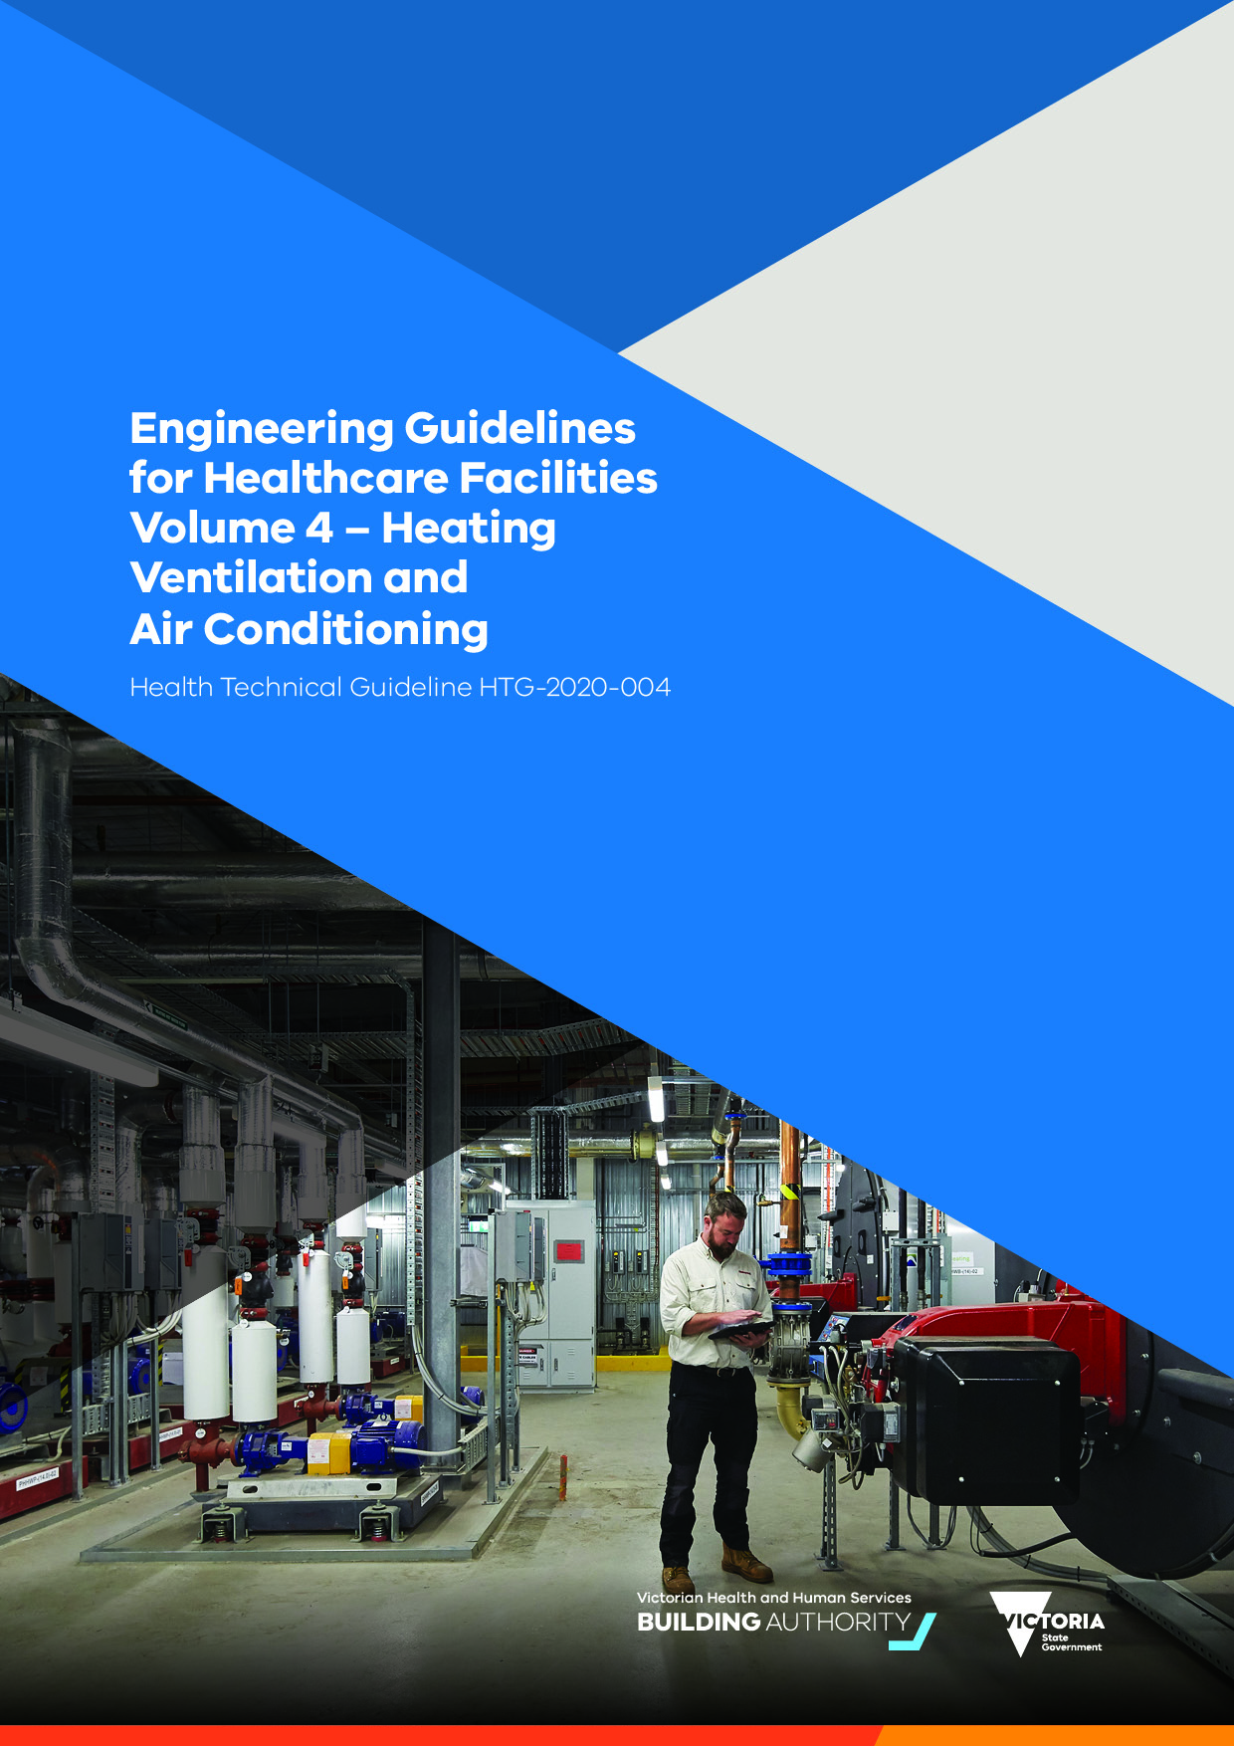

|  |
| --- |
|  |
|  |

|  |
| --- |
| Engineering guidelines for healthcare facilities:  Volume 4 – Heating, ventilation and air conditioning  Health technical guideline HTG-2020-004 |

|  |
| --- |
| To receive this publication in an accessible format phone (03) 8644 5966, using the National Relay Service 13 36 77 if required, or email the [Engineering and Technical Services team](mailto:assetmanagement@dhhs.vic.gov.au) <assetmanagement@dhhs.vic.gov.au>  Authorised and published by the Victorian Government, 1 Treasury Place, Melbourne.  © State of Victoria, Australia, Victorian Health and Human Services Building Authority, May 2020.  Except where otherwise indicated, the images in this publication show models and illustrative settings only, and do not necessarily depict actual services, facilities or recipients of services.  **ISBN** 978-1-76069-438-8 **(pdf/online/MS word)**  Available at the [Victorian Health and Human Services Building Authority website](https://www.vhhsba.vic.gov.au/) <https://www.vhhsba.vic.gov.au> |

Contents

Introduction 8

Scope 9

Design criteria 10

External design conditions 10

External humidity 10

Sustainability 12

Climate change adaptation 12

Energy efficiency and thermal modelling 12

Infrastructure 13

Steam 13

Heating 14

Cooling 14

Ventilation Systems 16

Minimum requirements 16

Outdoor air 17

Heat recovery systems 17

Exhaust air 18

Cross contamination 18

Anaesthetic gas evacuation 18

Room air movement 18

Air handling systems – general 19

Location 19

Outside air economy cycles 19

Construction 20

Ductwork 20

Insulation 20

Air filtration 21

Humidification 21

Humidity control 21

Specialised ventilation systems 23

Ventilation system primary purpose 23

Infection control – principles of design 23

Isolation rooms 24

Pressure gradient 25

General System Configuration 26

Supply and Exhaust System Design 26

Monitoring of pressure 26

Class Q rooms 26

Class P+N Rooms (combination isolation room) 27

Use of Class N isolation rooms for other patients 28

Operating theatres 28

Operating theatre system hierarchy 29

Supply air 30

Terminal HEPA diffusers (conventionally ventilated) 30

Ultra-clean ventilation systems 31

Hybrid Operating Theatres 32

Exhaust and return air 32

Surgical diathermy and laser exhaust systems 33

Burns and plastics operating rooms 33

Orthodontic operating rooms 34

Cardiac catheterisation units 34

ICU and CCU 34

Immuno-compromised patient areas 34

Sterile stock storage 34

Pathology 34

Cytotoxic and manufacturing clean rooms 35

Central sterilising and supply department (CSSD) 35

Laboratories and clean rooms 35

Procedure, recovery, delivery and dental rooms 35

Bronchoscopy and sputum induction units 35

Endoscopy Units 36

Mortuary 36

Mental health 36

Pandemic mode of operation 36

Purge modes 37

Unplanned air leakage in areas that rely on differential pressure 37

Building management and control system (BMCS) 38

Introduction 38

Scope 38

Functionality 39

BMCS failure and disaster recovery 39

Mechanical switchboard configuration 40

Commissioning 40

Appendix A: Image description 41

P+N combination isolation room plan 41

# Introduction

The purpose of heating, ventilation and air conditioning (HVAC) systems in healthcare projects is to satisfy internal environmental conditions for infection control, comfort, and safety.

These Engineering guidelines are a guide for the development of design and specification documentation for healthcare facilities. For a glossary of terms and common abbreviations used in the guide, refer to Volume 1.

A key objective for delivery of healthcare facility projects is the provision of facilities that provide for:

achievement of optimal patient care using a model of care for the patient

contemporary approaches to design

practical and easy usage

fitness for purpose

value for money.

It is expected that all projects will be delivered in line with the requirements of all relevant codes and regulations, and all designers are be aware of these obligations.

Any engineered deviations from relevant statutory requirements and other standards due to unique project circumstances need to be thoroughly and holistically assessed, proved, clearly articulated or documented, and signed off by the relevant authority.

All designers will assess the provisions of standards, such as the *Australasian health facility guidelines* (AusHFGs), and determine an appropriate application of these to their project. In new, major hospital developments, it is envisaged the requirements of AusHFGs and these guidelines will be closely adhered to, except where deviations are associated with new models of care, operational policies or procedures, or innovative approaches to the delivery of health services.

On smaller projects and projects where substantial refurbishment is envisaged, designers will critically evaluate the AusHFGs to determine their applicability and suitability to the project during planning, and deviations will be clearly articulated or documented, and signed off by the relevant authority.

Volume 4 – Heating, ventilation and air conditioning forms part of a suite of documents in the *Engineering guidelines for healthcare facilities*. The documents in this series are:

Volume 1 – Fundamentals

Volume 2 – Electrical and lighting

Volume 3 – Data, comms and security

Volume 4 - Heating, ventilation and air conditioning

Volume 5 – Fire and hydraulics

Volume 6 – Specialist healthcare engineering and provisions

Reference table 1 – Design parameters

Reference table 2 - Acoustic design parameters

Reference table 3 - Required noise reductions for room adjacencies

## Scope

The following services are considered part of HVAC systems:

cooling

heating

air conditioning

ventilation

heat recovery and rejection

steam

building management systems

energy management system

# Design criteria

## External design conditions

1. Outside design conditions will be based on the most accurate climatic data available for the location of the proposed project.
2. Outside design conditions will be selected as follows.

Outside design conditions will be considered on a project-by-project basis by the designers and facility teams. Designers should avoid oversizing plant and systems based on subjective conversations.

External design conditions will be selected from the nearest applicable location in Table 1A in AIRAH Application manual DA09.

For operating theatre plant and critical care areas use the 'critical process', 24-hour data if available for the location.

For all other plants use the 'comfort or non-critical process installations' data.

For locations not listed in design temperature data or where conditions for ‘critical process’ does not exist, the designer will undertake an assessment based on review of Bureau of Meteorological data for the nearest listed location with similar climatic characteristics.

All air-cooled heat rejection equipment will be selected to continuously operate with an external ambient of 50 ºC.

For new projects, designers will consider the potential effects of climate change and adjust the AIRAH design temperature data adjusted in line with the CSIRO 2030 projections. For more information refer to [Climate Change in Australia’s Climate projections page](https://www.climatechangeinaustralia.gov.au/en/climate-projections) <https://www.climatechangeinaustralia.gov.au/en/climate-projections>.

## External humidity

1. The CSIRO advises that humidity projections are unclear. In Victoria, there is anecdotal evidence from the past years (2014 to 2019) that summer and autumn humidity levels are becoming elevated. This is contrary to historical weather experience and has caused issues for cooling coils selected for a dry (sensible cooling) dominated climate.
2. The following design criteria is recommended for the selection of cooing coils and evaporation-based heat rejection equipment.

### Heat rejection plant (cooling towers, fluid coolers and evaporative systems)

1. Heat rejection plant will be selected to operate at a design ambient condition of 24°C wet bulb temperature (wb)

### Cooling coil design selection criteria (critical areas)

1. In areas where humidity ranges are referenced in Reference table 1. For the purposes of cooling coil scheduling and selection only the following outside air condition will be used:

26 db

23 wb.

As a result of this coil selection, the effect on system designs will be that cooling coils serving critical areas will generally increase in depth, typically 8 rows minimum to allow for the moisture removal. Chilled water flow rates to the cooling coils will be commissioned at the required flow rate to meet the external design ambient condition as per Table 1A of AIRAH Application manual DA09.

### Internal design conditions

1. Generally, internal design conditions will be in line with Reference table 1

### Spare capacity

1. Designers must avoid excessive or redundant safety margins or compounding multiple contingencies to compensate for inadequate design investigation or analysis. All plant and equipment must comply with the NCC Part J. Typically it will be more beneficial for the project to leave space to upgrade, or change plant, in the future rather than installing equipment that will be oversized for most of its life.

#### New installations

| System | Plant strategy | Spare capacity | Spare space allowance |
| --- | --- | --- | --- |
| Chiller plant | Infrastructure section (N+1) | 10% | 15% |
| Heat rejection plant | Infrastructure section (N+1) | 10% | 15% |
| Boiler plant | Infrastructure section (N+1) | 10% | 15% |
| Pumping | Duty or standby (N+1), where required to negate a single point of failure. | 10% (with variable speed drive) | n/a |
| Fans | Local air handling units increasing number of air handling units for critical areas | 15% | n/a |
| Cooling coils | In air handling units | 10% | n/a |
| Heating coils | In air handling units | 10% | n/a |
| Cold water | Two points of entry | 15% | n/a |

#### Existing installations

1. The designers will undertake checks of upstream capacity when making modifications to existing systems, and the effect on the overall infrastructure and spare capacity assessed on a project by project basis. Refer to ‘Refurbishment’ in Volume 1 – Fundamentals.

# Sustainability

1. Engineering design will be applied to reduce energy wastage and carbon dioxide emissions arising from the operation of the hospital, whilst maintaining clinical and functional standards.
2. Energy design should embrace:

an enterprise-level energy management program integrated with other functions (risk management, cost control, quality assurance, employee recognition)

include integrated performance monitoring and controls as well as incorporate operational information within maintenance and an ongoing process assessment

provide facility operations staff with site-specific training to minimise energy usage.

energy management systems integrated with the building management system (BMS) allowing monitoring, targeting and load-shedding capability of selected plant

consideration of energy input for hot water systems including energy and heat recovery from mechanical plant heating systems including co and tri-generation where applicable

intelligent design of maintenance and duty-cycle parameters to ensure availability and maintenance cycles encourage energy efficiency, noting that tariff efficiency may also be impacted in terms of load-factor issues for example.

## Climate change adaptation

1. Designers will consider the potential effects of a changing climate and should refer to the government’s climate change website at the feasibility and schematic design stages of the project, and assess the potential risks posed to the project.
2. For more information, refer to [Climate Change in Australia’s Climate projections page](https://www.climatechangeinaustralia.gov.au/en/climate-projections) <https://www.climatechangeinaustralia.gov.au/en/climate-projections>.

## Energy efficiency and thermal modelling

### Compliance modelling

1. Thermal modelling will be undertaken for new buildings, partial building modifications and extensions of existing buildings in line with NCC Part J.
2. Results from thermal modelling that has been undertaken for specifically for NCC compliance should not be used as a predictor of actual building energy usage or final plant sizing.

### Design thermal modelling

1. Design thermal modelling will generally be used to ascertain following during the design:

plant capacity

thermal comfort

optimisation of the building thermal performance – comparison of construction options to ensure the building envelope, fabric, glazing and shading provides an optimal solution with reduced internal space loads

renewable energy strategies such as

* + photovoltaic (PV) installations
  + solar thermal installations

energy management strategies such as;

* + thermal stores (water or phase change)
  + combined heat and power schemes (co-gen and tri-gen)

### Modelling for evaluation of operational energy performance

1. Operational energy modelling is a complex and time-consuming exercise. Where there is a briefed requirement for modelling that is to be used for the determination of operational energy, the designers will carry out the modelling in line with CIBSE TM54Evaluation of operational energy performance of buildings at the design stage.

### Modelling Software

1. The modelling software used will be current proprietary software. The calculation method used will comply with ANSI/ASHRAE 140.

## Infrastructure

1. Engineering design must address the following objectives.

Design must be appropriate for the location in terms of climatic conditions, sophistication of services, availability of skills and support.

Design must be reasonably adaptable to respond to changes in infrastructure planning and clinical health care models, and the likely changes in use.

Design must be robust and resilient, and consider the services delivered during normal operations, as well as disaster scenarios, as defined for each hospital.

Designs for infrastructure with useful lives greater than 25 years must consider future adaptability.

## Steam

1. Although central steam systems are gradually being decommissioned in many facilities, steam performs a significant role in healthcare, and is relied upon for sterilisation, humidification and in some instances energy distribution.
2. Central plant is generally gas operated and comprises steam boilers or more commonly steam generators. These units are usually located within a plant room and steam is chemically treated before being distributed via pipework. Distribution pipework must be carefully designed in line with the pressure piping regulations (AS 4041) and must include pressure regulation, moisture separators, condensation traps and be adequately insulated and drained.
3. Sterilisation is carried out on instruments, tubing and equipment in order to eliminate infection. Sterilisation is achieved using processes of washing, steam autoclaving, drying, packing and storage within a suitable environment.
4. Steam used for sterilisation generated either locally or via central plant must meet the quality requirements set out in AS 4187.
5. For sterilisation, two methods of generating steam are commonly used, central steam generation and local steam generation. The most important factor is in producing the correct dryness of steam at the point of use, for example, if the steam is too wet in the central sterilising and supply department (CSSD) then effective sterilisation will not be achieved.
6. Designers should consider the pros and cons of both central and local generation during the design phase as it will vary on a project by project basis.
7. The local steam generation is usually electrically operated and can be provided as part of the sterilising reverse osmosis (RO) plant requirement equipment. Although steam dryness can be more reliably achieved when produced locally, the electrical demand can become a significant load on the overall site electrical supply and this needs to be considered.

## Heating

1. All occupied areas will be heated.
2. Central heating plants are recommended to consist of a minimum of two adequately selected heating units, furnaces or boilers, to provide standby in the event of failure or maintenance of one heating unit. Condensing boilers will be used where system temperatures permit.
3. Boiler accessories including feed pumps, heat circulating pumps, condensate return pumps, fuel oil pumps, and waste heat boilers will be connected and installed to provide both normal and standby service.
4. Where the facility is fed by three or more boilers, power supplies will be arranged such that failure of a mechanical switch board does not affect all boilers.
5. Heating systems will be thermostatically controlled. Heating systems with long thermal lag, for example, most types of in-slab heating, will only be used when there is no alternative. These systems will incorporate a control system to hold space temperature within two (2) degrees Celsius (°C) of the winter design value. Temperature control that relies on opening windows to compensate for overheating will not be used.
6. The temperature at floor level will not deviate by more than 1.5 degrees Celsius above the air temperature at a height of 1.5 metres.

## Cooling

### General

1. The choice of refrigeration systems should give due consideration to system capacity and the appropriate application of the various technologies. For systems below 200 kW, VRF systems can be considered, for systems between 200 to 2000 kW, air cooled chillers should be considered, and for systems above 2000 kW, water cooled chillers should be considered.
2. Cooling towers, fluid coolers and evaporative condenser systems will be designed and installed in line with the Health (Legionella) Regulations and AS 3666 - Air handling and water systems of buildings – Microbial control.
3. Cooling towers and evaporative condensers will include a side stream filter or cyclonic separator system to provide solids removals from the circulating water systems.
4. Evaporative cooling may be used for support areas where relief cooling only is required such as kitchens and workshops and some other non-critical areas, where suitable. Observe standards and codes for design as for air conditioning.
5. Central cooling plant chiller sets will be selected to ensure that in the event of failure of a compressor, the chiller will continue to operate at a reduced capacity. Select chillers that maintain reliable, energy efficient low-load operation. Large systems will consider a low load chiller, as part of the chiller plant configuration.
6. Where the facility is fed by three or more chillers or cooling towers, power supplies will be arranged such that failure of a mechanical switch board does not affect all chillers.

### Condenser water

1. For major projects condenser water systems will be arranged such that a failure in the condenser water loop does not disable all the heat rejection in the facility, and cooling can still be supplied to critical areas.

### Heat rejection plant

1. Heat rejection plant will be arranged such that a failure of one unit does not disable the entire system. Make-up water meters linked to the BMS will be provided to cooling tower and fluid cooler systems
2. During the design stage, designers will assess the impact of any proposed acoustic or architectural enclosures on heat rejection equipment and apply the appropriate de-rating factors to the selected units. Where necessary computational fluid dynamic studies will be undertaken to establish the likelihood of air recirculation caused by the enclosures.
3. Water based heat rejection equipment will be provided with appropriate treatment systems to control the growth of biological materials in the rejection water system to safe levels.

### Cooling coils

1. Cooling coils will be designed with a maximum face velocity of 2 m/s. Limiting humidity range by cooling coil design may be acceptable unless there is a specific requirement to warrant precise control of humidity, refer to table Reference table 1.
2. Where de-humidification is required to maintain the conditions set out in Reference table 1, Cooling coils will need to be periodically cleaned or decontaminated. They must have good access both up and downstream and be suitably separated from the heater battery. Hinged access doors should be provided both sides of the coil. An eliminator will be required downstream of all cooling coils. The eliminator may take the form of an extension of the coil fins or be a separate device. If a separate device, it should be removable as a unit to permit cleaning of the coil face.
3. All cooling coils must be fitted with their own independent drainage system as specified above. A baffle or similar device must be provided in the drain tray to prevent air bypassing the coil. The tray should be large enough to capture the moisture from the eliminator, bends and headers.

### Chilled beams

1. Use of Chilled beams should be restricted to non-clinical and sub-acute clinical spaces. Chilled beams will not be used in zones designated as pandemic capable zones. If used in sub-acute clinical settings the use of beams must be considered in terms of the operational maintenance impact in the space during cleaning and the associated infection control implications. If installed as a minimum requirement, beams must;

meet the minimum outside air rates as designated in Reference table 1

have hinged cores

not be located over patient beds.

# Ventilation Systems

## Minimum requirements

1. All ventilation systems should be inspected annually to ensure conformance with minimum requirements, which are designed to:

ensure safe access when carrying out routine service and maintenance activities

prevent or control risks associated with Legionella and other potential hazardous organisms

check that the system remains fit for purpose

be operated in a manual mode in the event of a failure in the building management system, especially in critical care areas.

Every effort should be made to ensure that all ventilation systems achieve the following minimum requirements.

Air handling units (AHUs) should be secured from unauthorised access.

Units located on roofs should have a safe and permanent means of access. Suitable precautions must be in place to prevent personnel or equipment from falling during maintenance activities.

Units located outside at ground level should be secured within a compound to prevent unauthorised access. Vehicles should be excluded from the vicinity to ensure that exhaust fumes will not be drawn into intakes.

All parts of the AHU should be easily and safely accessible for routine inspection and service.

Fire precautions should be in line with AS 1668

Combustion equipment must not be in a fire compartment that houses air-handling equipment.

Plantrooms that house AHUs should not be used for general storage. Care should be taken to ensure that combustible material is not kept in the plantroom.

The plant must not contain any material or substance that could support the growth of microorganisms.

The plant must not contain any material or substance that could cause or support combustion.

Access to items that require routine service, such as filters, heating and cooling coils, should be via hinged doors.

Items requiring infrequent access such as attenuators may be via clipped or bolted-on lift-off panels.

All doors and panels should be close-fitting and without leaks.

Other services should not restrict or impede access to those parts of the AHU that require inspection.

Air handling units over 3000L/s. Viewing ports and internal illumination should be fitted into all sections of the AHU in order to inspect filters coils, fans and drainage trays.

Internal illumination of AHUs should be provided by fittings to at least IP55 rating. Fittings should be positioned so that they provide both illumination for inspection and task lighting. A single switch should operate all the lights in a unit.

## Outdoor air

1. Outside air will be provided according to AS 1668 Part 2, as adopted by the BCA. Reference table 1 contains data from AS 1668 Part 2, with the addition of data on areas of hospitals not covered by the standard. Where there is difference between the two documents, the higher quantity will apply.
2. All ventilation systems should be designed to control the higher level of odours often generated within health care facilities and ensures a high standard of indoor air quality.
3. Variable air volume (VAV) systems will incorporate control devices to ensure minimum outdoor air supply to all areas is always maintained when system volume is turned down. VAV air diffusers should only be used in very isolated cases to overcome unique zoning situations.
4. Regardless of whether the area is served via operable windows, forced fresh air will be provided in line with these guidelines to all air conditioned occupied spaces.
5. When and where conditions permit, natural ventilation may be used for non-patient areas (such as general support areas and central storage) or based on acuity of service being provided (for example, aged care).

## Heat recovery systems

1. NCC Part J5, requires outdoor air treatment as a required measure.

| Climate zone | Outdoor air flow (L/s) | Required measure |
| --- | --- | --- |
| 1 | Over 500 | Modulating control |
| 2 | - | No required measure |
| 3 | Over 1000 | Modulating control |
| 4 and 6 | Over 500 | Modulating control or energy reclaim |
| 5 | Over 1000 | Modulating control or energy reclaim |
| 7 and 8 | Over 250 | Modulating control or energy reclaim |

In most clinical settings, modulating control (demand-controlled ventilation in line with AS 1668.2) based on CO2 concentrations in the space is not appropriate for infection control and would fail to meet the minimum outside air requirements to clinical spaces as set out in Reference table 1. Heat recovery systems are required to be a minimum of 60 per cent efficient, run around coils are therefore not suitable. Designers will incorporate either cross plate heat exchangers or thermal heat wheels.

1. Where heat recovery is required to be incorporated into systems that are 100 per cent outside air for infection control, cross plate heat exchanges can be used provided the fans are arranged to ensure the extract side of the heat exchanger is under negative pressure, with respect to the supply side, to prevent air leakage from the extract to the supply air streams. Thermal wheel recovery systems can be used if they incorporate HEPA filtration on the supply air side downstream of the thermal wheel, in addition to the standard filtration upstream of the thermal wheel.
2. Before incorporating heat recovery into these systems, the risk should be assessed and the solution agreed with the maintenance, clinical and infection control teams or the facility.

## Exhaust air

1. All bathroom, toilet exhaust systems and dirty utility spaces will be fully ducted and discharge to the outside, not to common roof or ceiling space.
2. Contaminated exhaust systems, including those serving toilets, and those necessary to attain positive air flow from clean to dirty areas will be provided with duplex fans or fan motors and automatic change over from duty to standby in the event of a failure of the fan or motor. This will not apply to independent toilet exhaust systems serving single use toilet/shower or bath areas.
3. Local exhaust ventilation will be localised as close as practicable to the sources of contamination. Exhausts will be discharged in a manner that will not contaminate any adjacent area or system. Capture velocities at the point of localised extraction will designed to suit the function. Where air is contaminated with dust or particulate matter conveying velocities must be maintained, this includes areas such as autopsy, plaster rooms and mould rooms. Consideration is also to be given to acoustics to prevent noise nuisance from high velocity systems.
4. Where back of house workshop areas are required to be exhausted, fresh air, ventilation and air conditioning systems should be provided and, if the area is not listed in Reference table 1, BCA ventilation rates will apply.
5. When required, appropriate hoods and exhaust devices for the removal of noxious gases or chemical vapours will be provided in line with AS 1668.

## Cross contamination

1. Obnoxious exhaust systems (such as kitchens, pathology, waste handling room, smoke spill and the like) will be designed in line with AS 1668, and the designers will assess discharge locations in relation to outside air intakes. Site specific wind directions and topography may require greater separation from supply intakes rather than the AS 1668 regulatory separation to avoid nuisance odours being transmitted to areas of the facility.

## Anaesthetic gas evacuation

1. Each space routinely used for administering inhalation anaesthesia and inhalation analgesia will be served by a scavenging system to vent waste gases. Gases from the scavenging systems will be exhausted directly to the outside. If a medical vacuum system is used, the gas collecting system will be arranged so that it does not disturb patients' respiratory systems. The space will also include low level ventilation.
2. Scavenging systems are not required for areas where gases are used only occasionally, such as emergency rooms and offices for outline dental work. Anaesthesia evacuation systems may be connected to the room exhaust systems, provided that the system is a single pass system and the exhausts is directly to the outside or via heat recovery unit in line with NCC Part J5.
3. Any scavenging system is recommended to be designed to remove as much of the gas as possible from the room environment. It is assumed that anaesthetising equipment will be selected and maintained to minimise leakage and contamination of room air.

## Room air movement

1. The air velocity and temperatures within occupied zones will be provided to maintain accepted comfort limits, and the mean air velocity should be less than 0.25 m/s. The temperature gradient in the space between ankle and neck should be no greater than 3°C. The temperature difference between rooms on the same zone will generally vary by not more than 2°C.

## Air handling systems – general

### Zoning

1. The mechanical system for serving separate floors and departments should be able to be isolated without interrupting other areas. In this regard, each air handling system should serve either a floor or a department on a floor.
2. Matching air handling systems with functional floors, clinical departments and fire compartments is preferred this offers maximum flexibility in departmental functional patterns. This also facilitates the potential full shutdown of department to eliminate cross infection with other areas, and any fire smoke control requirements which may be needed without additional fire rating of ductwork or elaborate dampening arrangements.
3. Zoning of air handling systems will generally allow for the different dynamic loads and conditions likely to occur due to:

building fabric, glazing, roofs and suspended floors

hours of operation

internal heat gain from people, lights

clinical equipment.

smoke control

Variable control of air flow either by variable speed motor controls may be used where deemed beneficial unless constant volume systems are preferable to serve areas to ensure that pressure regimes are maintained. In such cases, the interaction of varying pressure regimes between areas should be assessed.

### System selection

1. In selecting air handling system types, consideration will be given to the cost and ease of maintaining the systems. Points to be considered include:

plant and components located over occupied areas will be installed in a manner so that routine maintenance does not cause disruption to normal hospital activities; in this respect it is not recommended to install plant in ceilings in clinical areas or patient areas.

the level of maintenance expertise available on site and the level of technical expertise available to the hospital to operate and adjust the system

preference will be given to simple systems requiring simple maintenance and adjustment with extended periods between routine maintenance.

separate localised air conditioning plant should be provided for rooms with unusually high heat gains or intermittent operation, such as meeting rooms, data rooms, control rooms.

## Location

1. Air handling plant will be in dedicated plantrooms. If the plantroom is used as a supply plenum, the plant room ventilation supply air will be filtered.
2. Where applicable, all air handling equipment must comply with NCC Part J, including minimum 60 per cent efficient heat recovery on qualifying outside air systems.

## Outside air economy cycles

1. Outside air economy cycles will be included as per NCC requirements and Reference table 1, unless detrimental to pressure regimes or humidity control.

## Construction

1. Air handling units and air conditioning units serving perioperative and clinical spaces will comply with the following:

easy door and hatch access and space to all internal areas of units for inspection, maintenance and cleaning; door access required where size permits.

no internal lining

double skin construction, minimum R value 1.2 m2K/W

all internal surfaces to be hygienic and cleanable such as powder coat finish, stainless steel or high-quality paint finish and or anti-microbial coating

internal lights will be installed in all units over 3000 L/s airflow

motorised shut off dampers, which close when the unit is not in use.

velocity over coils 2 m/s or less

minimum 600mm separation between cooling and heating coils, with eliminator plates after the cooling coil if the unit is required for de-humidification.

condensate trays to be well sloped to drain with no water retention in tray and constructed of corrosion resistant materials

all sections downstream of filters that operate below ambient pressure will be sealed to prevent air leakage.

filter frames will be durable and dimensioned to provide an airtight fit with the enclosing ducting. All joints between filter segments and the enclosing ducting will be fitted with a gasket or sealed to provide a positive seal against air leakage. A manometer or gauge is recommended to be installed across each filter.

Attenuators will be proprietary units, with impervious metal faced linings. All attenuation will be in the plantrooms, to allow access for cleaning

## Ductwork

1. Air handling duct systems will be designed in line with AS 4254 to be accessible for duct cleaning, generally by the provision of access panels. Access panels will be fitted at each coil, fire and smoke damper and each turn in direction to allow annual essential services inspection.
2. Roof voids will not be used for air plenums for return air.
3. Ceiling voids will not be used for air plenums for return air.
4. All supply return air and exhaust air will be fully ducted in clinical areas.
5. To reduce the extent of ductwork in ducted return air systems, and where clinically practical, consider transfer ducts between rooms and corridors; then ducted return from corridors, to minimise length of major ducts.
6. Acoustic silencers in these systems should be in accessible areas such as plant rooms such as they can be accessed and checked and cleaned.

## Insulation

1. Thermal insulation is applied to ductwork to reduce heat exchange and to prevent condensation, and as a minimum will be in line with NCC section J.
2. Internal thermal insulating of ductwork will not be permitted in systems serving clinical areas.
3. Condensation can arise in ductwork systems conveying cooled air and, apart from creating conditions conducive to corrosion of ductwork, condensation affects the heat and vapour-resisting properties of insulating materials themselves, which may induce further condensation.
4. In normal circumstances, the insulation thickness for heat resistance is enough to prevent surface condensation, but in extreme conditions the insulation thickness for vapour resistance may be greater than that for heat resistance. When cold ducts pass through areas that have a high dewpoint, carefully selected vapour barriers should be applied externally to the insulation.
5. Insulation will be mechanically protected in exposed locations e.g. plantrooms or externally situated ductwork.

## Air filtration

1. Heating, ventilation and air conditioning systems will control the concentration of air-borne particulates in high risk areas to minimise the risk of infection by means of air pressure, flow control and air filtration. Minimum filtration levels will be as indicated in Reference table 1.
2. Air handling plant and any other in-duct filter banks will be installed with manometers or differential pressure monitoring. Visual indication will not be required on terminal filtration.
3. Filter grades will be in accordance with Reference table 1. Where specific filter efficiencies are required for clinical purposes, filter efficiencies will be specified to ISO Standards.

## Humidification

1. Humidification is required in areas of a hospital as identified in Reference table 1.
2. To minimize wetting of ductwork, filters, and other components that are susceptible to microbial growth. The BMS will limit the in-duct relative humidity (RH) to a maximum of 80 per cent.
3. Clean steam can be generated in small, point-of-use electric, gas, or steam-to-steam generators at lower pressures, 0 to 35 kPa. Small, point-of-use generators have the advantage of producing clean steam, but typically require high levels of maintenance for proper operation.
4. Evaporative water systems should not be used to provide humidification in health care facilities. Reservoir type water humidifiers or evaporative-pan-type humidifiers should not be used in ductwork or air-handling units in health care facilities because of the risks posed to patient care and the spreading of disease – they are known to leak, corrode and cause other maintenance problems as they age. Ideally, direct steam injection humidifiers are preferred.

## Humidity control

1. Clinical and operating theatre air handling units will be required to actively de-humidify to maintain the range of conditions see Reference table 1.
2. The temperature ranges listed are a user controlled minimum and/or maximum. Air handling systems will be capable of maintaining the rooms within the guideline humidity range during normal operation.
3. The RH ranges listed in Reference table 1 are a controlled minimum and/or maximum allowable at any point within the user-controlled temperature range required for that space. Systems will be capable of maintaining the rooms within the range during normal operation. Lower or higher humidity will be permitted when patients’ comfort and/or medical conditions / equipment require those conditions, as a specific brief requirement.
4. Unless indicated by ‘min’ or ‘max’ in Reference table 1, minor excursions from the upper and lower limit (plus or minus10 per cent RH) are allowable during exceptional conditions, such as the outside air condition exceeding the design wet bulb.
5. Humidity will be monitored in peri-operative and sterile areas in line with VHHSBA HTA-2019-001

# Specialised ventilation systems

## Ventilation system primary purpose

1. The main purpose of the air conditioning system is identified in Reference table 1. Areas such as isolation rooms, PC laboratories and operating theatres will incorporate energy efficiency measures in line with NCC part J only where practical and where the measures do not interfere with the main purpose of the air conditioning system.

## Infection control – principles of design

1. Air conditioning systems will maintain fresh air, temperature, humidity and contaminant control (dust, micro-organisms and gases) of the air.
2. Design principles throughout the patient care areas will, in addition to comfort requirements, comply with infection control requirements. To minimise the risk of infection the ventilation system will be designed and balanced to provide directional air flow from clean to less clean areas. Maintaining required pressure regimes will frequently require air quantities in excess of the minimum scheduled in the Australian Standard, and Reference table 1. Positive flow at adequate rates is preferred to the defining of pressure differentials between areas. In some circumstances, flow may be required only on opening of doors and the system will have adequate flexibility to accommodate this requirement.
3. Provision will be made to ensure adequate air supply with varying filter resistances in areas requiring high levels of airborne contaminant control. Typically, this will be in operating rooms, set-up rooms, isolation rooms and high infection risk areas.
4. Local fan coil units are not to be used in high infection risk areas, unless expressly approved by the infection control committee. Where used high efficiency filters will be installed, and additional cleaning procedures will be implemented. Note that UV filtration may be appropriate in some cases.
5. Fans in systems serving areas requiring airborne contaminant control will be operated 24 hours per day to maintain airflow patterns from clean to less clean areas.
6. Both the supply and exhaust ventilation systems to isolation rooms will be either separate independent systems for each room or will incorporate controls to prevent the possibility of cross contamination in the event of a fan failure. Additionally, supply air and extract air ventilation fans will be interlocked such that failure in either supply or extract will shut down the corresponding extract or supply to that room.
7. Provide isolation room pressure instrumentation, local alarms to the nurse station with a delay to prevent nuisance alarms and monitor fan status.
8. Ensure that isolation rooms are well sealed, including all services penetrations, to enable the pressure differentials to be maintained. This usually requires briefing of all the building and other services trades to ensure a workman like result of the HVAC fans cannot sustain the required pressures and flows.
9. Isolation room supply air and exhaust systems should be interlinked to prevent one system over or under pressurising in the event of a failure in the other system.

## Isolation rooms

### Overview

1. This information should be read in conjunction with:

AusHFGs Part D Infection Prevention and Control, Section 02.06 Isolation Rooms;

AusHFGs Isolation Rooms – Engineering and Design Requirements

relevant Australian Standards, such as AS 1668.2:

ASHRAE 170 Ventilation

1. There are five types of isolation rooms that can be used to accommodate patients. These room types include:

|  |  |
| --- | --- |
| Isolation room type | Isolation room use |
| Class S | Standard isolation for patients capable of transmitting infection by droplet or contact routes |
| Class P | Protective isolation used to isolate immunocompromised patients. |
| Class N | Respiratory isolation used to isolate patients capable of transmitting infection. |
| Class Q | Quarantine isolation – a Class N room including an anteroom and fumigation facilities |
| Class P+N | Combination respiratory isolation and protective isolation room |

Alternating pressure in isolation rooms must not be used (that is, rooms that can be switched between positive and negative pressure). In addition to clinical risks, the cost of ongoing maintenance and special equipment will outweigh any perceived benefit of flexibility.

| Room features | Class S (standard) | Class P (positive) | Class N (negative) | Class Q (quarantine) | Class P+N (combination) |
| --- | --- | --- | --- | --- | --- |
| Hand basin in room | Yes | Yes | Yes | Yes | Yes |
| Ensuite bathroom | Yes | Yes | Yes | Yes | Yes |
| Door on room with door closer | Yes | Yes | Yes | Yes | Yes |
| Anteroom | - | - | Yes | Yes | Yes |
| Sealed room, with barometric dampers, for controlled air flow | - | Yes | Yes | Yes | Yes |
| 12 air changes per hour (ACPH) or 145 litres per patient | - | Yes | Yes | Yes | Yes |
| 100% outside air ventilation | - | Yes | Yes | Yes | Yes |
| Local differential pressure monitoring | - | Yes | Yes | Yes | Yes |
| Independent supply air | - | - | Yes | Yes | Yes |
| HEPA filters on supply air | - | Yes | - |  | Yes (note 2) |
| Low-level exhaust 150 mm above floor (unless alternate air distribution system can be demonstrated) | - | Yes | Yes | Yes | Yes |
| Independent exhaust discharging vertically at 10 m/s according to AS 1668.2 Type A exhaust | - | - | Yes (note 1) | Yes | Yes (note 1) |
| Exhaust duct under negative pressure within building with duplex fans | - | Optional | Yes | Yes | Yes |
| HEPA filters on exhaust | - | - | - | Yes | - |

**Notes**

Note 1: Alternatively, HEPA filtered terminal extracts can be fitted if a suitable AS 1668.2 Type A discharge location cannot be accommodated.

Note 2: HEPA filtration can be remote in the supply unit.

The plant and engineering systems should be designed so that maintenance can assess from outside the isolation room. This improves the safety of maintenance staff while maintaining containment and therefore patient safety.

## Pressure gradient

1. Class N isolation rooms will provide a negative pressure gradient from the isolation room to the anteroom and corridor. The most negative pressure environment will be the patient bedroom
2. Class P isolation rooms will provide positive pressure relative to the corridor.
3. The minimum differential pressure between the isolation room and adjacent ambient pressure areas should be 20 to 30 Pa if the isolation room has an anteroom and 10 to 15 Pa when there is no anteroom. In both cases, the pressure gradient relates to the differential from the corridor.
4. Barometric dampers will be needed to achieve these pressure gradients, acoustic lining of ducted inlets and outlets to barometric dampers will not be permitted.

| Area | Class S (standard) | Class P (positive) | Class N (negative) | Class Q (quarantine) | Class P+N |
| --- | --- | --- | --- | --- | --- |
| Patient room | - | +20 to +30 Pa | -20 to -30 Pa | -20 to -30 Pa | - |
| Ensuite | - | +20 to +30 Pa | -20 to -30 Pa | -20 to -30 Pa | -12 to -17 Pa[1] |
| Anteroom | - | - | -10 to -15 Pa | -10 to -15 Pa | +12 to +17 Pa |

**Note**: Pressures measured relative to the corridor.

## General System Configuration

1. In typical inpatient units where there are no more than one or two isolation rooms, each room should be provided with an individual fan coil unit for temperature control and an associated individual duty or standby exhaust fan. The fan coil unit should be provided with variable speed controllers for commissioning purposes. The exhaust fan should be provided with variable speed controller to account for filter loading. The pressure regimes are maintained by the barometric dampers. The outside air supply can come from a common source that may also supply other areas and provided with appropriate dampers for both shut-off and balancing purposes.
2. In clinical units with a high number of isolation rooms, the arrangement can also be similar as above. Alternatively, for economy and ease of ceiling spatial coordination, all the rooms can be provided from a common but dedicated full outside air handling system with terminal trimming reheat. The air handling system should have a duty and standby fan arrangement to provide redundancy and reliability. Dedicated exhaust fans with variable speed controllers should be provided to each isolation room.
3. In any arrangement, all equipment (such as fan coil units, filters, coils and fans) should be located outside the isolation rooms for ease of maintenance access.

## Supply and Exhaust System Design

1. Exhaust ducts from Class N and Class Q isolation rooms will be separate from the common building exhausts system so that contamination is avoided. Air from these rooms should be exhausted directly to the outside of the building. Discharge points for air should be located as far as possible from air-intakes. Ideally positioned above the roof line at a height that avoids possible re-entry of the exhausted air into the outside air intakes of the building.
2. Consideration should be given to undertaking modelling (computer or physical) of airflows where risks need to be assessed (such as possible contamination).
3. The minimum requirement for discharge should comply with requirements for obnoxious discharges specified in AS 1668.2. Discharge plume may need to be modelled to assess entrainment.
4. Supply and exhaust fans with variable speeds are recommended to facilitate commissioning and future adjustments. The exhaust fan in the system should be located as near as possible to the discharge point.

## Monitoring of pressure

1. Except for Class S, all isolation rooms will be monitored, both locally and at the BMS. Gauges should clearly display acceptable and unacceptable pressures. Control systems will be required to stop the supply (intake) air system if there is flow failure of the exhaust air system.
2. Motorised dampers will need to be positioned at supply air entry and exhaust exit points in the room. In Class N and Class Q isolation rooms, dampers will need to automatically shut if the associated fan stops.

## Class Q rooms

1. To enable Class Q isolation rooms should provide:

dedicated air conditioning, supply and exhaust systems;

front access Lint + HEPA filter (fitted differential pressure gauge) at each room exhaust point

ducts damper with edge and blade seals immediately downstream of each exhaust HEPA filter band for duct isolation prior to HEPA filter removal and room cleaning. Location of filter is important. A low-level location should be avoided so the filter does not collect dust

alarms that are activated on loss of differential pressure. However, as entry/exit from the isolation room will effectively negate the pressure difference, some form of delay or isolation of such an alarm will be necessary.

to be adequately and safely fumigated when require, airtight dampers will be:

* + installed in the supply air ductwork between the supply air fan and the room;
  + installed in the exhaust air ductwork, downstream of any HEPA filter installed in the room exhaust. HEPA filters are required.
  + purpose designed and fitted with seals and seal tight while fumigation is in progress. Standard balancing dampers will not be used.

## Class P+N Rooms (combination isolation room)

1. Combination isolation rooms are becoming increasingly common in Europe (positive pressure ventilated lobby, PPLV) and America (combination airborne infection isolation and protective environment, AII/PE). The room consists of a positive pressure anteroom, controlling the air flow into the isolation room, and a negatively pressurised ensuite removing the air from the isolation room. The clinical advantage is that the room can be used for airborne infectious patients or immuno-compromised patients without changing the pressure regime. Patient bed access must be through the anteroom, access or doors directly from the patient room to corridor will cause pressurisation issues due to leakage around the doors and should be avoided.

Figure : Plan of P+N combination isolation room

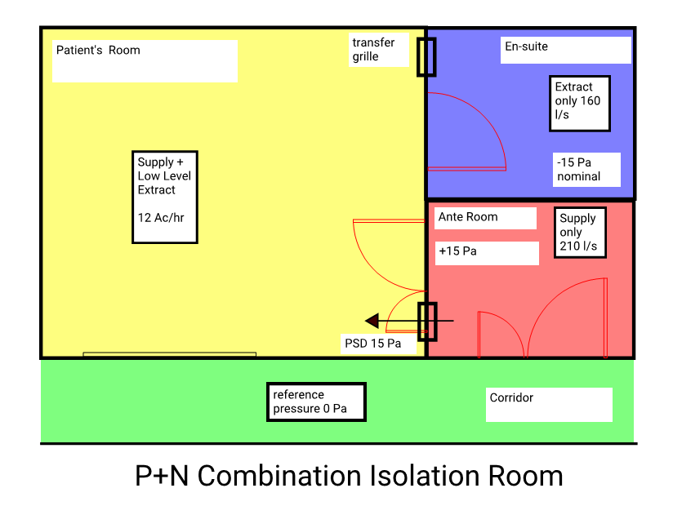

A pressure stabiliser of the balanced blade type, set to operate at 15 pascals, will be fitted above the door between the ante room and the patient’s room.

1. The stabiliser should be visible so that its correct operation can be seen. It will be of a style that will operate silently and be correctly sized and positioned so that it does not cause a draught that would be uncomfortable for patients.
2. A direct reading gauge showing the pressure in the ante room with respect to the corridor should be mounted at eye level on the corridor wall adjacent to the anteroom entry door. The gauge and ante room entry door will be clearly marked to identify the isolation room.
3. The pressure of Class P+N combination isolation rooms will be monitored, both locally and at the BMS. Gauges should clearly display acceptable and unacceptable pressures. Control systems will be required to stop the supply (intake) air system if there is flow failure of the exhaust air system.

## Use of Class N isolation rooms for other patients

1. Occupancy rates in hospitals are typically high and it is not possible to leave specialised rooms, such as Class N isolation rooms, unoccupied. Health services may seek to promote the utility of these rooms by installing systems that can ‘turn off’ dedicated alarm systems. This means that the patient entry doors to the room can be left open and as the pressure gradients change, an alarm will not be triggered. This functionality may also include a temporary mute function that can be used when cleaning a room or moving a patient in and out of the room. The mute function will typically only last for 10 minutes.
2. A control panel to disable alarms will typically located near the pressure gauges at the entry to the isolation room. By default, the alarm will be activated when the room pressures drop below the specified range. Selected staff will have access to a key that will disable the alarms. This control panel will also contain a button to temporarily disable the alarm. As the disabling of alarms is temporary, a keying system may not be needed.
3. Management regimes will need to be implemented to minimise risks associated with disabling alarms. These may include a record of approval to turn off the alarm and then turn back on.
4. It is not recommended that the negative pressure air handling system is turned off or maintained at a lower differential when not needed to manage a patient requiring respiratory isolation (also known as operating in ‘setback’ mode). This recommendation is based on expert local and international experience.

## Operating theatres

### Fundamental principles

1. In contrast to an isolation room, theatres rely on the barrier effect caused by air movement generated by a pressure differential. The actual pressure difference is not the most important criteria in an operating suite. The pressure differentials are relatively small, so to minimise the ingress of air to the operating theatre when doors are opened and closed the amount of air extracted will typically be 250 L/s to 300 L/s less than the air supplied. The actual air volume differential may vary depending on the theatre suite configuration.
2. Graduated pressurisation relative to pressure in areas adjacent to the operating unit ranging from not less than 10 Pa positive in operating rooms to slightly positive pressure in areas like anaesthetic bay, scrub, recovery and change rooms and slightly negative in clean-up rooms can be achieved by using carefully balanced supply air and exhaust air systems.
3. To allow doors to close easily and to prevent nuisance noise from air the barrier airflow, barometric dampers (air stabilisers) will be needed to achieve the barrier air flow rates and pressure gradients. The installation of a grille or baffle is not recommended in association with a stabiliser as this will alter the operating characteristics. It is recommended that a location be chosen to avoid the need for visual screening, for example, at high level. The location should be chosen to minimise the likelihood of damage. Acoustic lining or ducting inlets and outlets to barometric dampers will not be permitted, unless part of a proprietary system, with lining suitable for managing infection control.
4. Different designs of operating suites may require some variance in the barrier air quantity. Active control of the pressure difference is not necessary; however, supply air fans are required to be selected to maintain a constant air quantity as filter resistance increases. This can be achieved by selecting good fan curve characteristics or controls measuring supply air quantity and controlling fan speed by VSD to maintain supply air quantity. Air not exhausted or spilled outward from operating suites may be recycled as return air.
5. Surgeons or surgical procedures may require room temperatures, ventilation rates, humidity ranges or air distribution methods that exceed the indicated ranges. Designers should seek project-specific advice from the users regarding the types of surgery and their specific humidity and temperature needs.
6. To ensure operational flexibility and permit routine maintenance, AHUs should not be shared between suites. In the refurbishment of legacy installations, site conditions may preclude individual AHUs for each suite. In these circumstances, an AHU may be shared between not more than two operating suites, providing each suite has its own control of temperature. In addition, the branch supply and extract should be capable of being physically isolated and the main air-flow rate reduced so that either suite can be taken out of use without detriment to operating conditions in the other.
7. The temperature and humidity will be displayed at the surgeon’s panel in the operating theatre, from where the surgical team will be able to adjust the space temperature.
8. The system will be capable of operation in a set-back mode when the operating theatres are not in use. In set-back mode the operating suite will:

set to minimum outside air

widen temperature dead band to 14°C to 30°C

always maintain full humidity control within the limits set in Reference table 1

## Operating theatre system hierarchy

1. In normal operation, the following system hierarchy will apply:
   1. air flow regimes and filtration
   2. temperature control
   3. humidity control
2. In set-back mode, the following system hierarchy will apply:
   1. air flow regimes and filtration
   2. humidity control
   3. temperature control

## Supply air

1. Supply air to operating rooms will be delivered at high level in a way that minimises recirculation of potentially contaminated room air and provides the cleanest practical air supply over the operating table area.
2. The directions of air flows within Operating Units will always be from the operating room and set-up room, through immediately adjacent inner anterooms, scrub-up and anaesthetic rooms to the recovery, changing and post-operative clean-up rooms; from clean to less clean areas.
3. Airflow into the operating suite will be by means of a distribution system that provides a flow of clean supply air over the operating table area first. The designers will account for the adverse effect of air flow pattern near the surgical field created by equipment and surgical lamps due to their shape, size location and the heat generated by the lamps.
4. The clinical requirement will define the type of operating room theatre air delivery system required. There are two general type of systems:

terminal HEPA diffusers (conventionally ventilated)

ultra-clean ventilation systems

## Terminal HEPA diffusers (conventionally ventilated)

1. The design philosophy of a conventionally ventilated operating suite is based on the need to dilute contaminants and control both the condition and movement of air in an operating suite. The terminals will be arranged to distribute air in the immediate vicinity of the operating table. The terminal arrangement will vary depending on the type of theatre, and ceiling mounted equipment specified in the theatre. The system is a mixing system, some of the theatre air will be entrained into the diffuser air patterns and drawn over the table.

Figure : Conventional Theatre with terminal HEPA units, no obstructions

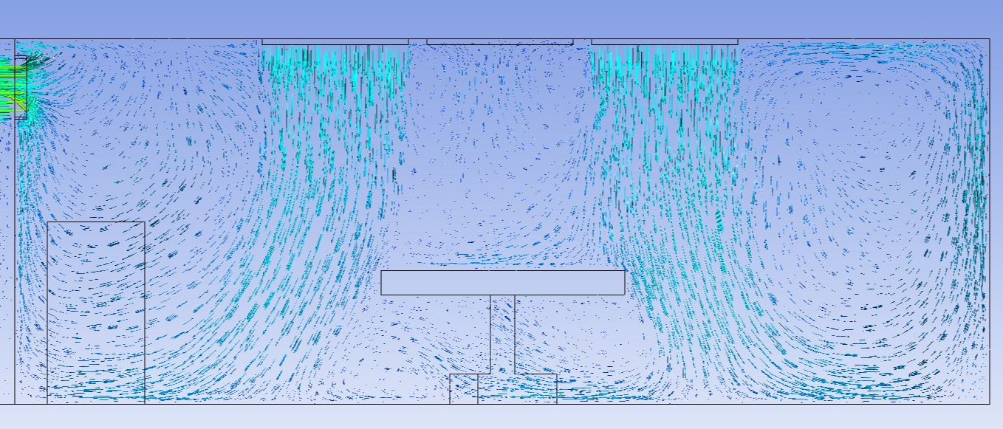

Supply air will be a downward air movement and will aim to achieve a minimum velocity 0.2 m/s at the level of the operating table under isothermal conditions. It is recognised that the mixing nature of the air flows and the variance in HEPA terminal positions will mean that this not always achieved across the operating zone. Tools such as computational fluid dynamics (CFD) analysis are useful for optimising air flow patterns during the design phases.

Figure : Conventionally ventilated theatre with terminal HEPA units, including theatre lights and anaesthetic equipment

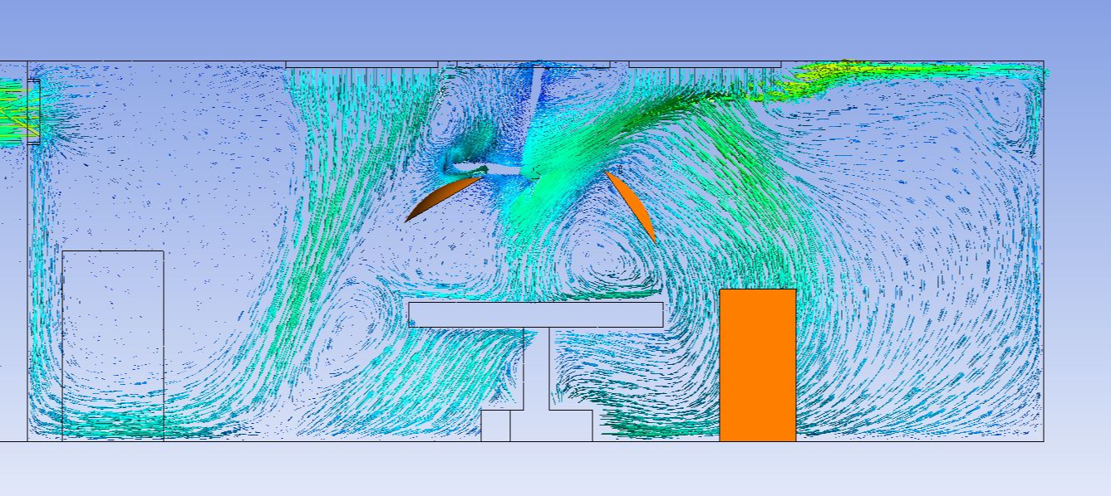

In a conventionally ventilated operating theatre, the space temperature and humidity will vary considerably depending on where the temperature is measured. For display, control and monitoring purposes the temperature and humidity of the operating room will be measured in a common return duct from the operating room. Room temperature will be adjustable from the surgeon’s panel as well as the building management system.

## Ultra-clean ventilation systems

1. Operating rooms for special procedures such as orthopaedic surgery, organ transplants or total joint replacement may require the provision of an ultra-clean ventilation (UCV) system to suit their intended use. The design philosophy of a conventionally ventilated operating suite is based on the need to dilute contaminants and control both the condition and movement of air in an operating suite. Ultra-clean ventilation (UCV) is a means of significantly increasing the dilution effect by providing a large volume of clean filtered air to the zone in which an operation is performed, and sterile items are exposed.
2. Air is discharged above the operating zone and, while not truly laminar, its downward displacement purges the clean zone (marked in the vinyl floor of the operating theatre) of any contaminants and particles generated within it. The air flow in and around the clean zone also serves to prevent particles originating outside the zone from entering. The resulting reduction in contaminants has been shown to reduce post-operative sepsis following certain procedures.

Figure : UCV System, no obstructions

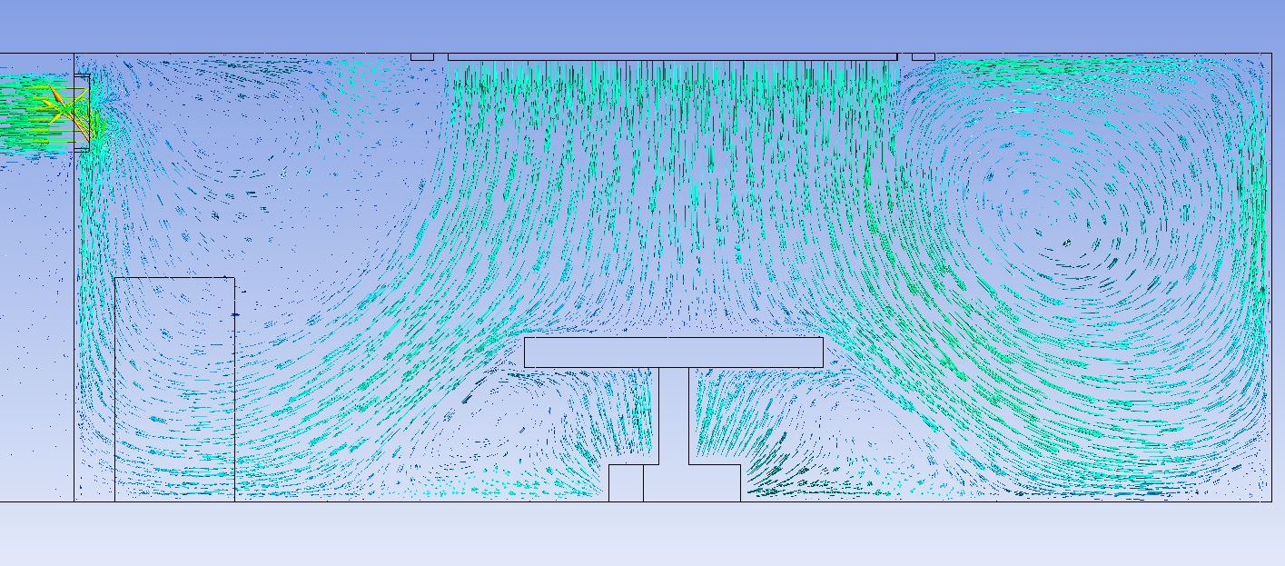

Downward air movement the air flow at one metre from the supply air outlet will have a minimum average velocity of 0.35 m/s and at working height (900mm) not less than 0.3 m/s, and will aim to achieve a minimum velocity 0.2 m/s at the level of the operating table in its lowest position under isothermal conditions with the pendants and operating lights retracted.

Figure : UCV System, including theatre lights and anaesthetic equipment

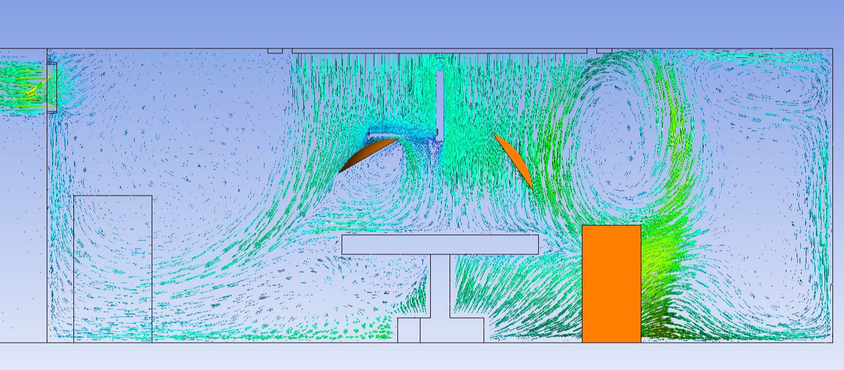

In an ultra-clean ventilation operating theatre, the space temperature and humidity will vary considerably depending on where the temperature is measured. For display, control and monitoring purposes the temperature and humidity of the operating room will be measured in the plenum of the UCV hood, as this will most closely represent the temperature experienced by the surgical team in the clean zone. Room temperature will be adjustable from the surgeon’s panel as well as the building management system.

## Hybrid Operating Theatres

1. Hybrid operating theatres will generally be treated in the same manner as a conventionally ventilated operating theatre, with terminal HEPA devices.
2. The designers will arrange the terminal devices to avoid imaging equipment support rails, umbilical cords and the like. Tools such as CFD analysis are useful to optimise air flow patterns during the design phases. The equipment heat gain in a hybrid OR can be very high depending on the installed machinery resulting in total air flows well in excess of the minimum 20 ACH required in Reference table 1. Where this occurs the minimum outside air rate of 10 ach need not be increased.
3. In a hybrid operating theatre, the space temperature and humidity will vary considerably depending on where the temperature is measured. For display, control and monitoring purposes the temperature and humidity of the operating room will be measured in a common return duct from the operating room. Room temperature will be adjustable from the surgeon’s panel as well as the building management system.

## Exhaust and return air

1. The location of exhaust and return air grilles in the operating theatre will depend on the layout of the theatre. Exhaust registers will be located to minimise dead spots in the room, particularly at floor level. As a general guide an operating theatre will normally require a minimum of two (2) and normally three (3) low level grilles, depending on the location of the barometric dampers. Tools such as CFD analysis are useful to optimise air flow patterns during the design phases.

Figure : UCV System, exhaust and return air location

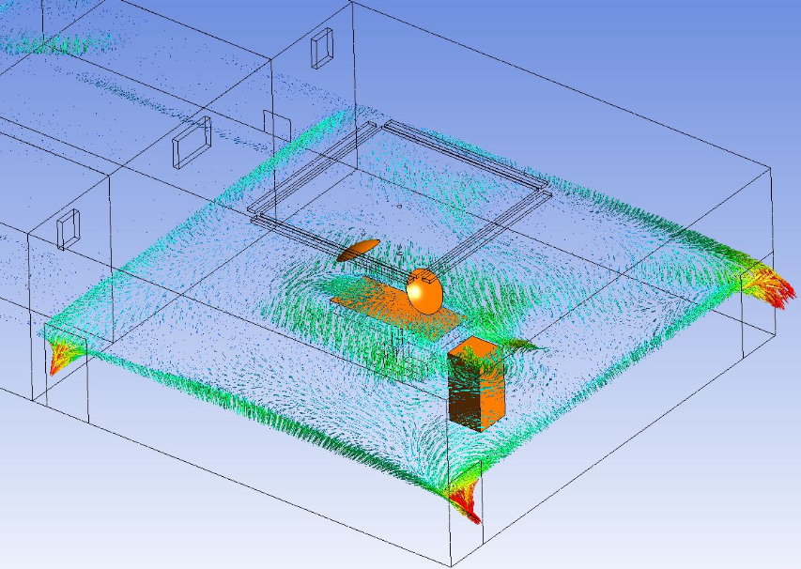

Lint from products used in the operating theatre can be a problem in the return and exhaust air path. The bottom of the low-level exhaust will be minimum 200mm above floor level. Lint filters will be provided in low level extract outlets (easily replaceable from behind hinged grilles).

## Surgical diathermy and laser exhaust systems

1. Surgical diathermy and increasingly surgical laser equipment are used in operating theatres to cut tissue and cauterise the surrounding areas. Both types of equipment produce a smoke plume that is unpleasant and is harmful to health. Equipment to remove the plume can be divided into two types: self-contained smoke evacuators and central systems. The self-contained smoke evacuators are portable units which are often supplied by the surgical diathermy or laser manufacturer as companion units. They can be purchased at the same time as the surgical diathermy or laser and can be accommodated on the surgical equipment pendant in the operating theatre. They comprise a suction unit with a HEPA filter to remove all contaminants and the cleaned air is returned to the operating room.
2. Central systems are usually found in the theatre plantroom and comprise a suction pump, and HEPA filter with piping through the surgical equipment pendant to the point of use of the diathermy or laser, and an exhaust system which discharges the air outside the building.
3. The point of discharge should be above roof level and well away from outside air intakes and open-able windows and be treated as an objectionable discharge as defined by AS 1668.2. The central system will be a group 1 or 2 item and planning for its installation is required before completion of the operating theatre.

## Burns and plastics operating rooms

1. Room temperature and humidity will be adjustable from the surgeon’s panel as well as the building management system.
2. The control system will limit the rate of change of humidity to prevent HEPA filter damage due to condensation.

## Orthodontic operating rooms

1. Engineering requirements for orthodontic operating rooms will be the same as for general operating rooms.

## Cardiac catheterisation units

1. Supply air to cardiac catheterisation units will be delivered at high level in a way that minimises recirculation of potentially contaminated room air and provides the cleanest practical air supply over the procedure area. The directions of air flows within the procedure room will always be from clean to less clean areas. Graduated pressurisation relative to pressure in areas adjacent to the procedure room can be achieved by introducing 10 per cent more supply air than exhaust air. Recirculated room air conditioning will not be used.
2. Total circulated air quantity will be not less than the requirement of Reference table 1 when the supply air filters are at their maximum pressure drop.

## ICU and CCU

1. Air handling units serving the ICU pressurised patient zone, incorporating remote HEPA filtration, (not in the ICU itself);

50 per cent outside air to the patient areas;

heat recovery to exhaust systems in line with NCC Part J

positive air movement maintained away from beds to the adjoining circulation space.

Conditions will be maintained as set out in Reference table 1. Air handling systems should be arranged such that in the event of an air system failure, as least 50 per cent of the clinical space is unaffected.

## Immuno-compromised patient areas

1. Ventilation systems serving areas such as haematology and oncology wards, will incorporate remote HEPA filtration. The air movement regime will be arranged to positively pressurise the ward or clinical zone. Conditions will be maintained as set out in Reference table 1.

## Sterile stock storage

1. The central sterile store will be conditioned to maintain 21 to 24°C, and a minimum 30 per cent RH and a maximum RH 70 per cent. Active humidification and de-humidification will be required to the space either locally via in-room process control units (PCUs) or remotely at the air handling unit serving the space.
2. The space will be controlled and monitored by the BMS and recording temperature, and humidity from multiple points in the zone.

## Pathology

1. Pathology areas will be designed in line with AS/NZS 2982.1 Laboratory design and construction – General requirements and AS 2243.8 Safety in Laboratories – Fume cupboards.

## Cytotoxic and manufacturing clean rooms

1. Cytotoxic Suites will be designed and constructed in line with AS 2252.5 Controlled environments – Cytotoxic drug safety cabinets (CDSC), design, construction, installation, testing and use.
2. Manufacturing facilities may be subject Therapeutic Goods Administration (TGA) regulation depending on the nature of the work carried out in the facility.

## Central sterilising and supply department (CSSD)

1. Sterile supply services will be air conditioned with a minimum of 10 ACHR.
2. The differential pressure between clean to dirty areas is a nominal pressure difference. Air movement and ventilation (barrier air flow) will achieve a positive airflow from clean to contaminated work areas. Simple visual methods such as smoke trail, ball-in-tube, or flutter strip will be enough for verification of airflow direction. All air supplied to the clean zones will be HEPA filtered. Ventilation rates will be maintained when the zone is not occupied to ensure dilution rates are maintained refer to Reference table 1.

## Laboratories and clean rooms

1. Laboratory areas and dispensing areas in pharmacy will be designed to comply with AS/NZS 2982.1 Laboratory design and construction – General requirements and AS 2243.8 Safety in Laboratories -– Fume cupboards.
2. Physical containment (PC) laboratories will be designed and constructed according to the requirements of the Genetic Manipulation Advisory Committee publication *Guidelines for small scale genetic manipulation work* when any work involving genetic manipulation is undertaken.

## Procedure, recovery, delivery and dental rooms

1. Procedure rooms in which the administration or aspiration of gaseous anaesthetics or analgesics are carried out, will have adequate ventilation to ensure that the level of gaseous contamination does not rise above a maximum acceptable level. The use of a scavenge system is acceptable. Local extraction of patient exhaled anaesthetic gas at source is strongly recommended. This becomes a mandatory requirement and will be provided where measured levels of anaesthetic gas within the area are considered excessive by the hospital's occupational health and safety committee.
2. Total air circulation will be not less than Reference table 1.
3. Cupboards containing anaesthetic machines will be ventilated to remove the build-up of nitrous oxide within the cabinet.

## Bronchoscopy and sputum induction units

1. Total circulated air quantity will not be less than Reference table 1 when the supply air filters are at their maximum pressure drop of which a minimum of 25 per cent will be outdoor air. Room air will not be recirculated. Procedure Rooms and Recovery Rooms will be maintained at a negative pressure in relation to adjacent areas. Design and construction will be in line with the requirements in Guidelines for the classification and Design of Isolation
2. Rooms or booths used for bronchoscopy, sputum induction, aerosolized pentamidine treatments and other high-risk cough-inducing procedures will be provided with local exhaust ventilation.

## Endoscopy Units

1. Manual disinfection of fibreoptic endoscopes is recommended to be carried out in a dedicated endoscope disinfection room equipped with a down draft trough with perimeter exhaust slots, exhausting at a rate enough to contain fumes.
2. Where automatic or semi-automatic disinfectors are used, a localised exhaust system will be provided to achieve appropriate capture and removal of contaminated air. Fumes will be drawn away from the operator's work position. Machine mounted filters are not always enough and require monitoring.
3. Fibreoptic endoscopes storage cupboards will be mechanically vented with an exhaust system to remove glutaraldehyde residuals.

## Mortuary

1. Requirements for facilities that conduct regular autopsies include:

single pass air conditioning using 100 per cent exhaust of all air

exhaust intakes arranged to provide maximum fume and odour removal with protection of personnel

operate the room at negative pressure in relation to adjacent areas

install down-draught or back-draught exhaust

down-draught exhaust will have a minimum face velocity of 2.5 m/s.

## Mental health

1. Consideration will be given to the type of heating and cooling units, ventilation outlets and equipment installed in patient-occupied areas of mental health units. Special purpose equipment designed for psychiatric or prison use with anti-ligature designs will be used to minimise opportunities for self-harm. The following will also apply:

All air grilles and diffusers will be of a type that prohibits the insertion of foreign objects. Air diffusers will be purpose designed with air flow performance data provided by the manufacturer to ensure correct air distribution ceiling-mounted air devices will be of a secure type, requiring bespoke tools for removal.

All exposed fasteners will be tamper-resistant.

All convector or HVAC enclosures exposed in the room will be constructed with rounded corners and will have closures fastened with tamper-resistant screws.

HVAC equipment will be of a type that minimises the need for maintenance within the room.

In mental health patient bedrooms, there will be no projections or points where a ligature can be fixed.

## Pandemic mode of operation

1. Where specifically briefed, zones that are designed to be capable of conversion as part of a group isolation scheme suitable for treatment of an infection mass outbreak. The system will:

Incorporate systems that can be ramped up and down from both a supply and return air/exhaust air perspective and can, when needed, create a nominal negative pressurisation of the zone served. Chilled beams will not be used in these zones.

Be designed such that air handling plant serving zones designated as potential pandemic zones will be capable of running in 100% outside air mode without loss of internal environmental conditions at design external ambient conditions.

Have return air dampers within the air handling unit that are capable of being physically blanked to prevent recirculation of air into the supply airstream.

Where required, heat recovery via cross plate heat exchanger maintaining the separation of the air steams. Thermal wheels will not be used in systems designed for pandemic use.

Be configured so that relief / spill air from designed pandemic capable systems do not share a discharge plenum with non-pandemic areas. Separation within a common plenum will be by means of solid dividing panels is a minimum requirement.

Be designed so that relief / spill air fans can accommodate additional filtration in the discharge plenum.

Be provided with both local and BMS indication of status.

## Purge modes

1. In operating theatres, and emergency departments or where specifically briefed, ventilation systems will have a purge mode. In this mode the system will, under user control, switch to 100 per cent outside air. Environmental conditions within the space will be relaxed during purge mode operation.

## Unplanned air leakage in areas that rely on differential pressure

1. Areas that rely on differential pressure relationships to meet their functional requirement will be constructed to minimise the exchange of air through the building fabric. Every window, door, wall joint and fitting inserted into the room is a potential source of leakage that needs to be sealed properly.
2. There is no standard on the amount of leakage, however for energy efficiency and longevity this should be minimised. A generally accepted level of leakage is a maximum of 10 per cent of the supply air required to the room. To achieve this all elements of the room construction will need to be adequately sealed. The mechanical contractor should not be expected to increase air volumes to overcome poor workmanship in other trades. For details of methodologies to effectively seal the building fabric, refer to the AusHFGs – Isolation rooms – Engineering and design requirements.
3. Air pressure leak testing should be conducted on completion of the room and sealing works undertaken until the leakage is brought within design parameters. Leakage should be tested by pressurising the room above the required design pressure and using smoke pencils to find the air paths of leakage. This can be very difficult or costly if the room was not designed to be airtight in the first place.

# Building management and control system (BMCS)

## Introduction

1. The purpose of this section is to set out the functions of a BMCS and the standards to be applied.
2. This section sets out proposals for achieving a system that gives enough information to enable the functions of the hospital to be carried out.
3. The provisions of the section are to be applied to all new BMCS and enhancements of existing systems.
4. The implementation of BMCS with digital technology and open communication standards will provide a unified approach to automation systems throughout healthcare projects. The aim is for seamless integration, energy monitoring and intelligent automation of the building services.
5. The BMCS should be an open building control system using Lon Mark, Lon Works, Modbus or BACnet standards with full interoperability. Selection of a BMCS system will be appropriate to the size, nature and location of the project. The degree of BMCS sophistication will also be considered on a project by project basis for example, overly sophisticated systems requiring a high level of maintenance and programming are not appropriate in remote locations.
6. It is preferable to extend on an existing BMS system on small to medium size projects, rather than to duplicate systems. Systems and plant should generally be selected with high level interface compatibility. Where this is not possible or where service continuity is critical for patient care, low level interface between systems will be used for system integration.

## Scope

1. New BMCS systems will be consist of a high speed, peer to peer network of DDC controllers, run and standby servers and operator workstations. The operator workstation will provide for overall system supervision and configuration, graphical user interface, management report generation and alarm annunciation.
2. Typical scope of BMCS provision will include:

engineering services control

engineering services monitoring and alarms

vertical transport systems monitoring

medical gas systems monitoring and alarms

communications network

open communications capability, such as BACnet, LON, Modbus Connectivity

all associated field devices such as; sensors, control valves, etc.

all associated hardware including computer workstation

all associated software

graphical Interface

remote access via web pages

energy management and reporting

historical data logging

12 month preventative maintenance and warranty.

Building management and control systems will be reliable systems, with components which have been in commercial or industrial use prior to any project delivery.

1. The system architecture will be flexible, expandable and backward compatible throughout the given life expectancy of the project. Systems will be configured to maximise energy efficiency without detriment to environmental conditions with all proposed control strategies pre-approved and tested.
2. Operator workstations will be engineered to provide clear three-dimensional animated graphics for all connected plant and systems with summary information of operational profiles such as times, conditions and energy usage.
3. The operator interface will include energy dashboards and building performance information.
4. Alarms will be clearly identified in plain English with all point identifiers / references labelled without acronyms and in line with any existing identification convention or as directed by the facility engineer or maintenance team.
5. Projects with an existing BMS will consider the life cycle of the existing system, integration of legacy technology and migration options onto a single open communications platform.
6. BMCS software will enable interrogation of stored historical data. The BMCS must be capable of output to database which will use an open standard such as SQL for operator queries integration to enterprise systems for seamless data transfer for a digital hospital.

## Functionality

1. The following functions will be provided by the BMCS system as a minimum:

plant control (temperature, humidity, pressure)

monitoring and trend logging

scheduled start and stop plant

optimisation

outside air economy cycle control (enthalpy)

alarm annunciation

data gathering and logging

electrical load shedding

The BMCS will also form an integral part of the energy management system

energy metering form supplier including (as appropriate) kWh and kVA

chiller and boiler kW output

power metering kW and kWh

data logging of plant run hours

emergency power mode operation

## BMCS failure and disaster recovery

1. The control system and mechanical switchboards will be arranged such that, in the event of a failure or disaster which causes the general BMCS to fail, it is possible for all critical and essential areas of the facility to run all plant in a ‘manual’ mode from the local mechanical switchboard, without relying on the BMCS interface.
2. The VSD systems will be robust and resilient. VSD drives will automatically re-set to last know setting after a power isolation or power failure.

## Mechanical switchboard configuration

1. Mechanical switchboard separation will be a minimum Form 3b.

## Commissioning

1. Commissioning is a critical element of project delivery and plays an integral role in enabling good designs to be good operational systems. It is vitally important to the safe and energy efficient operation of buildings. It must be carried out systematically.
2. Design teams will include seasonal adjustments in heating, ventilation and air conditioning (HVAC) systems during the defects liability phase of a project.
3. Design teams will allow for the early preparation of commissioning plans in the delivery process, this is essential for a successful outcome for the facility.
4. The commissioning process will reflect the interrelationship between systems, and thus the need of thorough and integrated commissioning across all systems.
5. The engagement of an independent commissioning agent is highly desirable and should only be omitted if the project is of relatively simple where there is not a BMS and therefore minimal coordination across disciplines.
6. When adapting existing systems, the testing and monitoring of the complete systems extended from existing site systems is will be recognised as part of the commission process.
7. The designers, and construction team, should adopt and document the commissioning procedures outlined in the chartered institution of building services engineers, CIBSE Code M. This provides good references for the commissioning and management processes required to successfully commission a project.
8. The builder will allow the appropriate programming allowance of time in the delivery and handover process. Commissioning times should not be reduced to fit into a construction program that is running late.

# Appendix A: Image description

## P+N combination isolation room plan

The floor plan shows a patient's room connected to an ensuite and an ante room (these two rooms are separated from each other by a wall). The plan also shows the corridor outside with a door to the ante room.

The patient's room:

* Supply and low-level extract – 12 Ac/hr
* Transfer grille between the room and the ensuite.

The ensuite:

* Extract only 160 L/s.
* -15 Pa nominal.

The ante room:

* Supply only 210 L/s
* +15 Pa.
* PSD 15 Pa from ante room to patient's room.

Corridor:

* Reference pressure 0 Pa.

1. Nominal pressure relative to corridor with the ensuite door closed