|  |
| --- |
| isolation rooms  Health Technical Advice HTA-2020-004 |
|  |

# Preface

In many healthcare facilities, patients who are known to or suspected of posing a risk of transmitting certain infectious micro-organisms are physically isolated from other persons. Physical isolation ceases when the patient is no longer capable of transmitting infection or an alternative diagnosis is made.

The purpose of this Health Technical Advice (HTA) is to provide guidance to on the types of isolation rooms available and the types of patients they are best suited for. The HTA also provides links to additional technical resources on the design and usage of isolation rooms.

# What is an isolation room?

When possible, a patient known to or suspected of harbouring transmissible micro-organisms should be placed in an isolation room. An isolation room helps prevent direct or indirect contact transmission, or droplet transmission of infectious agents. An infected or colonised patient can contaminate the environment or have difficulty in maintaining infection control precautions.

There are four primary types of isolation room:

* Standard pressure or Class S rooms are used for patients requiring contact or droplet isolation. A standard room with normal air conditioning is appropriate. Standard pressure rooms are typical one-bed patient rooms.
* Negative pressure rooms are used for patients requiring airborne droplet nuclei isolation. Patients are placed in negative pressure rooms to reduce transmission of disease via the airborne route. Class N or negative pressure rooms are also known as ‘airborne infection isolation’ and ‘infectious isolation units’. According to the Australasian Health facility Guidelines, Class N rooms should have an anteroom.
* Positive pressure rooms are used to isolate profoundly immuno-compromised patients, such as certain transplant and oncology patients. The aim is to reduce the risk of transmission of infection to a susceptible patient via the airborne route. Class P or positive pressure rooms are also known as ‘protective environment’ and ‘protective isolation units’.
* Quarantine isolation rooms are a negative pressure room including an anteroom and fumigation facilities.

A single room with appropriate air handling and negative ventilation is particularly important for reducing the risk of micro-organisms being spread by airborne transmission from a source patient to susceptible patients and other persons in hospitals.

Australian Standard AS1668.2-2012 *The use of ventilation and air-conditioning in buildings. Part 2: Mechanical ventilation in buildings* sets out minimum supply, outdoor and exhaust air rates for both negative and positive isolation rooms. AS1668 also prescribes the exhaust discharge and filtration requirements for isolation rooms.

# How does an isolation room work?

An isolation room works by managing the air flow within the room to either protect clinical staff and the broader hospital from an infectious patient (negative pressure room), or to protect immuno-compromised patients from the transmission of infection from clinical and other staff (positive pressure room).

Figure 1 below illustrates how air flow is managed to carry a clean air supply over the patient and directly to an exhaust. A negative pressure gradient is maintained from the room to the anteroom and the ambient air (for example in the corridor) via a separate exhaust system dedicated to each room that removes a quantity of air greater than that of the supply system. Exhaust air ducts should be independent of the common building exhaust air system to reduce the risk of contamination from back draught.

Figure 1: Diagram of air flow in a negative pressure isolation room

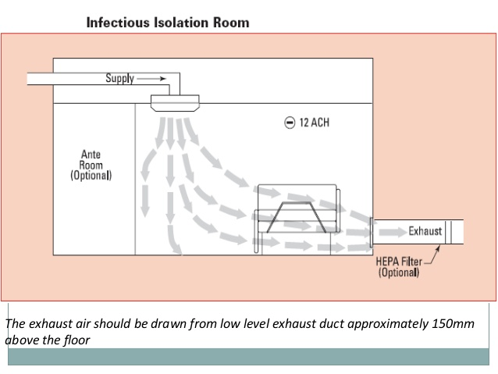

Notes: The exhaust air should be drawn from low level exhaust duct approximately 150mm above the floor. The room should have 12 air changes per hour.

# What are the key components of an isolation room?

While components vary between the different types of isolation room, the key components include but are not limited to:

* twelve air changes per hour or 145 litres per second per patient, whichever provides the greater air flow rate
* an anteroom for negative pressure rooms
* differential pressure gauges outside the room and a local alarm system to monitor fan status
* low-level exhausts
* clinical handbasins
* high quality sealing of the room, such as wall penetrations, doors, windows and ceiling
* independent supply air and independent exhaust on negative pressure rooms to ensure only clean air enters the room and prevents dirty air being recirculated in, or contaminating, the rest of the hospital,
* exhausts under negative pressure within the building
* minimum maintenance requirements.

Further information is available in the Victorian Health and Human Services Building Authority *Engineering guidelines for healthcare facilities: Volume 4 – Heating, ventilation and air conditioning* (Health technical guideline HTG-2020-004).

# When is an isolation room to be used for a COVID-19 patient?

Special environmental controls, such as negative pressure isolation rooms, are not necessary to prevent the transmission of COVID-19. Patients with suspected or confirmed COVID-19 may be isolated in negative-pressure rooms. This is of importance when undertaking aerosol generating procedures, such as tracheal intubation, non-invasive ventilation, tracheotomy, manual ventilation before intubation, and bronchoscopy as these procedures have been associated with an increased risk of transmission of infectious diseases.

Aerosol generating procedures should be performed in a negative pressure room whenever possible. This is consistent with advice in VHHSBA’s Health Technical Advice *HVAC system strategies to airbourne infectious outbreaks* (HTA-2020-001).

COVID-19 patients can be treated on an ongoing basis in an isolation room. However, as the risk of aerosol transmission is reduced once the patient is intubated with a closed ventilator circuit, isolation rooms should be made available for managing patients requiring aerosol generating procedures.

# What guidance is available on isolation rooms?

Australian Standard AS1668.2-2012 *The use of ventilation and air-conditioning in buildings. Part 2: Mechanical ventilation in buildings* sets out minimum supply, outdoor and exhaust air rates for both negative and positive isolation rooms. AS1668 also prescribes the exhaust discharge and filtration requirements for isolation rooms.

The Victorian Advisory Committee on Infection Control developed the *Guidelines for the classification and design of isolation rooms in health care facilities* (2007). The guidelines outline criteria that may be used to describe and identify settings that are appropriate for isolating patients, engineering and architectural recommendations for isolation facilities, and use and monitoring of the engineering components.

The Victorian Advisory Committee on Infection Control developed the *Maintenance standards for critical areas in Victorian health facilities* (2010). The document provides a set of general and additional maintenance standards that can be applied to all critical areas in hospitals and health services.

The Victorian Health and Human Services Building Authority *Engineering guidelines for healthcare facilities: Volume 4 – Heating, ventilation and air conditioning* (Health technical guideline HTG-2020-004) details the engineering design standards for isolation rooms in Victorian public hospitals. The guideline refers to other technical design requirements provided such as the Australian Health Facility Guidelines, Australian Standards and *ASHRAE Standard 170-2017 Ventilation of Health Care Facilities*. The VHHSBA guidelines are based on the Victorian Advisory Committee on Infection Control 2007 guidelines.

The UK National Health Service Health *Building Note 04-01 Supplement 1 Isolation facilities for infectious patients in acute settings* (2013) sets out practical guidance on how to provide safe, effective isolation facilities for infectious patients (source isolation) that are simple to use and meet the needs of most patients on acute general wards. This is often used as a reference document when designing isolation rooms.