

|  |
| --- |
| Latrobe regional hospital |
| Community engagement summary – August 2020 |

# Background

The Victorian Health and Human Services Building Authority (VHHSBA), in partnership with Latrobe Regional Hospital (LRH), is delivering the next stage of the Latrobe Regional Hospital expansion. The $217 million expansion will help to meet the region’s increasing and complex health needs.

With construction set to begin in 2021, the project team is working to finalise the detailed design by late 2020. The design objectives for the hospital expansion focus on creating a safe and welcoming atmosphere for patients and families.

To help inform the detailed design, we sought community feedback on what people would like to see in the new hospital family spaces, children play area and outdoors spaces. In July 2020, community feedback was sought through an online survey and webinar session.

# Online survey

From 6-20 July 2020, an online survey sought community feedback on aspects of the design, such as new artwork, greenery and family spaces in the hospital.

The survey was widely promoted to the community through local newspapers, websites and social media. The majority (70 per cent) of respondents were directed to the survey via social media.

In total, 256 people responded to the survey, providing valuable input to help shape the design of the hospital.

The key themes from the survey results included:

1. **Patient recovery areas**

We heard that more greenery, plants and patient and family lounges would help make the hospital feel welcoming, safe and assist with patient recovery. Some people also suggested additional retail and food outlets in the hospital.

1. **Outdoor areas**

Native trees and seating were popular responses in considering the design of the common courtyard and outdoor area. Respondents said it was important to have somewhere comfortable to sit outside. Other suggestions for the outdoor area included murals, music, seating, and ornamental plants.

When provided with some inspirational photos of what the design of the outdoor spaces could look like, the landscaping photo featuring greenery and earthy wood finishes rated the most popular.

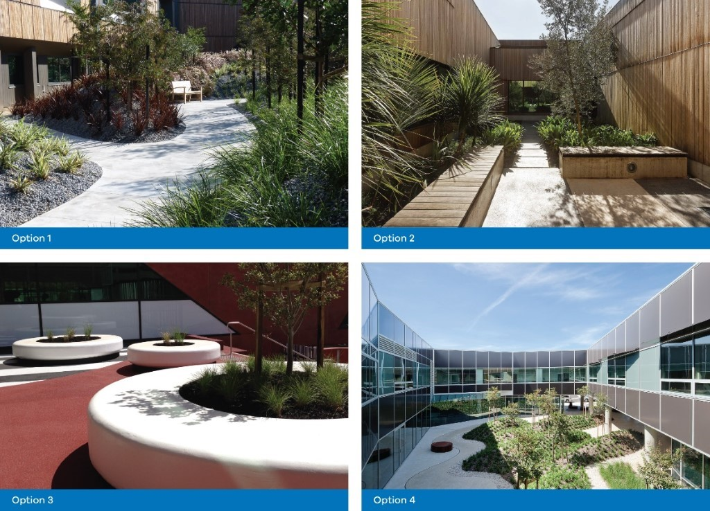

1. **Artwork**

Over 30 per cent of respondents felt that artwork would help make the hospital feel more welcoming. Overwhelmingly, people would like to see artwork created by local Gippsland artists. Artwork in the form of photographs and paintings were also popular.

1. **Indoor family areas**

We heard that quiet and private spaces are important to consider when designing the indoor family areas at the hospital. Some feedback also suggested children’s areas to make it easier for parents to visit patients in hospital.

# Webinar

Due to social distancing restrictions in place, face-to-face community sessions were unable to take place. Instead, an online webinar was hosted by Latrobe Regional Hospital from 7 – 8pm on 23 July 2020.

The webinar was promoted to the local community through social media and direct mail. The purpose of the session was to provide information and answer questions about the project, as well as address any concerns or issues from the community.

Latrobe Regional Hospital staff presented at the webinar, and community members also heard from the Principal Consultant Architects, Billard Leece Partnership (BLP).

Feedback from the webinar is largely consistent with the survey responses, highlighting the importance of a design that promotes health and wellbeing and family-friendly areas. People also wanted to see more local Gippsland artwork and native plants around the hospital.

# Next steps

The feedback from the survey and the webinar will be used by the project team, architects and Latrobe Regional Hospital to inform the detailed design of the hospital expansion. The detailed designs are expected to be released in late-2020.

As the project progresses, there will be more opportunities for the community to be involved in the project. For more information and to keep up to date on the project, visit the [Victorian Health and Human Services Building Authority](https://www.vhhsba.vic.gov.au/health/regional-facilities/latrobe-regional-hospital-expansion-stage-3a) website or [Latrobe Regional Hospital’s website](https://lrh.com.au/important-info/lrh-information/projects/296-expansion-designs-revealed)