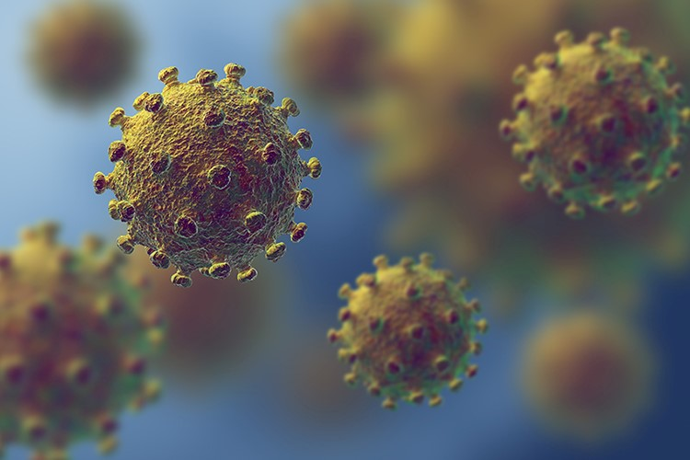

|  |
| --- |
| HVAC system strategies to airborne infectious outbreaks  Health Technical Advice: HTA-2020-001-Rev B  OFFICIAL |
|  |

|  |
| --- |
| This document has been prepared as a guide and for information purposes only.  No legal obligation for any loss, damage or expense is incurred by any person relying on the information provided. |
| To receive this publication in an accessible format, email the [Victorian Health and Human Services Building Authority](mailto:vhhsba@dhhs.vic.gov.au?subject=Accessibility%20request) <vhhsba@dhhs.vic.gov.au>  Authorised and published by the Victorian Government, 1 Treasury Place, Melbourne.  © State of Victoria, Australia, Victorian Health and Human Services Building Authority, November 2020.  **ISBN** 978-1-76096-306-4 **(pdf/online/MS word)**  Available on the Resources page of the [Victorian Health and Human Services Building Authority website](https://www.vhhsba.vic.gov.au/resources/technical-guidelines) < <https://www.vhhsba.vic.gov.au/resources/technical-guidelines>> |

Contents

Preface 5

The issue 6

Airborne transmission 7

Particle sizes 8

Approaches for healthcare facilities 8

Airborne precautions for aerosol-generating procedures 9

Ventilation and air-cleaning strategies 10

Minimum healthcare HVAC system criteria 11

Strategies 12

Dilution 14

Temperature and humidity 16

Facilities maintenance 16

Summary 17

References and bibliography 18

Attachment 1: HVAC system checklist 19

Design criteria 19

General criteria 20

Additional comments/observations 21

# Preface

Infectious diseases such as Avian Flu, Severe Acute Respiratory Syndrome (SARS) and Severe Acute Respiratory Syndrome Coronavirus 2 (SARS-CoV-2) can spread very quickly to become a pandemic.

Acute infectious disease outbreaks may be anticipated and provide the ability to plan in advance, or there may be no notice and require immediate response.

This Health Technical Advice (HTA) was developed to provide guidance to Hospital Engineers on actions that could be taken in the event of airborne infectious outbreaks with regards to HVAC systems installed within a healthcare facility.

As evidence emerges relating to the COVID-19 pandemic, this HTA has been updated to assist Hospital Engineers, health service leaders and infection control specialists to ensure that appropriate systems are in place to support and promote prevention and control infections and minimise and manage risks to patients, the workforce and the health system.

This HTA is not to take the place of any health agency specific infectious diseases or pandemic mode plans or any facility specific emergency response plans associated with acute infectious disease outbreak. Instead this HTA should inform hospital engineering teams on how to implement interventions aimed at mitigation of risk from airborne infectious disease and understand the uncertainty of the effectiveness of current practice recommendations.

Final recommendations and proposed solutions should be discussed and agreed as part of a collaborative multidisciplinary team of engineers, building operators, scientists, infection prevention specialists, epidemiologists and occupational hygienists.

**Statement regarding aerosol transmission of COVID-19**

The potential for aerosol transmission of COVID-19 has been a matter of much discussion worldwide. Different jurisdictions, national bodies and countries have various interpretations of the potential risk, and the science is still emerging. The Healthcare Worker Infection Taskforce discussed this issue in October 2020, acknowledging that regular reviews of the scientific evidence was ongoing through groups such as the Infection Control Expert Group (ICEG). The Australian Commission on Safety and Quality in Health Care are also currently working to revise the National Safety and Quality Health Service Preventing and Controlling Healthcare-Associated Infection Standard.

It was agreed to make a statement on the mode of transmission which acknowledged the potential for aerosol transmission.

**Mode of transmission statement**

“Evidence to date suggests that, similar to other respiratory viruses, SARS-CoV-2 (the virus that causes COVID-19) is mainly transmitted by respiratory droplets which are spread from an infected person to others, during talking, shouting, singing, coughing or sneezing. These droplets can also land on objects or surfaces so the virus is transmitted through contact with a contaminated surface or object. Experts agree there is a gradient from large droplets to aerosols, however, those who have been in close or direct contact with a COVID-19 case are at highest risk.

SARS-CoV-2 can be transmitted via aerosols in specific circumstances. The extent of transmission via aerosols is still being researched, but is well recognised during aerosol generating procedures in a health care setting, and probably important in the context of other behaviours, such as singing or shouting. This risk may be higher in certain conditions such as poorly ventilated crowded indoor environments.

Given the potential for aerosol spread, a precautionary approach has been taken toward controlling this risk in Victoria. This includes the requirement of particulate filter respirators (e.g. P2, N95 respirators) in all care interactions for patients with COVID.

The most effective individual measures to prevent the spread of SARS-CoV-2 are good hand and respiratory hygiene, physical distancing, staying home and getting tested if you are unwell, and wearing a mask. Together, these measures minimise the risk of transmission of SARS-CoV-2.”

# The issue

In an increasingly accessible society, emerging and acute infectious diseases are easily transported and transmitted around the world. Any region anywhere could be exposed to outbreaks of established diseases or other unknown emerging infectious disease.

Infectious diseases spread by several different routes. Many viruses and in some cases influenza, the common cold, and other diseases are spread via the airborne route. This spread can be accelerated or controlled by heating, ventilating, and air-conditioning (HVAC) systems.

The purpose of this HTA is to provide health agency engineering staff and other interested persons with information on the following:

* the implications for the design, installation, and operation of heating, ventilating, and air conditioning (HVAC) systems
* the means to support facility management and planning for options to adjust HVAC systems to respond to outbreaks of airborne infectious diseases.

The potential for airborne transmission of disease is widely recognised, although there remains uncertainty concerning which diseases are spread primarily via which route, whether it be airborne, short range droplets, direct or indirect contact, or multimodal (a combination of mechanisms).

Ventilation and airflow are effective for controlling transmission of only certain diseases. Several ventilation and airflow strategies are effective and available for implementation in buildings and will be discussed in further detail.

Hospital engineers are able to manage the indoor environment to support patient’s health and reduce viral disease by regulating critical indoor air factors such as temperature, humidity, air exchange rate and fresh air content.

Working as part of a multi-disciplinary team, hospital engineers can add value to the development of strategies and systems for infection prevention and control. Strategies and systems must be consistent with relevant national guidance, including the Australian Guidelines for the Prevention and Control of Infection in Healthcare, and relevant jurisdictional law and policy, including work health and safety legislation.

# Airborne transmission

This HTA covers the spread of infectious disease from an infected individual to a susceptible person, known as cross transmission or person-to-person transmission, by small airborne particles (droplet nuclei) that contain microorganisms.

Exposure through the air occurs through

* droplets, which are released and fall to surfaces about 1-2 m from the infected
* droplet nuclei, which potentially remain airborne for an extended period and can be transported long distances.

The aerobiology of transmission of droplets and droplet nuclei produced by a person is illustrated in Figure 1.

Because droplets are heavy and settle under the influence of gravity quickly, general dilution, pressure differentials, and exhaust ventilation do not significantly influence droplet concentrations, velocity, or direction.

When droplets reduce in diameter via evaporation, thus becoming a droplet nuclei (aerosol), they can travel longer distances through the airborne route, including via HVAC systems. HVAC systems are not known to entrain the larger particles.

Small particles that can become airborne are typically generated by coughing, sneezing, shouting, and to a lesser extent by singing and talking. Even breathing may generate such particles in sick and highly infectious individuals.

Figure 1 Droplet suspension: Aerobiology of droplets and small airborne particles produced by an infected patient.

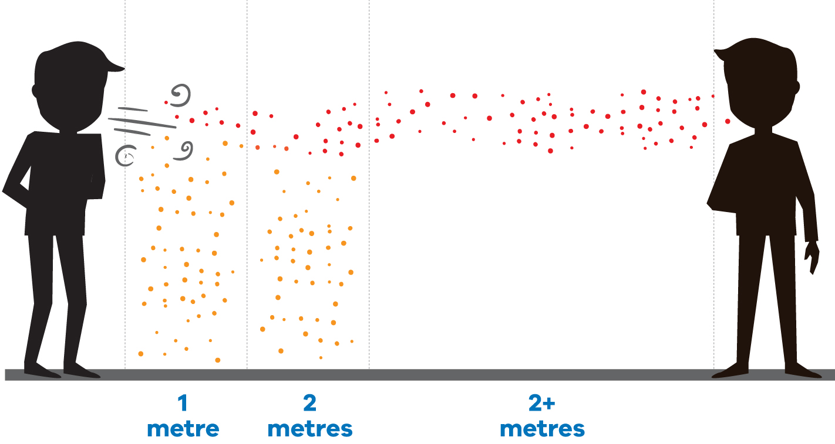

**Note: Drops land on surfaces and dry to become desiccated. If disturbed these particles can be ejected back into the air stream.**

## Particle sizes

There is no one recognised defined particle size referenced with droplets, droplet nuclei nor the term aerosol. Aerosol is a suspension of fine solid particles or liquid droplets in air or another gas. Many factors including size, shape, the density of the suspension gas and some other factors (temperature and humidity) are responsible for particles remining in suspension. For the purpose of this HTA, droplets are particles generally in the size range of between 5-10 μm in greater in diameter. Droplet nuclei are particles generally in the size range of 5 μm or smaller in diameter.

# Approaches for healthcare facilities

Healthcare facilities have criteria for ventilation design to mitigate airborne transmission of infectious disease.

Because of the difficulties in separating out the relative importance of transmission modes, healthcare facilities should focus on ‘infection control bundles’ (i.e. use of multiple modalities simultaneously). In healthcare settings this bundle approach may include engineering, administrative, environmental controls and personal protective equipment.

The ‘hierarchy of control’ is a model used in work health and safety risk assessment. It is a step-by-step approach to eliminating or reducing risks that ranks risk controls from the highest level of protection and reliability through to the lowest and least reliable protection. The hierarchy should be used in conjunction with infection prevention and control frameworks to design health service organisation infection prevention and control programs.1 The levels of the hierarchy of control, from most to least effective, are as follows:

* elimination – physically remove the risk or hazard, for example use telemedicine for patient encounters
* reduce the risk:
* substitution – replace the risk with lesser risk isolation - isolate people from the risk
* engineering controls – isolate people from the risk
* administrative controls – change the way people work
* personal protective equipment– Protect the worker and reduce transmission risks for patients.

As with managing risks within any complex system, successful infection prevention and control within health service organisations requires the involvement of a range of experts, and multiple, integrated strategies across all levels of the healthcare system.

HVAC strategies should not be considered as the primary nor the only form of control, HVAC strategies can offer a level of protection but in many instances may not be the most effective control. Engineering control measures supplement additional control strategies; however, they should certainly not replace them. HVAC strategies along with other controls will assist in reducing the risk and managing probabilities of risk. A complete assessment across all control measures available needs to be reviewed by a multi-disciplinary team to ensure the appropriate ‘infection control bundle’ is developed for the specific risk.

Safe Work Australia have developed a Code of Practice ‘Model Code of Practice: How to manage work health and safety risk’, which re-iterates ‘*aim to eliminate the risk, which is the most effective control. If this is not reasonably practicable…. minimize the risk by working through other alternatives in the hierarchy*. (shown in Figure 2 below)

Figure 2 The hierarchy of control measures (Safe Work Australia)

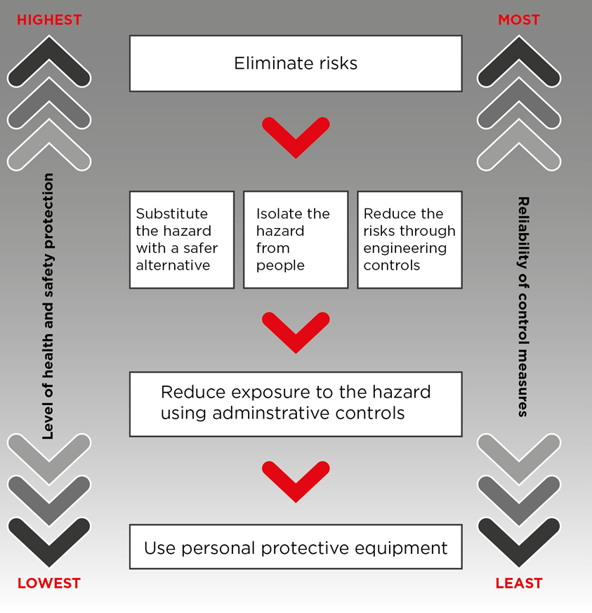

## Airborne precautions for aerosol-generating procedures

Some aerosol-generating procedures, such as tracheal intubation, non-invasive ventilation, tracheotomy, cardiopulmonary resuscitation, manual ventilation before intubation, and bronchoscopy, have been associated with an increased risk of transmission of infectious diseases.

Health agencies are to ensure that all aerosol-generating procedures are performed in an adequately ventilated room or in negative pressure rooms with at least 12 air changes per hour and controlled direction of air flow when using mechanical ventilation.

During some clinical interventional procedures or aerosol generating behaviours (cough, yelling, singing), the generated particles are small many of which are less than 0.5 micron in diameter which is 1/200th the width of a human hair. At this size, the interaction between the particle and the air means that gravity has very little effect and they remain suspended in the air stream. These aerosol particles can remain in suspension in air streams for significant periods before eventually evaporating or bumping into a surface and coming to rest. In an indoor environment this significantly increases the direct and indirect potential for infection beyond the widely quoted and referenced 1.5m social distancing rule. Setting up an air movement regimen to make sure that air flows toward a control zone helps limit the movement of the suspended particles.

Further details and resources can be found at on the department’s website:

1. [Infection prevention control resources](https://www.dhhs.vic.gov.au/infection-prevention-control-resources-covid-19#infection-control-guidelines) <https://www.dhhs.vic.gov.au/infection-prevention-control-resources-covid-19#infection-control-guidelines>
2. [For health services and professionals](https://www.dhhs.vic.gov.au/health-services-and-professionals-coronavirus-covid-19) <https://www.dhhs.vic.gov.au/health-services-and-professionals-coronavirus-covid-19>

## Ventilation and air-cleaning strategies

Because particles produced from aerosol generating procedures or aerosol generating behaviours can remain airborne for some time, the design and operation of HVAC systems that move air can affect potential transmission in several ways, such as by the following:

* supplying clean air to areas where treating susceptible occupants
* containing contaminated air and / or exhausting it to the outdoors
* diluting the air in a space with cleaner air from outdoors and / or by filtering the air
* provide as much outside air as practicable possible via the HVAC systems and minimise the recirculation of air

It is important that clinical teams recognise that once inside a controlled zone the ventilation system has limited influence over how aerosol suspended particles are distributed. This is because most healthcare HVAC ventilation systems, other than spaces like operating theatres or isolation rooms, are designed to mix the air in the space to provide uniform environmental conditions.

The Centres for Disease Control and Prevention provides *Guidelines for Environmental Infection Control in Health Care Facilities.* Refer to the Centers for Disease Control and Prevention (CDC) *Guidelines for Environmental Infection Control in Health-Care Facilities* (2003) Appendix B. Air <<https://www.cdc.gov/infectioncontrol/guidelines/environmental/appendix/air.html#tableb1>>

The following is an extract of the table and nominates typical healthcare setting air changes per hour (ACH) and the time required for airborne contaminant removal by efficiency.

**Table 1 Typical healthcare setting air changes per hour and time requires for airborne contaminant removal by efficiency**

|  |  |  |
| --- | --- | --- |
| **ACH** | **Time (mins.) required for removal 99% efficiency** | **Time (mins.) required for removal 99.9% efficiency** |
| 6 | 46 | 69 |
| 8 | 35 | 52 |
| 10 | 28 | 41 |
| 12 | 23 | 35 |

Caution should be exercised in using the table in healthcare setting for the following reasons:

* these values apply to an empty room with no aerosol-generating source
* the times given assume perfect mixing of the air within the space
* removal times will be longer in rooms or areas with imperfect mixing or air stagnation.

# Minimum healthcare HVAC system criteria

The HVAC criteria for healthcare facilities should focus on to minimise the risk of airborne transmission include the following four major principles.

* room ventilation rates (air change per hour)
* outside air rates (air change per hour)
* airflow direction
* filtration requirements for HVAC recirculating systems.

The following table outlines the minimum expected values for these criteria as applicable within an inpatient treatment area in a healthcare setting as defined within the *Engineering Guidelines for Healthcare Facilities.*

Note that these criteria are not relevant for operating room spaces nor isolation rooms. Further details on HVAC requirements for isolation rooms can be found at HTA-2020-004 Isolation rooms.

Table 2 Minimum performance criteria for an in-patient unit as defined within *Engineering Guidelines for Healthcare Facilities*

|  |  |  |  |
| --- | --- | --- | --- |
| Criteria | Below minimum recommendation | Minimum recommendation | Exceeds minimum recommendation |
| Room ventilation rate | <6 ACH | 6-8 ACH | >8 ACH |
| Outside air rate | <2 ACH | 2 ACH | >2 ACH or 100% outside air |
| Airflow direction | Net Positive environment between patient zones and common areas. | Balanced to slight net negative air flows between patient zones and common areas | Net Negative environment between patient zones and common areas. Greater than -2.5Pa |
| Filtration (for recirculating HVAC systems) | < MERV 13 (F7 or below) | MERV 13-16 (F8 or F9) | HEPA filters |

# Strategies

Table 3 highlights a number of strategies available to hospital engineers to consider and validate against existing HVAC systems installed. The merits for each of these strategies are detailed within the table.

Irrespective of which strategy is to be adopted, the minimum prerequisite is a well-designed, installed, commissioned, and maintained HVAC system.

Refer Attachment 1 HVAC System Checklist, which provides a standard checklist that could be used by hospital engineers or designers to interrogate the existing HVAC systems and identify and determine the suitability of the proposed approach.

Natural ventilation, such as that provided by openable windows, is not covered as a method to mitigate airborne transmission of infectious diseases within healthcare facilities. The World Health Organisation (WHO) suggest that natural ventilation rates would need to be significantly higher than the ventilation rates required in mechanical systems.

Further information regarding natural ventilation strategies can be found on the WHOn website [‘World Health Organization Natural Ventilation for Infection Control in Health Care Settings’](https://www.who.int/water_sanitation_health/publications/natural_ventilation/en/) <https://www.who.int/water_sanitation_health/publications/natural_ventilation/en/> .

Table 3 Ventilation and air cleaning strategies to reduce airborne transmission of infectious disease

| Strategy | Comments |
| --- | --- |
| Controlled volumetric air movement (barrier airflow) | * Controlled air movement into the segregation area * Relatively low differential pressure (-2 to -5Pa) * Total air movement approximately 150 to 200 l/s / double door into the zone * Air movement detectable with the door cracked open using a wetted finger or smoke trace |
| Dilution ventilation | * Where capable, run systems at 100% outside air * In systems not designed for 100% outside air, calculate and operate the unit at the maximum % outside air based on heating and cooling coil size |
| Laminar and uni-directional in-room flow regimes | * Uni-directional low-velocity airflow is important in several settings, specifically operating theatres * Limited locations within a healthcare facility where these are installed * Installation of such systems is costly and requires major disruptions and detailed planning * Generally installed during major capital works and limited to operating theatres |
| Differential room /zone pressurisation | * Pressure differentials are important for controlling airflow between areas in a building * Negative pressure differentials assist to maintain potential infectious agents within the area * Positive pressure differentials provide protective environments to assist in maintaining potential infectious agents out of the areas * Adjustment to building HVAC systems and air leakage paths may be required to ensure pressure differentials are achieved/maintained * Relatively quick and cost efficient method to provide protected areas, provided HVAC system have capability and capacity |
| Personalised ventilation | * Personalised ventilation systems may be suitable to provide a protection zone around an occupant’s breathing zone. Personalised ventilation may be effective against aerosols that travel both long distances as well as short-range routes * There are no known studies that confirm the efficacy of personalised ventilation systems * Protective zone may need verification via computational fluid dynamics (CFD) analysis * Not all facilities will have infrastructure to provide this level of protection where required |
| Source capture ventilation | * Local, efficient portable filtration units may be used to reduce local airborne loads * May serve purposes in high traffic public occupancies * Based on size of unit coverage generally small and localised * Relatively quick cost-efficient solution * Where specific processes are being undertaken, source capture hoods can be positioned very close to the where the source of the aerosol is being generated |
| Filtration | * The addition of efficient particle filtration to central ventilation systems is likely to reduce the airborne load of infectious particles. This strategy may reduce the transport of infectious agents within individual areas and from one area to another when these areas share the same HVAC system * Specific personnel safety procedures may be required when changing filters * Filter efficiency varies with particle size, so the type of filtration required varies with the type of organism and aerosol * HEPA filtration should only be considered where existing system performance can be maintained. Minimum filtration grade MERV 13-16 (F8 or F9) is advisable * Relatively quick cost-efficient solution * Existing fan duties will need to be verified |
| Ultraviolet germicidal irradiation | * UVGI systems located either within air handling units or in-duct configurations can inactivate some disease-transmitting organisms * UV irradiation is harmful to room occupants if exposed * Thorough planning required before UVGI systems are installed * Cost and time prohibitive. |

**Controlled volumetric air movement (barrier air flow)**

Controlled volumetric air movement (barrier air flow) is an important factor i.e. controlled volumetric air movement. It is not necessarily a good idea to target a set differential pressure (excluding aerosol generating procedures that are performed in controlled negative isolation rooms) because in well-sealed areas, high differential pressures can be achieved with very little air flow. This would not be useful as a containment strategy as the doors are in regular use in these zones and pressure equalises very quickly through large openings such as doors allowing air to move freely between the spaces. Controlled volumetric air movement (barrier air flow) is hard to disrupt and in the right quantity provides containment where there is continual people movement to and from a control zone.

Where possible zone designated as segregation areas (controlled zones), should be configured to encourage a net movement of air into the zone.

This can often be achieved by changing the balance of supply air to extract air at the zones’ air handling unit, either by adjusting the fan speed via a variable speed drive (VSD) or adjusting the volume control damper positions at the air handling unit. An equally valid balancing strategy is to increase the supply air into the adjacent zone forcing air towards the controlled zone.

The re-balance should aim to achieve a net inward air movement into the controlled zone, this should be visibly detectable at the doors into zone by using a wetted finger or a smoke trace with the door cracked open. Typically, the differential pressures between the controlled zone and the adjacent space will be low (in the order of -2 to -5pa). If commissioning information is available, the re-balance should target 150 to 200 l/s of differential between supply and exhaust per double door into the zone.

Figure 2 Barrier airflow to a typical controlled segregation zone

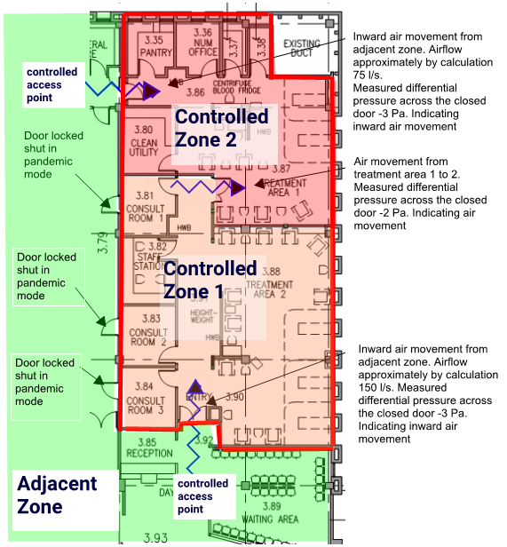

## Dilution

Where capable, air handling systems serving controlled zones, should provide 100 per cent outside air to the zone.

Most systems that are required to be used for control zones in a pandemic mode were never designed or intended to be used to provide 100 per cent outside air under all outside air conditions. If set to full outside air it is unlikely that they will be able to maintain clinical levels of environmental control in zones caring for critically ill patients. In systems that cannot achieve 100 per cent outside air, when operating in pandemic mode they should be configured to supply the maximum amount of outside air the heating and cooling coils can handle, and the main filtration should be a high enough grade to prevent recirculation of droplet nuclei through the system. Refer to the section below for guidance on filtration systems.

**Filtration**

In systems where 100 per cent outside air is not practical, filtration will be required to remove the suspended particles produced from AGP and AGB. The air returning to the air handling unit is a mixture of the air containing the aerosol and air returning from all the other zones in the system. The air is significantly diluted compared to the original aerosol source.

To achieve good levels of aerosol removal it will be necessary to install a minimum F8 or ideally an F9 multi-pocket or V bank filter in the air handling unit as the main filter. Table 4 provides details of various filters and efficiency rates across a wide particle range.

**Table 4 Minimum filter efficiency**

|  |  |  |  |
| --- | --- | --- | --- |
| Methodology | | ISO16890 Minimum Filtration efficiency % of PM | |
| EN779.2012 | ASHRAE 52.2 | 0.3 – 1.0 µm | 0.3 – 2.5 µm |
| ISOePM1 | ISOePM2.5 |
| G1 | MERV 1-2 | Nil | Nil |
| G2 | MERV 3-4 | Nil | Nil |
| G3 | MERV 5 | Nil | Nil |
| G4 | MERV 6-7 | Nil | Nil |
| M5 | MERV 8A-9A | >20% | >30% |
| M6 | MERV 10A-12A | >40% | >50% |
| F7 | MERV 13A | >50% | >60% |
| F8 | MERV 14A | >60% | >75% |
| F9 | MERV 15A-16A | >80% | >90% |

In a system such as Figure 4 below, an air handling system with 50 per cent outside air and an F9 filter will remove >90% of aerosol particles (being recirculated back to the AHU) in the 0.3 to 1.0 micron range.

Figure 4 Typical air handling system

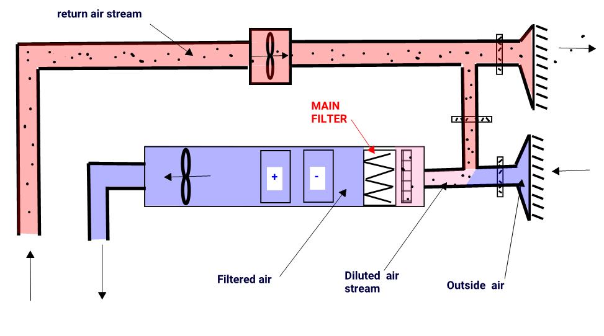

In large systems serving segregation areas (controlled zones) where the aerosol load is likely to be significant due to the clinical procedures or patient numbers, additional filtration could be introduced in the return air stream as an additional level of filtration, see Figure 5.

Figure 5 Additional filtration in systems serving zones with significant aerosol load

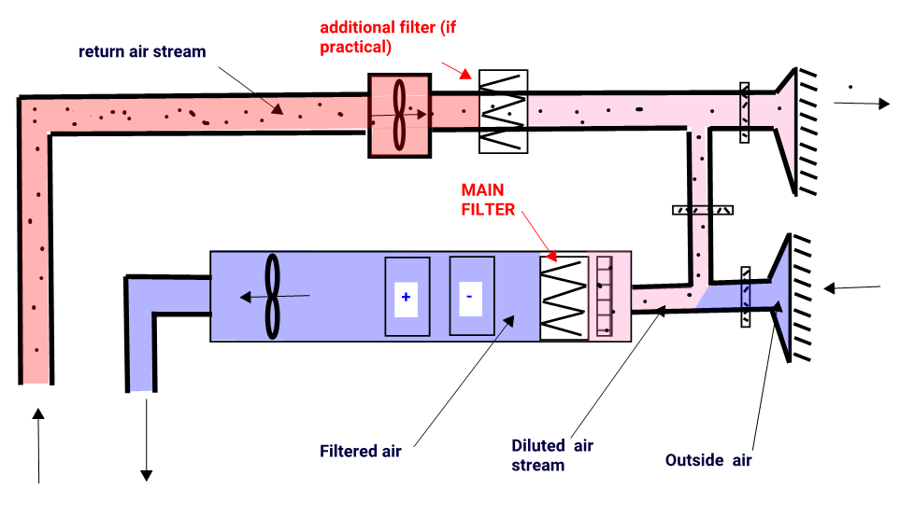

In this configuration, an air handling system with 50 per cent outside air and a combination of an F8 filter in the return duct and an F9 in the main filter bank will remove >96% of aerosol particles (being recirculated back to the AHU) in the 0.3 to 1.0-micron range.

## Temperature and humidity

Many HVAC systems can control indoor humidity and temperature, which can in turn influence transmissibility of infectious agents.

Although the weight of evidence at this time suggests that controlling relative humidity (RH) can reduce transmission of certain airborne infectious organisms, including some strains of influenza, this HTA does not make a broad recommendation on indoor temperature and humidity for the purpose of controlling infectious disease, beyond the humidity limitations and controls set out in the engineering service guidelines.

The Global Heat Health Information Network suggest maintaining indoor temperatures between 24degC and 27degC for cooling during the warmer months and RH between 50 per cent and 60 per cent. Additionally it is recommended that HVAC system are not set to low ‘cold’ temperatures, below 21degC (Chin et al., 2020) and ‘dry’ low humidity settings, below 40 per cent, as these are optimal conditions for SARS-COV-2 virus to survive (Chan et al., 2011; Van Doremalen et al., 2020).

Hospital engineers along with specialist practitioners may use the information above to make building design and operation decisions on a case-by-case basis.

## Facilities maintenance

When air handling units or systems are placed in pandemic mode, they will be clearly labelled and identified as such.

During any maintenance carried out in or on systems which are placed in pandemic mode, operatives should wear appropriate PPE, that is, filtering facepiece respirators, disposable gown or suit and disposable gloves. Suitable training in the use of PPE equipment along with fit testing of respirators will be required for these personal. When not working on these systems in the plantroom, site-specific PPE requirements will apply.

Minimum maintenance schedules for air handling is described in the ‘[*Maintenance standard for critical areas for Victorian Healthcare Facilities*](https://www2.health.vic.gov.au/about/publications/researchandreports/maintenance-standards-for-critical-areas-in-victorian-health-facilities)*’* <https://www2.health.vic.gov.au/about/publications/researchandreports/maintenance-standards-for-critical-areas-in-victorian-health-facilities>.

The standards cover air change rates, air flow visualisation, HEPA filter validation, door seal checks and more. Scheduled maintenance should be reported to the infection control team three-monthly to ensure patient safety.

As an adjunct to this, air movement may be mapped on an ad hoc bases (for example, using a smoke stick) from sterile field to ventilation exhaust.

# Summary

The *DHHS Engineering Design Guidelines for Healthcare Facilities* covers specific minimum HVAC requirements including ventilation rates, filtration, and pressure relationships among rooms.

The *Engineering Design Guidelines for Healthcare* Facilities and the *Australasian Health Facility Guidelines* can describe other criteria that can guide designers of these facilities.

All healthcare facilities are expected to maintain a base level of preparedness to provide testing and care for all acute infectious disease patients, and should maintain protocols to ensure the ability to promptly identify and safely evaluate, stabilize and isolate if necessary, suspected infectious disease patients and implement guidance for transfer of patients to designated facilities when indicated.

Each healthcare facility is responsible for developing a plan for the control of infectious disease outbreaks that may be needed during pandemic events.

Hospital engineers can support emergency planning by understanding the design, operations, and maintenance adequacy of buildings for which they are responsible and helping emergency planners mitigate vulnerabilities or develop interventions or strategies.

Actions should be thoughtfully undertaken in collaboration with infection control professionals and based on knowledge of the system and its operation and the nature and source of the threat.

At the building level, hospital engineers may provide support by:

1. identifying vulnerabilities with air intake, wind direction, shielding etc.
2. identifying building systems and safe zones in the general building environment
3. identifying approaches to interrupting air supply to designated ‘shelter-in-place’ locations in general building environments
4. identifying cohorting possibilities for pandemic situations so that whole areas of a hospital may be placed under isolation and negative pressure.

Commissioning, maintenance, and proper operation of buildings, and HVAC systems intended to control transmission of airborne infectious disease, are necessary for buildings and systems to be effective.

Infection control strategies should always include a bundle of multiple interventions and strategies (not just ventilation). Airborne infection risk prevention measures include the following interventions, ventilation, space available per patient, spacing of beds, physical barriers, PPE and use of separate rooms for highly vulnerable patients.

Spatial separation of at least 1m to 1.5m should be maintained between all patients. Both spatial separation and adequate ventilation can help reduce the spread of many pathogens in the healthcare setting.

Hospital engineers can play a key role in reducing disease transmission that occurs in healthcare facilities via the following:

* ensuring all facility designs follow the latest practice standards
* new healthcare facilities, including key points of entry such as emergency, admission and waiting rooms, should incorporate the infrastructure to quickly respond to a pandemic. Such infrastructure may include HVAC systems that separate high-risk areas, physical space and HVAC system capacity to upgrade filtration, the ability to increase ventilation even as high as 100 per cent outdoor air, the ability to humidify air and ability for installation of local ceiling mounted UVGI units
* provide ability for the installation of improved particle filtration for central air handlers
* the ability to quickly and temporarily increase the outdoor air ventilation rate in the event of an infectious disease outbreak
* avoiding unintended adverse consequences in infectious disease transmission resulting from lower ventilation levels motivated solely by reduced energy consumption.

# References and bibliography

*ASHRAE Position Document on Airborne Infectious Diseases (5/2/2020)*

*ASHRAE Handbook – HVAC Applications (2019)*

*CDC Interim Guidance for Businesses and Employers to Plan and Respond to Coronavirus Disease 2019 (COVID-19), February 2020*

*World Health Organization Interim Guidance Infection prevention and control during health care when novel coronavirus (nCoV) infection is suspected (2020)*

*World Health Organization Interim Guidance Clinical management of severe acute respiratory infection when novel coronavirus (2019-nCoV) infection is suspected (2020)*

*Northwest Healthcare Response Network Regional Acute Infectious Disease Response Plan (2017)*

*World Health Organization Essential Environmental Health Standards in Health Care (2008)*

*World Health Organization Natural Ventilation for Infection Control in Health Care Settings*

*Victorian Health and Human Services Building Authority – Engineering Guidelines for Healthcare Facilities (2019)*

*DHHS Victorian Advisory Committee on Infection Control – Maintenance standards for critical areas in Victorian health facilities (2010)*

*Safe Work Australia – Model Code of Practice: How to manage work health and safety risks*

*CDC Guidelines for Environmental Infection Control in Health-Care Facilities (2003)*

# Attachment 1: HVAC system checklist

## Design criteria

|  |  |  |
| --- | --- | --- |
| **Air handling unit** | | |
| AHU location |  | |
| Capacity |  | m³/s |
| Pre-filter |  | grade |
| Main filter |  | grade |
| Return air |  | m³/s or % |
| Outside air |  | m³/s or % |
| Spill air |  | m³/s or % |
| Cooing coil capacity |  | kW |
| Heating coil capacity |  | kW |
| Fan static |  | Pa |
| VSD speed (if applicable) |  | Hz |
| **Extract fan** | | |
| Capacity |  | m³/s |
| Fan static |  | Pa |
| VSD speed (if applicable) |  | Hz |
| **Return air fan** | | |
| Capacity |  | m³/s |
| Fan static |  | Pa |
| VSD speed (if applicable) |  | Hz |
| **Psychrometric check** | | |
| External condition limitations when operating in 100% o.a mode | | |
| Mode | Dry bulb C | Wet bulb C |
| Heating |  |  |
| Cooling |  |  |
| **Floor Distribution** | | |
| Return air volume as a % of supply air |  | % |
| Dedicated extract to |  |  |
| **Fire Mode** | | |
| Current HVAC fire alarm response in zone |  | |
| Current HVAC fire alarm response in adjacent zone |  | |

## General criteria

|  |  |  |
| --- | --- | --- |
| **Air handling Unit** | | |
| Humidifier | Yes | No |
| AS1668 separation from discharge louvres? | Yes | No |
| BMS controlled | Yes | No |
| Room in AHU to blank return air path | Yes | No |
| Return air damper capable of tight shut off? | Yes | No |
| Economy cycle available | Yes | No |
| Mixing Box | Yes | No |
| Power | Essential | Non-essential |
| **Extract fan** | | |
| Power | Essential | Non-essential |
| BMS Controlled | Yes | No |
| **Return air fan** | | |
| Power | Essential | Non-essential |
| **Psychrometric check** | | |
| Supplemental cooling / heating required in zone | Yes | No |
| **Fire mode** | | |
| Does response need to be adjusted for Pandemic Mode? | Yes | No |
| **Floor distribution** | | |
| Supply air diffusers to all areas | Yes | No |
| Toilets | Yes | No |
| Showers | Yes | No |
| Dirty utility | Yes | No |
| Current air balance checked | Yes | No |
| Can system be easily re-balanced to achieve new air flow patterns | Yes | No |
| Does proposed area match fire zones | Yes | No |
| Does proposed area match HVAC zones | Yes | No |
| Return air path | Ducted | Plenum |

## Additional comments/observations

|  |
| --- |
|  |