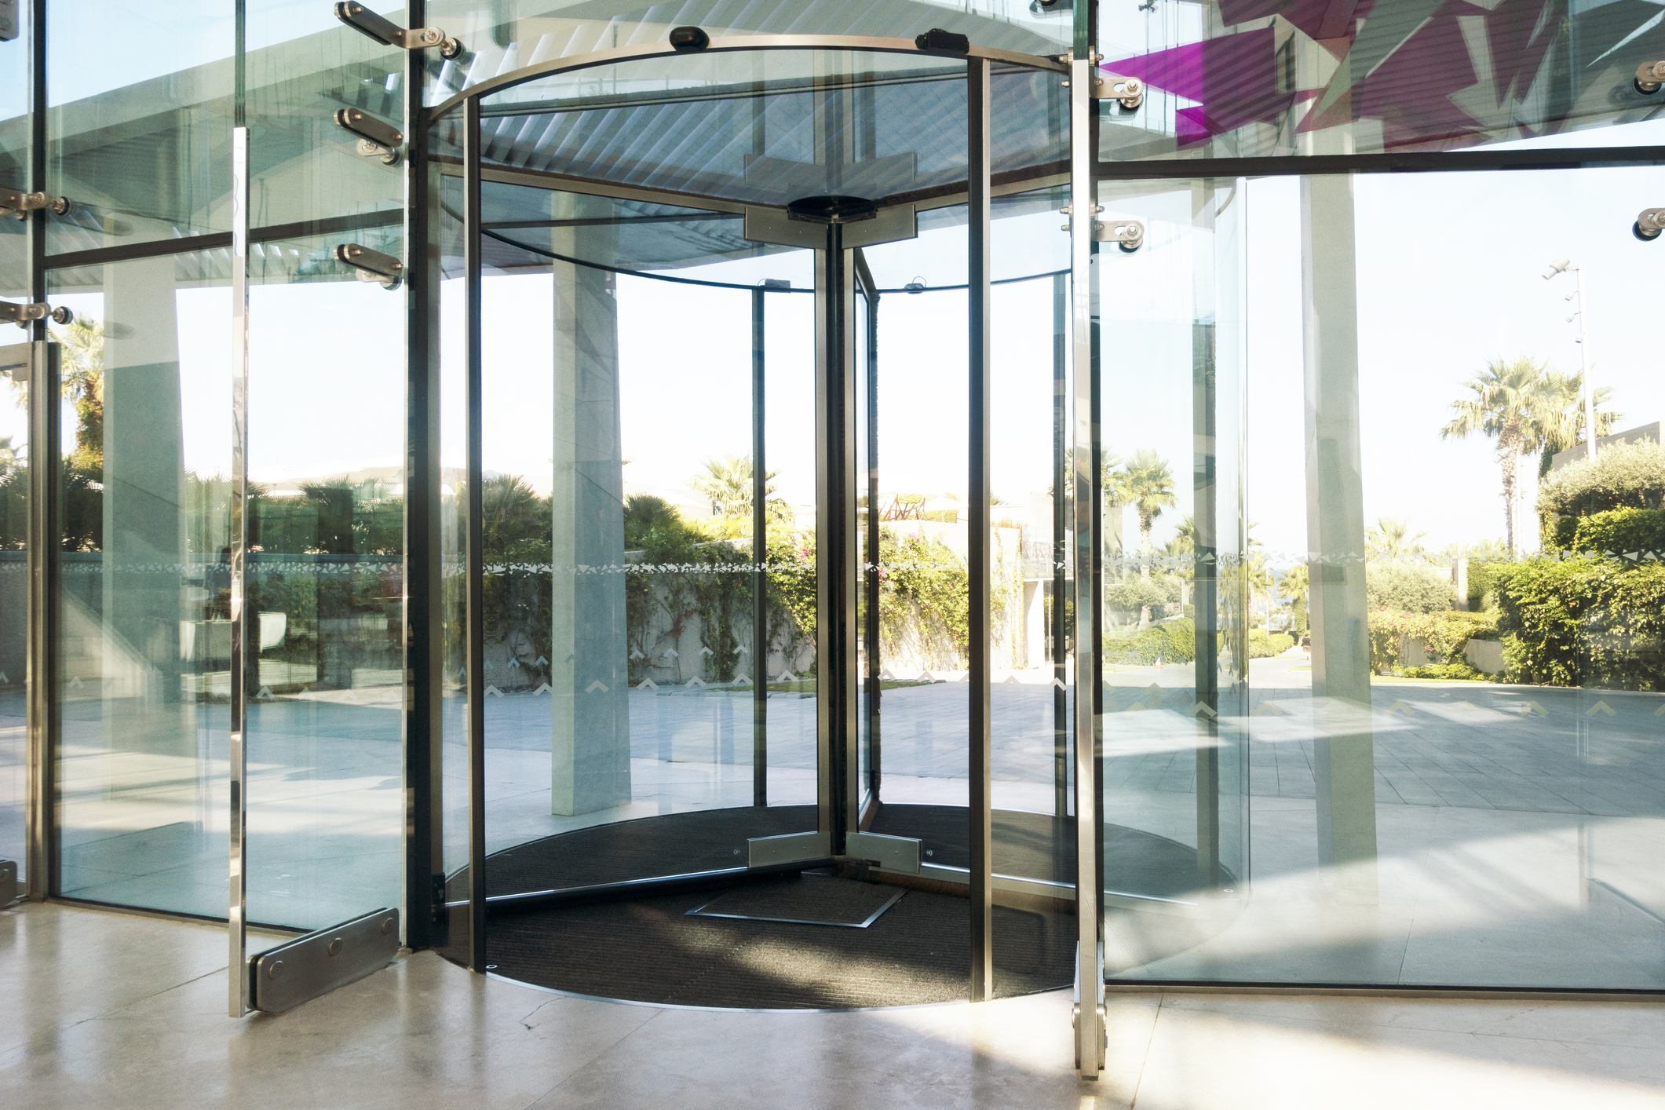

|  |
| --- |
| advice on selection of revolving doors for health care facilities  Health Technical Advice: HTA-2020-006  OFFICIAL |
|  |

|  |
| --- |
| This document has been prepared as a guide and for information purposes only.  No legal obligation for any loss, damage or expense is incurred by any person relying on the information provided. |
| To receive this publication in an accessible format, email the [Victorian Health and Human Services Building Authority](mailto:vhhsba@dhhs.vic.gov.au?subject=Accessibility%20request) <vhhsba@dhhs.vic.gov.au>  Authorised and published by the Victorian Government, 1 Treasury Place, Melbourne.  © State of Victoria, Australia, Victorian Health and Human Services Building Authority, November 2020.  **ISBN** 978-1-76096-234-0 **(pdf/online/MS word)**Available on the Resources page of the [Victorian Health and Human Services Building Authority website](https://www.vhhsba.vic.gov.au/resources/technical-guidelines) <https://www.vhhsba.vic.gov.au/resources/technical-guidelines> |

Contents

Preface 4

Introduction 4

Recommended ways to control risk 4

References 6

# Preface

Automatic revolving or rotating doors can be found in a variety of locations including many commercial and health care facilities. People entering and exiting buildings through revolving doors can be at risk of being struck, trapped, or injured.

Revolving doors pose a particular hazard to users who have mobility issues. A revolving door generally consists of two, three, or four doors (wings) that attach to a rotating vertical central shaft. They are designed to create greater energy efficiencies in buildings while allowing large numbers of people to pass through.

The purpose of this technical note is to provide guidance to health care facilities and design teams when considering the installation of a revolving door at their facilities.

# Introduction

Health agencies have experienced some incidents in the past with revolving doors. The most common incidents have occurred during the transition through the revolving doors by people with mobility issues and/or children that have experienced being pushed/struck by the revolving door leaf, which then leads the user to lose their balance, or being stuck between the revolving door and the edge of the entrance; both cases may cause significant or fatal injuries.

Due to the risk associated with revolving doors, the Victorian Health and Human Services Building Authority’s (VHHSBA) recommendation is to install air locks as a means of maintaining internal environmental conditions instead of revolving doors where suitable.

Where traditional air locks cannot be installed to prevent uncontrolled natural ventilation, and revolving doors are to be used as the building air locks, they will be designed with consideration of health care user cohorts, the number of revolving door leaves, and revolving door diameter.

Installation of a revolving door may be required where this is the only practical method of ensuring the main entrance to the building provides an effective airlock. This consistently closed, yet always open, buffer provided by the revolving door provides significant energy efficiency benefits.

# Recommended ways to control risk

Revolving doors generally have sensors to slow or stop the door rotation under certain conditions. However, these sensors do not eliminate the risk completely. A person who is fragile or has a mobility issue could be knocked or jammed during transit by the leading edge of the door.

Designers and health agencies are required to follow procedures and checks to minimise these incidents as per the check list below:

* Any proposed revolving doors are to be in accordance with the following:
  + Larger two leaf hybrid type doors. Hybrid doors allow passage doors as manually operated swinging doors or automatic sliding doors to be integrated within the revolving doors. However, the use of the sliding door configuration on many models is usually limited to emergency situations as it is not capable of coping with the high duty cycle of a purpose-built sliding door.
  + Large three-leaf revolving doors with min diameter to ensure a 2000 mm wide revolving door entry and exit openings.
  + Large four-leaf revolving doors with min diameter to ensure a 2000 wide mm revolving door entry and exit openings.
* All doors to be designed and installed in accordance with:
  + AS 5007-2007 Powered doors for pedestrian access and egress.
  + AS 1428.1 2009 Design for access and mobility.
* Regularly test and maintain rotating door sensors.
* Presence detection device test, to be undertaken weekly in accordance with AS 5007 section 5.5 Occupier safety checks, and manufacturer’s specifications. Additional tests above and beyond the recommendations of the Australian Standard may need to be implemented in order to demonstrate controls are as far as is reasonably practicable.
* A procedure should be developed to document all test procedures in order to ensure consistency and repeatability. All test results should be documented.
* Ensure all revolving doors are provided with additional occupant protection, to all door leaves and all leading mullions. This may be in the form of additional sensors to detect a pedestrian. The range and coverage of the sensors should be considered as many sensors may need to be adjusted to detect the presence of pedestrians closer to the ground (for example, small children). The ideal scenario is to have the sensors detect the presence of a person (under various likely scenarios) and slow, then stop, the door movement prior to any physical impact.
* All revolving door installations are to be load force tested, to ensure that doors will stop rotating prior to the 250N maximum impact force of 250N in accordance with AS 5007.

**NOTE: for high risk cohorts (fragile, mobility issue) this maximum impact force may still pose an unacceptable risk. If it is not possible to eliminate the possibility of physical contact through the means outlined in the previous bullet point, a lower maximum impact force may be required. The testing should be done with appropriate equipment that has been calibrated and maintained.**

* Clear and obvious occupant signage and tactile indicators on the approach of the doors is to be provided.
* Alternative door access to be provided adjacent to revolving doors. This needs to be clear to all users, including those who are visually and mobility impaired.
* Installation of additional ‘supervision’ warning signage to be provided.

# References

Victorian Health and Human Services Building Authority (2019) [*Engineering Guidelines for Healthcare Facilities*](https://www.vhhsba.vic.gov.au/resources/technical-guidelines) *<*https://www.vhhsba.vic.gov.au/resources/technical-guidelines>

WorkSafe (18 March 2020) [*Hazards of automatic revolving or rotating doors*](https://www.worksafe.vic.gov.au/safety-alerts/hazards-automatic-revolving-or-rotating-doors)<https://www.worksafe.vic.gov.au/safety-alerts/hazards-automatic-revolving-or-rotating-doors>

‘[Revolving doors turn into a major Boon for healthier building environments](https://www.fmmedia.com.au/sectors/revolving-doors-turn-into-a-major-boon-for-healthier-building-environments/)’*, Facility Management Media, 18 March 2020* <https://www.fmmedia.com.au/sectors/revolving-doors-turn-into-a-major-boon-for-healthier-building-environments/>

[National Construction Code](https://ncc.abcb.gov.au/) <https://ncc.abcb.gov.au/>