|  |
| --- |
|  |

|  |
| --- |
| Helicopter and medical transport landing sites  Planning and development guidelines |

To receive this publication in an accessible format, [email the Property team](mailto:vhba.property@health.vic.gov.au) <vhba.property@health.vic.gov.au>

Authorised and published by the Victorian Government, 1 Treasury Place, Melbourne.

© State of Victoria, Australia, Victorian Health Building Authority, June 2020 (rebranded June 2021)

**ISBN** 978-1-76096-003-2 **(pdf/online/MS word)**

Available on the [resources page of the Victorian Health Building Authority website](https://www.vhba.vic.gov.au/resources) <https://www.vhba.vic.gov.au/resources>

Contents

Foreword 5

Definition 5

Purpose of this guideline 5

Departmental planning and development guidelines 5

1. Introduction 6

1.1. Purpose and scope of heliport guidelines 6

1.2. Related guidelines and applicable standards 6

1.3. Department of Health planning and development guidelines 7

1.4. Approval of heliport prior to the planning, design and commissioning phase 7

1.5. Further information 8

2. Planning and concept design for heliports 9

2.1. Introduction 9

2.2. Consideration of need for a heliport 9

2.3. Site identification and feasibility assessment 10

2.4. Planning and concept design 11

2.5. Generic heliport requirements 11

2.6. Risk analysis and mitigation 12

2.7. Design helicopter 12

2.8. Assessment of flightpath track options and heliport usability 14

2.9. Performance objectives for hospital heliports 14

3. Detailed design for heliports 16

3.1. Structural design 16

3.2. Surface markings 18

3.3. Lighting 21

3.4. Wind indicator 22

3.5. Fire risk management 22

3.6. Heliport design development overlays 23

4. Heliport management and operations 24

4.1. Management structure 24

4.2. Heliport operations manual 24

4.3. Heliport inspections 26

4.4. Biennial approach survey 27

4.5. Conditions of use 28

4.6. Ancillary equipment 28

Appendix 1: Related guidelines and applicable standards 29

List of related guidelines and applicable standards 29

Application of Civil Aviation Regulation 92 29

Application of the ICAO SARPs 29

ICAO Doc 8168 – Procedures for Air Navigation Services – Operations (PANS-OPS) 30

Appendix 2: Glossary 31

Abbreviations 31

Definitions and other expressions 32

Appendix 3: Heliport approval process 35

Appendix 4: Physical characteristics of the design helicopter 36

Overview 36

Structural design characteristics for AB139 helicopter 36

Appendix 5: Image descriptions 38

Figure 1: Layout of a generic heliport to meet design helicopter Category-A criteria (single flightpath track) 38

Figure 3: FOTA and aiming point marking requirements 39

Figure 4: Form and proportion of numbers an letters for surface markings 39

Figure 5: Form and proportion of ‘D’ character 41

Figure 8: Dimensions of the AB139 helicopter 42

# Foreword

## Definition

A helicopter landing site (HLS) for helicopters engaged in helicopter medical transport (HMT) operations is a facility provided to enable the safe and efficient transfer of critically ill patients by helicopter and associated activities. The facility may be located on or near a hospital site and may be at ground level or elevated. It also includes the airspace associated with arrival and departure flightpaths. In this guideline, the term ‘heliport’ encompasses all these elements.

## Purpose of this guideline

The purpose of this guideline is to:

* support the planning, design development and operation of heliports that enable the safe and efficient operation of helicopters engaged in medical transport operations
* ensure the development and construction of heliports follows best practice and reflects applicable Australian and international regulations, standards and recommended practices
* enable details, including any cost–benefit analysis, for the planning, development and operation of heliports to be integrated with hospital service and master plans
* provide guidance to public healthcare services and other heliport owners in relation to the management, operation and maintenance of a heliport
* support effective consultation with user groups and stakeholders including landowners, local governments, communities and responsible authorities.

## Departmental planning and development guidelines

See the [Capital Planning website](http://www.capital.health.vic.gov.au) for more on the department’s planning and development guidelines for capital works projects <http://www.capital.health.vic.gov.au>.

This guideline replaces previous versions of the department’s *Air ambulance heliport guidelines*.

1. Introduction
   1. Purpose and scope of heliport guidelines

These guidelines assist government and public health services to plan, develop and operate a landing site for helicopter medical transport (HMT) flight operations.

They apply principally to the development of new facilities, which have the best opportunity to implement relevant standards and recommended practices. The guidelines also provide baseline criteria for the assessment and upgrade of existing facilities, although we acknowledge it may be impractical to fully implement these provisions at some existing sites.

The guidelines have been produced in consultation with Department of Health staff with assistance from expert technical consultants and in collaboration with Ambulance Victoria (AV), the Civil Aviation Safety Authority (CASA) and Victorian public health services.

The specific objectives of these guidelines are to:

* support the planning, design development and operation of heliports that enable safe and efficient operation of helicopters engaged in medical transport operations
* ensure the development and construction of heliports follows best practice and reflects applicable Australian and international regulations, standards and recommended practices
* ensure details, including any cost–benefit analyses, for the planning, development and operation of heliports are integrated with hospital service and master plans
* provide guidance to public healthcare services and other heliport owners in relation to the management, operation and maintenance of a heliport
* support effective consultation with user groups and stakeholders including landowners, local governments, communities and responsible authorities.

These guidelines apply to heliports that are intended to enable patient transfer by helicopters conducting medical transport operations in Victoria. The guidelines are broadly applicable to ground-level and elevated facilities at onsite or offsite locations, and include the airspace associated with arrival and departure flightpaths. The guidelines should be used in the planning and design phase of a helipad development project.

These guidelines are only applicable to helicopter medical transport flights operated in visual meteorological conditions (VMC), which includes flight within the direct and manoeuvring visual segment of a point in space (PinS) approach or departure procedure.

These guidelines are not intended to provide definitive requirements for all circumstances, and it may be impractical to implement these guidelines at all sites. Note, however, that heliports may not be funded by government or used by AV if they are not designed and built in accordance with these guidelines.

* 1. Related guidelines and applicable standards

The Civil Aviation Safety Authority (CASA) does not currently have a legal instrument to certify or register heliports that are not an integral element of an aerodrome certified or registered under Part 139 of the Civil Aviation Safety Regulations 1998.

The responsibility for determining the suitability of a place as a helicopter landing site is held under Civil Aviation Regulation 92 (CAR 92) by the pilot in command and in some circumstances, is shared with the aircraft operator.

In 2012 CASA published a consultation draft for Part 133 of the Civil Aviation Safety Regulations *Australian air transport operations: rotorcraft*. In 2013 CASA released a Notice of Proposed Rule Making (NPRM) 1304OS *Regulation of aeroplane and helicopter ‘ambulance function’ flights as air transport operations*. The NPRM provides directional guidance to the future regulatory environment for helicopter medical transport flights in Australia.

The International Civil Aviation Organisation (ICAO) sets out international standards and recommended practices for the safe conduct of civil aviation activities in the Annexes to the *Convention on International Civil Aviation* (Chicago, 1944), of which Australia is a signatory.

These heliport guidelines have been developed to incorporate the current and proposed regulatory framework for helicopter medical transport flights as well as the relevant international standards and recommended practices. The physical requirements for heliports and associated airspace have been developed to support Performance Class 1 and Performance Class 2 flights.

Appendix 1 contains more information on related guidelines and standards, and Appendix 2 contains a glossary of terms.

* 1. Department of Health planning and development guidelines

Department of Health planning and development guidelines cover each phase of the capital investment process, and are relevant to all projects regardless of size, cost, complexity and source of funds.

The departmental guidelines assist the planning, organising and implementation capital works projects.

Where areas or spaces are not covered by departmental guidelines, the design team is advised to seek the advice of the Department of Health, as well as to identifying industry best practice and consulting user groups.

Elements or aspects of healthcare provision can change rapidly. Make sure you are using the latest version of the guidelines, and that they are appropriate and applicable to the situation.

The planning and development guidelines are available on the Capital Planning website <http://www.capital.health.vic.gov.au>.

* 1. Approval of heliport prior to the planning, design and commissioning phase

CASA does not currently have a legal instrument to undertake the certification or registration of helicopter landing sites other than those located on an airport. Formal approval and acceptance of the facility rests with the helicopter pilot in command under the provisions of Civil Aviation Regulation 92.

The process for approving the heliport design and operations manual is as follows:

* The professional design consultants and principal consultant (if applicable) certify that the design complies with relevant design standards.
* Ambulance Victoria agrees to the design in writing or by recorded minutes of joint design review meetings.
* The project control group (if applicable) approves the design and it is noted by the steering committee.
* If the design does not meet all the criteria, variations need to be subject to a risk assessment and agreed by the design review committee. Variations to provisions may impose operational limitations on the facility.

The approval process is to follow the project phases set out in the Capital development guidelines summarised in Appendix 3.

* 1. Further information

These guidelines do not cover the detailed technical specifications relevant to a heliport, nor are they a substitute for experience. Suitably qualified and experienced consultants are to be engaged to provide technical advice to plan or establish a heliport and associated flightpaths, and stakeholders should be consulted throughout the planning and design process.

For further information relating to this guideline, [email the Victorian Health Building Authority Property team](mailto:vhba.property@health.vic.gov.au.) <vhba.property@health.vic.gov.au>

1. Planning and concept design for heliports
   1. Introduction

Air ambulance services play an increasing and critical role in emergency healthcare. We need to plan effectively to meet current and future needs, taking into account technological advances in healthcare, helicopters and heliport requirements, the growing and ageing population, more densely populated cities and increasing financial pressures on healthcare provision.

The aeronautical operations aspects of these guidelines incorporate current practices and procedures applied by AV and take into account the future regulatory environment for helicopter medical transport flights proposed by CASA in their 2013 NPRM 1304OS.

These guidelines set out the requirements for heliports and associated airspace for flightpath protection in terms of location, spatial considerations, access, lighting, flightpath design, planning protection and operational issues.

The guidelines provide a generic project planning approach, however each heliport project and development process will have unique characteristics. It is essential that all stakeholders, including the department, AV and the health service, collaborate to achieve an outcome that is practical to implement and safe to operate.

* 1. Consideration of need for a heliport

The need for an onsite heliport will depend on local service needs, the role of the hospital within the broader system and the proximity of other heliports. The need for a heliport in a particular area should be agreed by the department and other relevant health services, in the context of service planning.

The needs assessment for an onsite heliport should include the impact of additional demand generated at the health service in response to primary trauma events and road/air ambulance transfers. Also consider that while heliports are under the control of a health service, they are state assets and patients being delivered to and from other centres may also need access to the heliport.

Other factors that should be taken into account include:

* the hospital’s role in the state trauma system
* hospital networking arrangements and proximity to other hospitals
* need for additional emergency department services
* staff skills and 24-hour clinical support
* ease of access for patient transfer between the helicopter and hospital and also, for surface level heliports, between helicopter and road ambulance vehicles
* local geography
* road network capacity for patient transfer and travel times.

Health services considering the development of a heliport will need a service plan and a master plan agreed with the department and developed either prior to or as part of a feasibility study of a heliport.

It is important that the health service consider the proposed facility and area associated with the flightpaths, as these will become a feature to be incorporated in the precinct and site master plans and will restrict future development opportunities for other activities such as car parks, buildings, landscaping (trees), light poles, masts and aerials. Existing and potential structures outside the hospital and within the potential flightpath also need to be considered.

The master plan and design stages are to consider:

* precinct service network planning
* a site that can remain viable for period of not less than 10 years
* reviewing the location of the heliport whenever major changes occur to the hospital
* the space allocated for the heliport not being used for car parking or other purposes
* the heliport site being level and able to support aircraft
* the ability to support road ambulance vehicle access (if required) and room to load/unload patients
* existing and future fixed structures as well as changing elements (such as trees, masts, towers)
* broader town planning issues in the vicinity of the proposed heliport location and the ability to apply a design and development overlay (DDO) to protect the operational airspace against obstacle intrusion.
  1. Site identification and feasibility assessment

If the need for a heliport has been established and approved by the department and health service, specialist and technically competent consultant/s can be engaged to undertake a feasibility study to assess development options. The study should be based on a concept design reflecting the generic criteria presented in these guidelines for Performance Class 1 flights. Refer to the Department of Health planning and development guideline for a feasibility study.[1]

Before undertaking any heliport study, the health service and the department is to have an agreed planning brief and a consultant brief setting out the basis, reasoning and background for the feasibility study.

The feasibility study for a helicopter medical transport heliport development option is to address the following:

* identification of design helicopter and operational criteria for operations in Performance Class 1
* spatial requirements of the heliport to suit the design helicopter operating in Performance Class 1
* assessment of site-specific winds to determine flightpath track options and overall usability for flights operating in Performance Class 1
* identification of obstacle accountability area (OAA) boundary for each flightpath track and assessment of obstacle environment within the OAA against criteria for flights operating in Performance Class 1 (assessment of trees within the OAA needs to consider the mature height as well as the existing tree growth)
* calculation of the length of the continued take off (CTO) segment for a range of site-specific density heights reflecting ISA conditions as well as peak summer-time conditions (assessment of obstacles with the CTO segment is required to determine the range of adjustments to the CDP elevations needed to meet Performance Class 1 obstacle clearance criteria)
* obstacles may be permitted to penetrate the obstacle limitation surfaces associated with an approach/take-off climb surface having a 4.5 per cent design slope (subject to an aeronautical study to identify risks and mitigation measures, and approval of AV and the helicopter service provider)
* consideration of available site and airspace characteristics against concept design parameters, and identification of modified design parameters if compliance with the generic design parameters is not possible. Undertake a site-specific risk assessment if the technical criteria in these guidelines cannot be met. Exemptions from technical standards may be permitted if the risk assessment demonstrates the risk is acceptable to the helicopter operator(s) and the agencies responsible for heliport ownership and operation
* consideration of the heliport location relative to the hospital emergency department and clinical areas, with reference to distance, gradient, weather protection and access for road ambulance vehicles where appropriate (in some locations, health services may need to consider locating a heliport offsite, which will require the use of road ambulances to transfer the patient to and from the hospital)
* consultation with AV and other key stakeholders about the operational acceptability of the concept design, and where necessary the identification and consideration of risk mitigation measures
* consideration of historic, heritage listed or environmentally significant buildings, trees or other structures that cannot be changed from their present location or height.

The consultants who undertake the feasibility study are to have experience in planning and design of helicopter medical transport heliports for flights operated in Performance Class1 and Performance Class 2, and they must have appropriate insurance (including professional indemnity with maintenance cover).

After the feasibility study, a preliminary business case can be developed to analyse the costs and benefits of a new or upgraded heliport. The preliminary business case should be mindful of broader precinct needs and the associated level of investment.

* 1. Planning and concept design

The planning and development of heliports for use by helicopters operating medical transport flights in Victoria is based on the performance capability of the helicopters as defined by:

* ICAO in Annex 6 Part III
* ICAO Annex 14 Volume II
* the relevant rotorcraft flight manual
* CASA in the Consultation Draft of Part 133 to the Civil Aviation Safety Regulations.

The proposed regulatory environment identified in the CASA NPRM for helicopter medical transport flights should also be considered.

All developments are to be assessed against the operational requirements for medical transport flights operated in Performance Class 1. Some locations, particularly existing sites that have been operational for some time, may not be capable of meeting all the operational requirements to support Performance Class 1 flights. In these cases, availability of suitable forced landing areas in addition to the heliport physical characteristics may be required.

Flights conducted in Performance Class 2 require suitable forced landing areas in the vicinity of the heliport. The suitability of the heliport for Performance Class 2 with exposure flights will be determined by the medical transport helicopter operators and CASA, but heliport planning and design studies need to consider the availability of such sites, if Performance Class 1 flights are not possible. In consultation with AV and a chief pilot representative, sites need to be assessed for the safe completion of a forced landing in the vicinity of the heliport.

* 1. Generic heliport requirements

Based on the characteristics of the design helicopter, it is possible to identify a generic specification of physical characteristics for helicopter medical transport heliports and the associated airspace that will meet the operational requirements of helicopters flown in Performance Class 1.

The design helicopter is a composite vehicle reflecting the critical characteristics of the range of helicopters representing the current and foreseeable future of medical transport flights in Victoria.

The generic heliport requirements seek to maximise the accessibility of the heliport through both the operating conditions at time-of-use, as well as over the heliport’s design life. It may not be possible to meet all the generic heliport requirements at all locations, and if this occurs, the department, health service and AV need to collaborate to find a safe and practical solution.

Consideration needs to be given to any road ambulance access, manoeuvring, positioning (if required) and the movement of patients to and from an ambulance over a smooth surface using a wheeled stretcher, trolley, bed or cot.

The suitability of the heliport surface for the passage of gurneys with non-pneumatic wheels needs to be considered and in particular where a prefabricated aluminium deck has been selected to take advantage of its enhanced fire protection capabilities.

* 1. Risk analysis and mitigation

If aspects of the proposed heliport do not meet significant aspects of the relevant ICAO and CASA rules and or guidelines, these non-conformances are to be risk assessed and presented to the design review committee.

The design review committee is chaired by the Department of Health and includes representation from AV and contracted helicopter operator(s). Specialist expert opinion and health service representation may be included if necessary. After a review, the committee may decide to:

* accept the proposal unchanged
* require further detail on the risk assessment
* propose changes
* reject the proposal outright.
  1. Design helicopter

The range of helicopter types currently engaged in helicopter medical transport flights are in the ‘medium-twin’ grouping, being twin engine aircraft certified with Category-A single engine performance capabilities. The use of medium-twin helicopters for helicopter medical transport flights is not expected to change significantly in the longer term, and the key parameters for the design helicopter have been selected on the basis of current and foreseeable types in the medium twin grouping.

The principal characteristics adopted for the design helicopter engaged in helicopter medical transport flights in Victoria are presented in Table 1.

Table : Principal characteristics adopted for the design helicopter engaged in medical transport flights in Victoria

| Characteristic | Value |
| --- | --- |
| D-value, the largest overall dimension with rotors turning | 18.5 metres |
| Rotor diameter | 15 metres |
| Maximum mass | 8 tonnes |
| Undercarriage type | Skid and wheel |
| Height | 5 metres |

Table 2: Operational airspace and physical characteristics required for design helicopter to operate in Performance Class 1

|  |  |
| --- | --- |
| Physical characteristic | Value |
| Heliport (FATO/TLOF) dimensions (single flightpath) | 23 x 27 metres |
| Heliport (FATO/TLOF) dimensions (perpendicular flightpath) | 27 x 27 metres |
| Heliport safety area dimensions | 37 x 37 metres |

Obstacle accountability area (OAA)

|  |  |
| --- | --- |
| Physical characteristic | Value |
| Inner edge | 37 metres |
| Lateral boundary splay | 15 per cent |
| Maximum width of splay | 150 metres |

Obstacle limitation surface within OAA (see commentary following table)

|  |  |
| --- | --- |
| Physical characteristic | Value |
| Optimum gradient from end of CTO segment | 4.5 per cent (2.58 degrees) |
| Length of CTO segment | Determined after consideration of site-specific helicopter performance capabilities for ambient weather |
| Alternate gradients | Available after consideration of site-specific obstacle environment and helicopter performance capabilities |
| Elevation of OLS inner edge | Raised as necessary to ensure PC1 obstacle clearance requirements are met |

Note: FATO is final approach and take-off area; TLOF is touchdown and lift-off area.

The parameters listed in Table 2 and illustrated in Figure 1 represent the optimum design configuration with no objects above the helipad elevation within a nominal CTO segment of 240 metres in length. It will not be possible to achieve all these criteria at some sites, and alternative design parameters may need to be proposed. In these cases, the design review committee will consider alternative design parameters and decide on a practical concept design that is safe and efficient.

The generic layout shown in Figure 1 reflects the configuration for a heliport with a single flightpath track alignment. Perpendicular flightpath tracks increase the overall usability of the facility with a corresponding heliport (FATO) dimensional requirement of 27 metres by 27 metres to support flights operated in Performance Class 1.

* 1. Assessment of flightpath track options and heliport usability

The overall usability of a site and the alignment of flightpath tracks requires an assessment of site wind conditions. Helicopter medical transport flights conducted in Performance Class 1 need to operate within the crosswind limitations specified in the rotorcraft flight manual. While some helicopter types can operate in relatively high crosswind velocities, others are restricted to a 10 knot (5.14 metres a second) crosswind limit. The overall usability of the heliport therefore needs to be assessed with reference to the limiting case of a 10-knot crosswind.

The desired minimum usability for a site is 95 per cent. Multiple flightpath tracks are often needed to achieve that result and as such single flightpaths are to be avoided where possible.

Figure : Layout of a generic heliport to meet design helicopter Category-A criteria (single flightpath track)

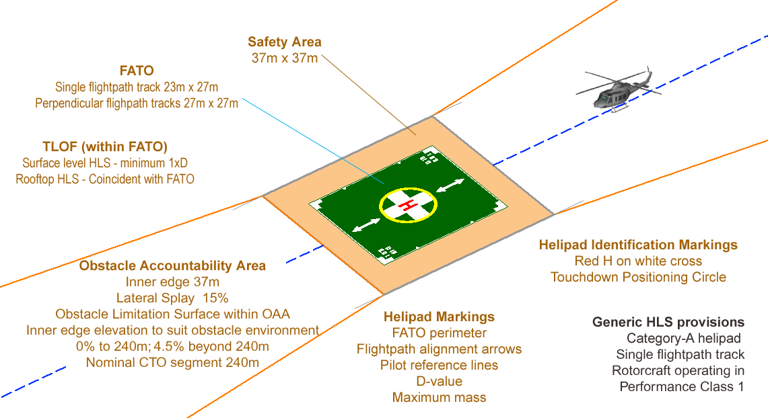

* 1. Performance objectives for hospital heliports

New elevated and rooftop heliports and associated airspace must in all instances meet the physical criteria of the design helicopter operating in Performance Class 1.

The department will always aim to locate, design and build new surface-level heliports that support helicopter flights to operate in Performance Class 1. If a heliport is necessary at a health service, and the physical characteristics of a surface-level site cannot meet the criteria for Performance Class 1 flights, it may be possible to consider facilities that support Performance Class 2 flights.

Before approving a facility to support Performance Class 2 flights, a complete risk assessment needs to be undertaken and endorsed by the design review committee.

The department does not support the design and construction of new heliports that only support Performance Class 3 operations.

The planning and concept design studies for sites where Performance Class 1 cannot be achieved will need to consider the availability of suitable forced landing areas, as well as the physical characteristics of the heliport. The design of these facilities may be based on the use of a square or rectangular FATO area with a TLOF located within the FATO. The safety area outer boundary needs to have a minimum diameter of twice the design helicopter D-value with the FATO having a diameter of 1.5 times the D-value and the TLOF having a diameter equal to the D-value.

These dimensions are based on information provided by CASA reflecting current considerations for future standards and recommended practices. A FATO area with 1.5 times D-value dimensions plus the safety area will also better serve as a suitable forced landing area for Performance Class 2 flights.

The suitability of facilities with characteristics that do not meet criteria will need to be assessed in detail via an aeronautical study that includes the identification of risks and ways to mitigate them. The design review committee will consider the results of this study. The study may identify significant operational restrictions for some non-compliant sites.

These design guidelines should be considered for any temporary or interim heliport. The extent to which the design guidelines are met will depend on the length of time the temporary heliport is in place and how often it will be used.

1. Detailed design for heliports

Detailed design activities are to be based on the concept design approved by stakeholders during the concept design development stage.

The concept design phase identified the following parameters:

* design helicopter characteristics including D-value, maximum mass and minimum dimensions of heliport as published in the Category A supplement to the rotorcraft flight manual
* dimensions of key heliport elements including safety area boundary, FATO area and the TLOF area
* flightpath track alignments for optimum usability of the facility and the dimensions of the associated obstacle accountability area
* length of the CTO segment and elevation of the OLS to ensure obstacle clearances meet Performance Class 1 criteria.

All heliports are to be planned, designed and built for both day and night use.

The detailed design stage will focus mainly on making connections between the heliport and the engineering services that link the heliport with the hospital.

It will also involve consultation with the relevant local council(s) about planning and development constraints that may affect the flightpaths and any offsite heliports.

Activities in the detailed design stage will include:

* structural design for heliport components
* detailed layout and dimensioning for heliport surface markings
* detailed layout and dimensioning for heliport lighting
* location and dimensions of illuminated wind direction indicator (IWDI)
* detailed design of access and egress, including emergency egress
* detailed design of the helipad surface, which are to be constructed to allow the smooth transition of the patient to and from the aircraft to the ambulance or hospital using a wheeled stretcher, bed, trolley or cot
* detailed design of any road ambulance access (if required) and the ability for the ambulance to be manoeuvred and positioned to achieve the timely loading and unloading of patients
* fire protection measures to be incorporated into the heliport site
* approval of the design by the department, health service and AV.
  1. Structural design

Guidance for the structural design of surface level and rooftop heliports is available in the ICAO *Heliport design manual*, document 9261-AN/903 (the ICAO manual).

For surface-level heliports, the ICAO manual advises that the bearing strength of a FATO used by helicopters operating in Performance Class 1 should cover the loadings generated by a rejected take-off, which may equate to an emergency landing. The bearing strength of a surface level FATO should cover an emergency landing with a rate of descent of 3.6 metres per second. The design load in that case should be taken as 1.66 times the maximum take-off mass of the heaviest helicopter for which the FATO is intended.

All surface-level heliport FATOs must be designed to accept the dynamic loads associated with helicopters operating in Performance Class 1, albeit infrequently. The TLOF, on the other hand, needs to accept these dynamic loads frequently and is likely to be a concrete slab, whereas the FATO may be a natural surface area with the desired load-bearing capability.

The following information has been extracted from the ICAO manual.

For elevated heliports, the manual assumes for the purpose of design that the helicopter will land on two main wheels, irrespective of the actual number of wheels in the undercarriage, or on two skids if they are fitted. The loads imposed on the structure should be taken as point loads at the wheel centres. The manual advises that the FATO should therefore be designed for the worst condition derived from the helicopter-on-landing situation and the helicopter-at-rest situation.

The helicopter-on-landing situation for an elevated heliport requires consideration of:

* the dynamic load due to impact on touchdown for the serviceability as well as the ultimate limit loading states
* a sympathetic structural response factor on the FATO
* the overall superimposed load on the FATO
* the lateral load on the platform supports
* the dead load of the structural members
* wind loading and punching shear.

The helicopter-at-rest situation for an elevated heliport requires consideration of:

* the dead load of the helicopter
* the overall superimposed load on the FATO
* the dead load of the structural members and
* wind loading.

Further details of the values and application of the relevant load factors are presented in the ICAO manual.

The structural design of surface level and elevated medical transport helipads needs to be undertaken by suitably qualified and experienced engineers to ensure the relevant site-specific characteristics are identified and included in the design considerations. In addition, the helicopter characteristics applied need to represent the design helicopter rather than be based on generic criteria. The relevant characteristics are to be identified in the design helicopter selection phase of a project.

For information purposes only, an indication of the range of information needed for a structural design analysis is presented in Appendix 4.

* 1. Surface markings

Heliport surface markings need to include the following elements, with dimensions stated in ICAO Annex 14 Volume II SARPS:

Figure : Hospital heliport identification marking

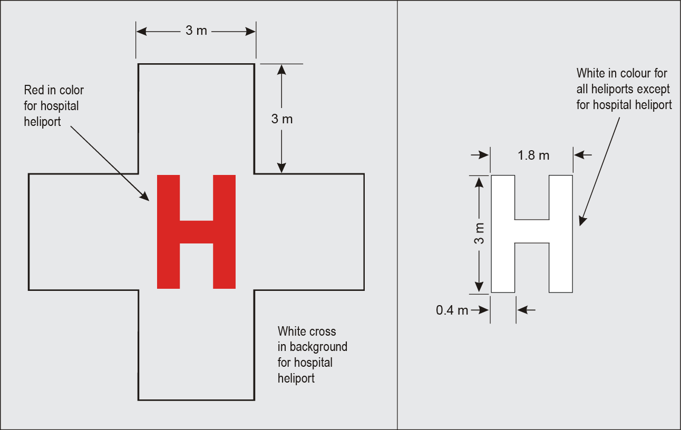

* Hospital heliport identification marking is a red H marking within a white cross. The H has dimensions of 3 metres by 1.8 metres by 0.4 metres; the white cross is a combination of five squares of 3 metres by 3 metres. The legs of the H are to be aligned with the primary flightpath direction to give enhanced visual guidance for an approaching helicopter.
* Touchdown positioning marking (TDPM) is a yellow circle with line width of 500 millimetres and an inner diameter equal to half the D-value of the design helicopter. Touching down with pilot seat on or inside the circle ensures clearance from obstacles and circular shape gives approach angle guidance.
* TLOF perimeter marking is applied to identify the boundary of the dynamic load-bearing area of the heliport designated for normal use. A TLOF perimeter marking shall be displayed on an elevated heliport noting that the TLOF and FATO are considered to be coincident. The TLOF perimeter marking shall be located along the perimeter edge of the TLOF and consist of a continuous white line with a width of at least 300 millimetres.
* FATO perimeter markings or markers shall be provided at a surface level heliport on the boundary edge of the FATO. For a paved FATO, the TLOF and FATO have the same dynamic load capability and the perimeter of the FATO and the TLOF can be considered coincident with the FATO perimeter marked in accordance with the TLOF perimeter marking criteria, provided the touchdown positioning marking is applied. For an unpaved FATO the perimeter shall be defined with flush in-ground markers. The FATO perimeter markers shall be 300 millimetres in width, 1500 millimetres in length, and with end-to-end spacing of not less than 1.5 metres and not more than 2 metres. The corners of a square or rectangular FATO shall be defined. FATO perimeter markings and flush in-ground markers shall be white.
* Aiming point marking is used where it is necessary for a pilot to make an approach to a point above a FATO before proceeding to a TLOF. Marking is a 9 metre by 9 metre triangle with stripe width of 1 metre. Configuration of aiming point marking is shown in Figure 3.
* Flightpath track alignment guidance (FTAG) arrow markings can be applied if considered beneficial after consultation with AV.
* Maximum mass and D-value markings are included in the ICAO heliport SARPS and recommended for inclusion at hospital heliports. This information is also provided to approved operators via the heliport operations manual. The use of 900 mm high characters with text based on ICAO Annex 14 font supplemented by AS1744 – medium D fonts have been successfully used on existing sites.
* Heliport name marking is considered optional however the AS1744 Medium D font with a 900 millimetre character height is recommended where the option is adopted.

Figure : FATO and aiming point marking requirements (not to scale)

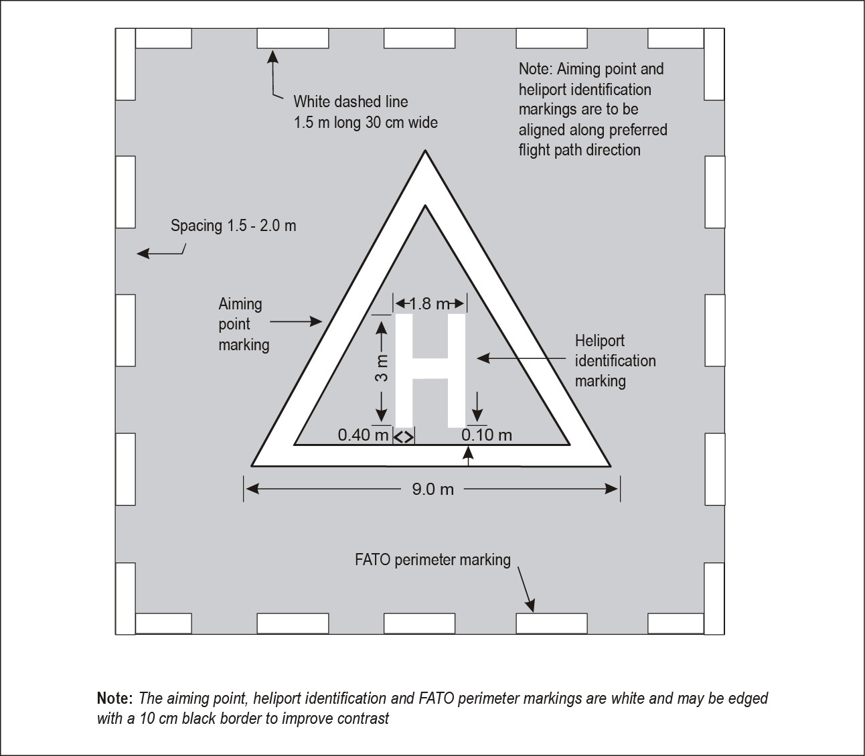

All markings should be painted against a contrasting colour background. Where the background colour is similar to the markings (for example white on concrete) a black border 50 to 100 millimetres wide can be used to provide contrast.

The form and proportions of at ICAO font library with a character height of 900 millimetres is shown in Figure 4 as a scaled version of ICAO Annex 14-II Figure 5.4. The form and proportions for the character D, based on the ICAO font is set out in Figure 5.

Figure : Form and proportion of numbers and letters for surface markings

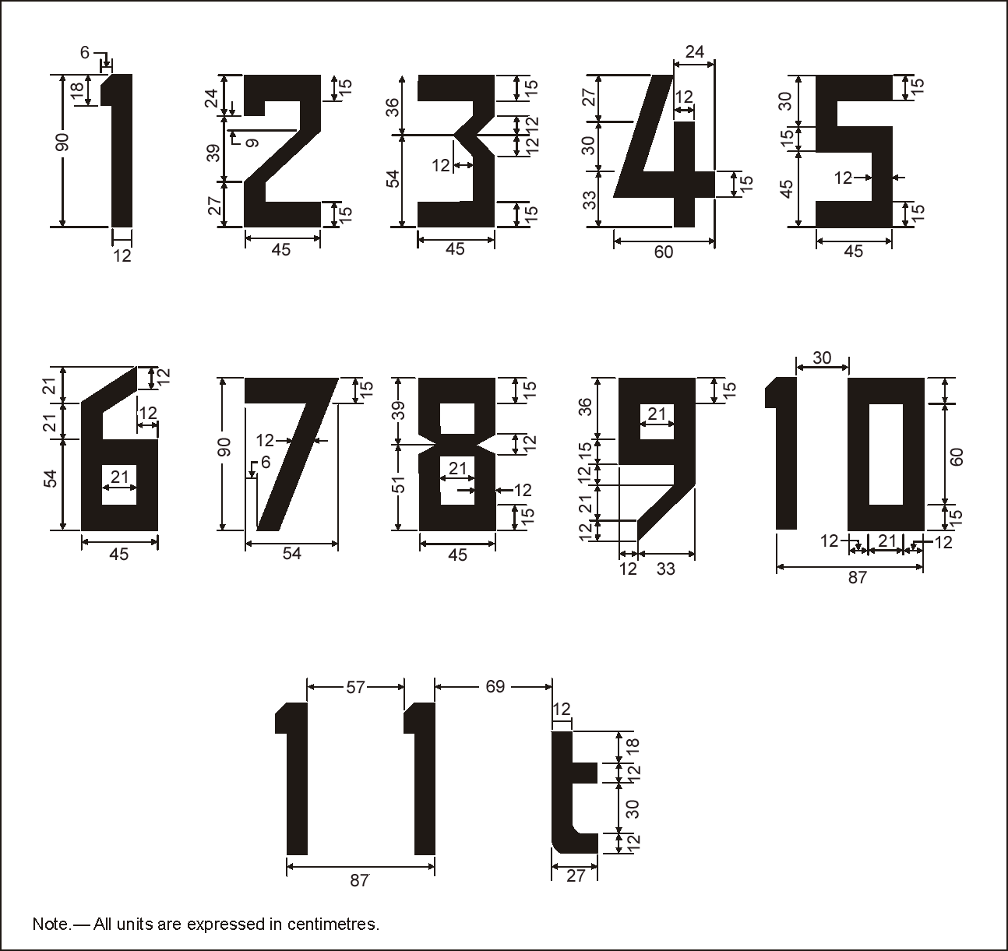

Source: ICAO Annex 14-II, Figure 5.4 - scaled for character height of 900mm.

**Note**: Dimensions shown in Figure 4 are based on a character height of 900 millimetres. Characters used for hospital helipads are 900 millimetres high. The set-out of the D character is shown in Figure 5 and the decimal point is a square of 150 millimetres by 150 millimetres for a 900 millimetres text height.

Figure : Form and proportion of ‘D’ character

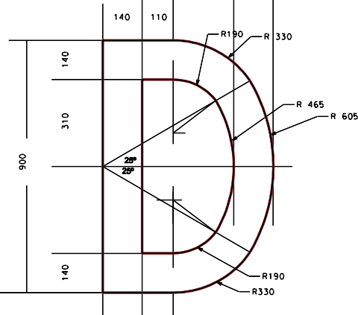

* 1. Lighting

Provide heliport lighting for night-time use of the heliport. Surface mounted and/or flush lights are superior to external elevated floodlighting options, however for low-use areas floodlighting may be acceptable. There are three types of light fitting in general use for hospital heliport lighting:

* Elevated fittings with a maximum height of 250 millimetres are suitable for use around the perimeter of the heliport outside the normal operational area.
* Inset fittings mounted flush or nearly flush with the surface are used within the operational area of the heliport. Both fittings are point light sources and located within fittings with a circular display.
* Linear light arrays are created by multiple LED lights positioned within a rectangular unit with the illuminated section being around 400 millimetres in length. The lights are inset in the pavement and aligned to be flush with the pavement level. The use of linear lights illuminates the touchdown positioning marking and the flight track alignment arrow markings as well as the TLOF boundary.

The TLOF boundary shall be illuminated by omnidirectional green perimeter lights at a spacing not exceeding 3 metres for elevated heliports and not more than 5 metres for surface-level heliports.

The FATO perimeter for a surface-level heliport should be illuminated by white omnidirectional lights, but these may be omitted where the TLOF and FATO boundary are nearly coincidental. Where the FATO and TLOF areas have similar surfaces and dynamic load capabilities, they can be considered nearly coincidental and the perimeter of the load bearing area should be illuminated with green TLOF lights.

Full details of the lighting set out arrangements and options are provided in Annex 14 Volume II.

Illumination of the touchdown positioning marking (TDPM) can be achieved with linear lights to give the appearance of a dashed line with sufficient light units to give a linear coverage greater than 25 per cent of the overall length of the marking to be illuminated.

Details of the illumination of the flightpath track alignment guidance (FTAG) markings are given in Annex 14 Volume II with five lights for each arrow marking.

Illumination of the heliport surface by low-level perimeter floodlights is an option aimed at removing the black-hole effect in the middle of the heliport operational area in the absence of lights inside the TLOF boundary. The presence of touchdown position marking and flightpath alignment markings lights is more effective than perimeter flood lights.

Figure : Effect of lighting with LED strip lights for the TLOF, TDPM and FTAG

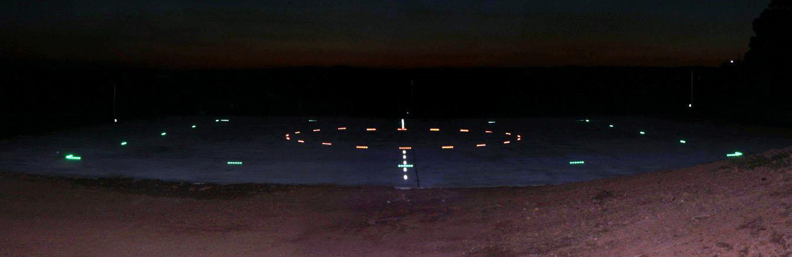

There is a preference to have pilot activated lighting (PAL) with manual backup and linked into the uninterrupted power supply system.

Where separate TLOF, FTAG and TDPM lights are installed, the system should include a separate dimming control for each circuit.

* 1. Wind indicator

An illuminated wind direction indicator (IWDI) needs to be provided at each heliport and located in a position to catch the prevailing wind as well as be visible from the helicopter and heliport.

The IWDI should be installed and provisioned to allow for ease of maintenance and replacement of the windsock or globes as they deteriorate over time.

The standard aerodrome IWDI has a 3.6 metre long windsock and is mounted on an 8 metre high pole. An alternate IWDI with a 2.4 metre windsock and a 5 metre pole height has recently become available with mains powered and solar powered options available. The smaller IWDI complies with the ICAO Annex 14-II SARPS for heliports. The lighting used for the mains powered IWDI should be compliant with the CASA MOS139 criteria for IWDI lighting.

* 1. Fire risk management

Fire risk management measures for the heliport are determined by the type of facility. Hospital staff who have operational access to the heliport are to be trained in the use of hand-held firefighting equipment and procedures for responding to a fire at the heliport. In general hospital heliports can be considered as normally unattended installations with reference to fire risk management.

Surface-level heliports should be provided with at least two 9 kilogram hand-held extinguishers of the dry chemicals type for Class A, B and E fires in accordance with the National Fire Protection Association standard for Heliports (NFPA 418-2011). It should be noted that the extinguisher ratings nominated in NFPA 418 refers to the North American ANSI/UL711 standard. The AS/NZS1850:2009 rating of 6A:120B:E for a 9 kilogram ABE extinguisher has an equivalent UL rating of 20A:120B:C which exceeds the NFPA requirements.

Elevated heliports need to consider the fire protection measures presented in the National Fire Protection Association standard for Heliports (NFPA 418-2011) in consultation with relevant fire authorities and specialist consultants.

A foam fire-extinguishing system is not required for elevated heliports located on open parking structures, or buildings that are not normally occupied. This includes heliports located on top of rooftop car parks.

Heliports on hospital rooftops require full protection measures in accordance with the NFPA 418- 2011 criteria.

The fire risk assessment, or strategy, of the building on which a heliport is located is to be undertaken on the basis that heliport is in operation. The detailed design of the fire risk management measures are to be approved by the relevant firefighting authorities.

* 1. Heliport design development overlays

There are provisions in the Victorian planning system for a design and development overlay (DDO) to be applied to the flightpaths of a helicopter medical transport heliport. The presence of a DDO requires local councils to formally refer development above a certain height within the flightpaths to the department as a referral authority. Local councils must follow advice from a referral authority when determining applications.

Once the detailed design of a heliport is approved, the department will commence the process for including a DDO for the flightpath within the local planning schemes. If the heliport is on the boundary of one or more councils, a DDO may need to be included in one or more local planning schemes.

DDOs are usually established through a planning scheme amendment (PSA) in conjunction with the local council and the Department of Environment, Land, Water and Planning (DELWP).

The cost for establishing a DDO within the relevant local planning schemes is to be included within the project cost.

1. Heliport management and operations

A helicopter medical transport heliport and associated flightpaths are hospital assets, and they need to be maintained and operated in a way that ensures continued safety and availability.

Details of the heliport facility and operating procedures need to be documented in a heliport operations manual, which is to be prepared by the health service in consultation with AV.

* 1. Management structure

The hospital will appoint a heliport manager to be responsible for the continuing safe operation and maintenance of the heliport and associated flightpaths. Management of the heliport is required regardless of whether the heliport is located on or off the hospital site. The heliport manager is to liaise with AV about the use and availability of the heliport.

The heliport manager is the contact person for the local council or, if the heliport is located offsite, the owner of the heliport and/or the property on which the heliport is located (for activities such as access and maintenance).

* 1. Heliport operations manual

The heliport operations manual should be established and maintained by the heliport manager in consultation with AV. The heliport operations manual needs to include the following topics:

* physical characteristics of heliport facility and flightpaths
* heliport aeronautical data
* normal operating procedures
* emergency procedures
* staff training programs for safe operations
* maintenance and inspection practices
* the use of the heliport by AV for patients not going through the health service operating the heliport
* ground ambulance operations with the heliport.

A particularly important part of normal operating procedures is the development of an effective communications protocol and the training of staff.

The manual is to be reviewed at least annually and is to include details of the following procedures and practices.

* + 1. Part 1: General information

Details of the distribution of the manual, the control and recording of amendments, contact names and numbers.

The manual is to include:

* general reference to the operation of the heliport and, if necessary, any disclaimers or restrictions relating to the availability or use of the heliport
* details of authorised users and procedures to follow when applying for permission to use.
  + 1. Part 2: Heliport and flightpath details

Operational details of the heliport including:

* location
* latitude and longitude including the WGS 84 grid
* description and dimensions of the facilities, markings, lighting, and wind indicator
* operational weight limits if applicable
* access and egress details under normal and emergency conditions
* operational restrictions such as use of search lights and ‘avoid’ areas
* communications frequencies
* adjacent airspace restrictions and preferred operating directions
* details of flightpaths and surveyed details of heliport and obstacles within flightpath obstacle accountability areas for all nominated flightpath tracks. Details to include locations in terms of WGS 84 coordinates and elevations above the Australian Height Datum. Results of detailed survey to be presented in tabular form as well as in plan and elevation, similar to a Type A chart as described in Section 7.2.1 of the CASA MOS Part139 with amendments to scale as appropriate. Details of obstacles surveyed needs to be presented with heights above the helipad elevation and heights above the obstacle limitation surface adopted for the helipad
* photographs of the heliport FATO and environs including the obstacle accountability area airspace for each nominated flightpath track are recommended to assist easy identification of obstacles and familiarity with the heliport and operational environment. Aerial photographs of the heliport and OAA are highly recommended for inclusion in the manual identifying the location of significant obstacles within the OAA.
  + 1. Part 3: Normal operating procedures

Normal operating procedures should be described and include consideration of:

* staff details and responsibilities
* procedures for notifying and responding to an arriving helicopter
* communications between hospital and helicopter and hospital and ambulance control, including radio operating procedures and phraseology
* heliport ground access control including inspection and securing heliport before helicopter arrives, procedures during start-up of the helicopter and inspection of heliport after departure
* records of heliport use including purpose, frequency and duration
* loading and unloading procedures, including safety of personnel and equipment within heliport boundary
* serviceability inspection of heliport including markings, wind indicators and lights and monitoring of any changes to the obstacle environment such as cranes erected without notice et cetera
* procedures for hot unloading (that is, with rotors turning) where permitted, noting that hot loading is not a normal procedure and may not always be permitted.
  + 1. Part 4: Emergency procedures

This section of the manual should document the following information:

* definition of emergency situations
* notification procedures in the event of an emergency
* response procedures in the event of an emergency
* rescue guidelines
* firefighting guidelines
* accident site security procedures
* heliport evacuation plans and routes
* coordination arrangements with other hospital emergency plans
* personnel accounting procedures
* emergency contacts list.
  + 1. Part 5: Personnel training

This section will cover details of the training programs for hospital staff who will or may access the heliport or work around helicopters in normal and emergency procedures including:

* safety around helicopters and the control of public in the vicinity
* safety briefings for hospital personnel
* procedures to review safety measures and practices
* training for new staff
* maintaining training standards for existing staff
* accreditation and/or registration of staff for heliport operations
* requirements for firefighting and evacuation drills for the hospital heliport.

Training options for hospital personnel should extend to include arrangements with AV for aircraft inspection and familiarisation either as a special event or when convenient in conjunction with a flight to the heliport. This can also be extended to firefighting procedures inspection and familiarisation with the local fire brigade.

* + 1. Part 6: Heliport maintenance

This section includes details of procedures and practices to ensure the continuing availability of the heliport, including:

* inspection and reporting procedures
* notification to AV in the event of the heliport not being available
* standard markings
* use and placement of non-serviceability markings
* details of suppliers for equipment and spares
* details of firefighting facility maintenance and serviceability checks
* details of annual surveys of flightpath airspace and the conduct of heliport condition reports.
  1. Heliport inspections

Heliports at hospitals should be inspected daily to ensure the facilities are operational and suitable for use by air ambulance helicopters.

Both onsite and offsite heliports need to be inspected before each helicopter landing to ensure the facility is available and ready for the inbound helicopter.

Inspections are to include but not be limited to access for hospital staff and road ambulance (if necessary), maintenance of firefighting equipment, surface markings, lighting, the wind indicator and any ancillary equipment installed.

Any interruption to the availability of the heliport needs to be notified in accordance with the procedures in the heliport operations manual.

When it is known in advance that works or events will affect the availability of the heliport, consider alternative arrangements that will minimise the effects on the heliport availability.

In the event that the heliport is not available for use, for example due to maintenance or obstacle intrusion into the operational airspace, the ‘closed’ state of the heliport should be indicated by use of unserviceability markers. Guidance on the physical characteristics of the marking is given in Section 4.19 of CAAP 92-4 which nominates a yellow cross 0.5 metre wide on a red 4 metre by 4 metre background that will cover the ‘H’ inside the touchdown position marking (TDPM). While not specified, the marking should be made of durable material that can withstand UV light exposure and be suitable for manual installation on the heliport surface. The unserviceability marker is to be fixed into position so it is not blown away. An example of the 3 metre by 3 metre unserviceability marking is shown in Figure 7.

Figure : Example of an unserviceability marking

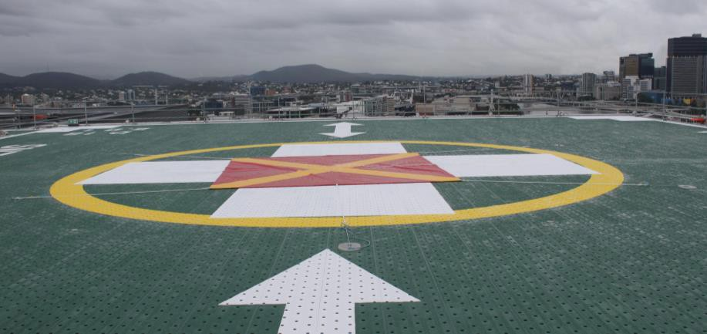

* 1. Biennial approach survey

A detailed survey should be undertaken biennially to monitor the presence of obstacles and identify changes such as tree growth within the flightpath envelopes.

The survey results should be presented in a suitable format and include details of the location and relative height of the obstacle. The report should be supplemented by photographs of the obstacles taken from the survey point on the heliport.

The results of the detailed survey should be recorded in the operations manual and compared with previous survey results. Any significant changes to the height of existing obstacles or the presence of new obstacles should be reported to AV and included as an amendment to the operations manual if necessary.

Measures should be taken to ensure that the OAA and flightpath envelope is not intruded on any further from the original assessment. For example, trees identified in the survey as intruding into the operational airspace should be pruned.

* 1. Conditions of use

Consider establishing and promulgating a conditions of use document for the heliport. The landowner of properties on which the heliport is located should address potential issues such as public liability, professional indemnity and access.

* 1. Ancillary equipment

Depending on the location of the heliport and its extent of use, supplementary equipment may be incorporated into new heliports, or retrofitted into existing heliports. This may include:

* remote access live site video
* satellite navigation-based instrument flight procedures for approach and departure phase of flight between heliport and en-route with lowest safest altitudes with consideration of OEI performance capabilities
* automated weather information systems.

# Appendix 1: Related guidelines and applicable standards

## List of related guidelines and applicable standards

* CAAP 92-2(2) Guidelines for the establishment and operation of onshore helicopter landing sites (1)
* CASA Notice of Proposed Rulemaking (NPRM 1304OS) Regulation of aeroplane and helicopter ‘ambulance function’ flights as air transport operations
* Civil Aviation Regulation 92 (CAR 92)
* Civil Aviation Safety Regulations 1998
* Civil Aviation Safety Regulations Australian air transport operations – rotorcraft
* Convention on International Civil Aviation (the Chicago Convention) Annex 6: Operation of aircraft – Part III: International operations – Helicopters [current 7th Ed, Amdt 17 – Nov 2012]
* Convention on International Civil Aviation (the Chicago Convention) Annex 14: Aerodromes – Volume II: Heliports [current 4th Edition – July 2013]
* ICAO Heliport Design Manual, Document 9261-AN/903
* National Fire Protection Association standard for Heliports, (NFPA 418-2011) US FAA Advisory Circular AC150/5390-2C *Heliport design*

## Application of Civil Aviation Regulation 92

The Civil Aviation Safety Authority does not currently have a legal instrument to certify or register HLS that are not an integral element of an aerodrome certified or registered under Part 139 of the Civil Aviation Safety Regulations 1998. The responsibility for determining the suitability of a place as a helicopter landing site is held under Civil Aviation Regulation 92 (CAR 92) by the pilot in command and in some circumstances, is shared with the aircraft operator.

CAR 92 prohibits the use of a place as an aerodrome unless the place is suitable for the intended aircraft operations and that having regard to all the circumstances of the proposed landing or take- off (including the prevailing weather conditions) the flight can be conducted in safety.

Consideration of the safety of flight includes consideration of Civil Aviation Order 95.7 (as amended). CAO95.7 exempts pilots of helicopter medical transport flights when operating in the vicinity of aerodromes (including hospital HLS) from the requirements of paragraph 157(1)(b) (low flying) and sub regulation 163 (1) (Operating near other aircraft) of the regulations.

The CAO 95.7 exemptions are subject to conditions including consideration the effect of rotorwash and design of hospital helipads requires consideration of the potential effect of rotorwash on aircraft, persons or adjacent objects including buildings.

## Application of the ICAO SARPs

The International Civil Aviation Organisation (ICAO) sets out international standards and recommended practices (SARPs) for the safe conduct of civil aviation activities in the Annexes to the Convention on International Civil Aviation (Chicago, 1944).

The following ICAO Annexes present the principal SARPS applicable to helicopter operations and heliports:

* Annex 6: Operation of aircraft – Part III: International operations – Helicopters [current 7th Ed, Amdt 17 - Nov 2012]
* Annex 14: Aerodromes – Volume II: Heliports [current 4th Edition - July 2013]

## ICAO Doc 8168 – Procedures for Air Navigation Services – Operations (PANS-OPS)

Amendment 6 (Nov 2014) to Volume I and II of Doc 8168: PANS-OPS includes provision for the development of Point in Space (PinS) approach and departure procedures featuring a visual segment between the HLS and the missed approach point and the initial departure fix.

Details of the design parameters for the PinS instrument flight procedures are outside the scope of these guidelines. The provisions of these guidelines are compatible however with the establishment of visual segments in support of PinS approach and departure procedures. The PANS-OPS provisions for PinS procedures are based on all engines operational and a speed of 93 kph (50 knots) or lower in the visual part of flight.

# Appendix 2: Glossary

The following information has been extracted from the relevant reference documents

## Abbreviations

| Abbreviation | Definition |
| --- | --- |
| AIP SUP | Aeronautical Information Publication Supplement |
| AS | Australian Standard |
| AV | Ambulance Victoria |
| CAAP | Civil Aviation Advisory Publication |
| CAR | Civil Aviation Regulation |
| CASA | Civil Aviation Safety Authority |
| CASR | Civil Aviation Safety Regulation |
| DH | Department of Health |
| FATO | Final approach and take-off area |
| HLS | Helicopter landing site |
| HMT | Helicopter medical transport |
| ICAO | International Civil Aviation Organisation |
| IWDI | Illuminated wind direction indicator |
| MOS | Manual of standards |
| NFPA | National Fire Protection Association |
| NPRM | Notice of Proposed Rule Making |
| OAA | Obstacle accountability area |
| OEI | One engine inoperative |
| PinS | Point in space |
| SARPS | Standards and recommended practices |
| SFLA | Suitable forced landing area |
| TDPM | Touchdown positioning marking |
| TLOF | Touchdown and lift-off area |
| VMC | Visual meteorological conditions |
| WGS84 | World Geodetic Survey 1984 |

## Definitions and other expressions

| Term | Definition |
| --- | --- |
| Approach and departure path | The track of a helicopter as it approaches or takes-off and departs from the final approach and take-off Area (FATO) of an HLS. |
| Back up distance | The horizontal distance from the start of the take-off to the TDP during a backup take-off procedure. |
| Balked landing distance | The horizontal distance from the LDP to the point at least 35 feet above the take-off surface where VBLSS and a positive rate of climb are attained following an engine failure before LDP. |
| Building | Any elevated structure on land. |
| Category A [CASR 133.360] | With respect to rotorcraft, means a multi-engine rotorcraft that is:   1. designed with engine and system isolation features specified for Category A requirements in Parts 27 and 29 of the FARs or EASA CS-27 and CS-29 and 2. capable of operations using take-off and landing data scheduled under a critical engine failure concept which assures adequate designated ground or water area and adequate performance capability for continued safe flight or safe rejected take-off in the event of engine failure. |
| Continued take-off distance | The horizontal distance from the start of the take-off procedure to a point at least 35 feet above the take-off surface where VTOSS and a positive rate of climb are attained following an engine failure at or after TDP. |
| CTO | Continued take off |
| D-value (d) | [CAAP 92-2(2)] the largest overall dimension of the helicopter when rotors are turning. This dimension will normally be measured from the most forward position of the main rotor tip path plane to the most rearward position of the tail rotor tip path plane (or the most rearward extension of the fuselage in the case of Fenestron or Notar tails). |
| Elevated HLS | References in the guidelines to elevated heliports relate in a physical sense to facilities that are located on a raised structure on land (Annex 14-II)  In an operational sense however, elevated HLS need to meet the dimensional criteria of ground level facilities as nominated in the relevant Category-A flight manual supplement for the design helicopter to ensure that the OEI fly-away profile remains above the elevation of the helipad.  It is assumed that the FATO and TLOF for elevated HLS are coincidental. (Annex 14-II) |
| Final approach and take-off area (FATO) [CAAP 92-2(2)] | In relation to an HLS, means an area of land or water over which the final phase of the approach to a hover or landing is completed and from which the take-off manoeuvre is commenced. |
| Final approach [CAAP 92-2(2)] | The reduction of height and airspeed to arrive over a predetermined point above the FATO of an HLS. |
| Helicopter landing site (HLS): [CAAP 92-2(2)] | An area of land or water, or an area on a structure on land, intended for use wholly or partly for the arrival or departure of   1. helicopters 2. a helideck or 3. a heliport. |
| Heliport [CAAP 92-2(2)] | An area that is:   1. intended for use wholly or partly for the arrival or departure of helicopters, on:    1. land or    2. a building or other raised structure on land; and 2. meets the heliport standards set out in Annex 14, Volume II to the Chicago Convention. |
| Landing decision point (LDP) | The last point in the approach landing path, from which it is possible either to land on a predetermined area of accomplish a balked landing. |
| Landing distance | The horizontal distance required to land and come to a complete stop from a point 50 feet ATS. |
| Lift-off [CAAP 92-2(2)] | In relation to a helicopter, means to raise the helicopter from a position of being in contact with the surface of the HLS into the air. |
| Movement | A touchdown or a lift-off of a helicopter at an HLS. |
| Obstacle accountability area [ICAO Annex 6-iii, CASR 133.450) | Defined region centred about the flightpath track centreline within which obstacles need to be accounted for when determining compliance with performance requirements. |
| Obstacle limitation surface | An inclined plane or combination of planes to identify the design height limits of obstacles within the obstacle accountability area |
| Operations in performance class 1 [ICAO Annex 6-iii] | In the take-off and initial climb phase, the helicopter shall be able, in the event of the failure of the critical engine being recognized at or before the take-off decision point, to discontinue the take-off and stop within the rejected take- off area available or, in the event of the failure of the critical engine being recognized at or after the take-off decision point, to continue the take-off, clearing all obstacles along the flight path by an adequate margin.  In the approach and landing phase and in the event of the failure of the critical engine being recognized at any point during the approach and landing phase, before the landing decision point, the helicopter shall, at the destination and at any alternate, after clearing all obstacles in the approach path, be able to land and stop within the landing distance available or to perform a balked landing and clear all obstacles in the flight path by an adequate margin. |
| Operations in performance class 2 [ICAO Annex 6-iii] | In the take-off and initial climb phase, the helicopter shall be able, in the event of the failure of the critical engine at any time after reaching the defined point after take-off (DPATO), to continue the take-off, clearing all obstacles along the flight path by an adequate margin. Before the DPATO, failure of the critical engine may cause the helicopter to force-land.  In the approach and landing phase and in the event of the failure of the critical engine before the defined point before landing (DPBL), the helicopter shall, at the destination and at any alternative, after clearing all obstacles in the approach path, be able either to land and stop within the landing distance available or to perform a balked landing and clear all obstacles in the flight path by an adequate margin |
| Operations in performance class 3 [ICAO Annex 6-iii] | At any point of the flight path, failure of an engine will cause the helicopter to force-land. |
| Path 1 | The segment between the end of the CTO distance (or BL distance) to a height of 200 feet ATS during an OEI 2.5 minute power climb at VTOSS (or VBLSS) and for a minimum ROC of 100 fpm. |
| Path 2 | The segment between 200 feet ATS and 1000 feet ATS during an OEI MCP power climb at VY and for a minimum ROC of 150 fpm. |
| Rejected take-off distance | The horizontal distance from the start of the take-off procedure to a point where the helicopter lands and stops safely following an engine failure prior to TDP. |
| RTO | Rejected take-off. |
| Safety area [CAAP 92-2(2)] | A defined area on a standard HLS surrounding the FATO, or other defined area, which is free of obstacles, other than those required for air navigation purposes, and intended to reduce the risk of damage to helicopters accidentally diverging from the FATO. |
| Suitable forced landing area | An area of land on which the rotorcraft could make a forced landing with a reasonable expectation that there would be no injuries to persons in the rotorcraft or on the ground. (CASR Part 133 Clause 133.016) |
| Surface level HLS | References in the guidelines to surface level heliports relate in a physical sense to facilities that are located on the ground at the same elevation as the surrounding surface (Annex 14-II). In an operational sense, the dimensions of the FATO need to meet the dimensional criteria of ground level facilities as nominated in the relevant Category-A flight manual supplement for the design helicopter. |
| Take-off [CAAP 92-2(2)] | In relation to a helicopter, means to accelerate into forward flight and commence climb at the relevant climb speed. Note: dependent on the take-off technique being used, the aircraft may be positioned using a vertical or a back-up profile prior to the forward acceleration segment. |
| Take-off decision point (TDP) | The first point in the take-off path from which as CTO capability is assured and the last point from which a RTO is assured, within the rejected take-off distance. |
| Take-off path | The path from the point of commencement of the take-off procedure to the point at which the helicopter is 1,000 feet ATS. This is composed of two segments, PATH 1 and PATH 2. |
| Take-off safety speed (VTOSS) or Balked landing safety speed (VBLSS) | The airspeed at which the scheduled climb gradient OEI can be achieved. |
| Touchdown [CAAP 92-2(2)] | Means lowering the helicopter from a flight phase not in contact with the surface of the HLS into a position which is in contact with the surface of the HLS for a landing. |
| Touchdown and lift-off area (TLOF) [CAAP 92-2(2)] | A defined area on an HLS in which a helicopter may touchdown or lift-off. |
| VBLSS | Balked landing safety speed |
| VTOSS | Take off safety speed |
| VY | Speed for best rate of climb |

# Appendix 3: Heliport approval process

Key:

* HDC: Helipad design committee
* SC: Steering committee
* PCG: Project control group

|  |  |  |  |  |
| --- | --- | --- | --- | --- |
| Stage | Project phase | Helipad approval phase | Approved by | Endorsed by |
| Planning | Master plan | Confirmation of helipad and need | HDC or SC | - |
| Planning | Feasibility study | Initial location on site and helipad capacity | HDC or PCG | AV |
| Delivery | Schematic design | Firm location, size and elevation of helipad | HDC or PCG | AV (if changed from FS) |
| Delivery | Design development | Detailed design and engineering services requirements | HDC or PCG | AV participates in user groups |
| Delivery | Documentation | Detailed design and engineering services requirements, operations manual draft | HDC or PCG | AV |
| Delivery | Tender evaluate award | - | - | - |
| Delivery | Construction | Inspection of HLS at practical completion. Final draft operations manual issued. | - | - |
| Delivery | Commissioning | Handover of helipad and final operations manual, which have been certified as fit for purpose by helipad design consultant | HDC, PCG or SC | AV inspection and agreement to use of helipad and operations manual |
| Operation | Operation | Continuous updating of operations manual | Agency | AV |

# Appendix 4: Physical characteristics of the design helicopter

## Overview

The overall dimension of the helicopter, the D-value, determines the dimensions of the heliport safety area and the obstacle accountability areas around each flightpath track. The heliport criteria as promulgated by the design helicopter manufacturers in the relevant Flight Manual Supplement for Category-A flight determines the size of the final approach and take-off (FATO) area.

The analysis undertaken of the range of medical transport helicopter types indicates that the size of the design helicopter FATO for Victoria is controlled by the Bell 412EP. The Bell 412EP has a rectangular area of 22.86 metres by 26.52 metres (75 feet by 87 feet) which for design purposes is rounded up to 23 metres by 27 metres for single flightpaths and 27 metres by 27 metres for perpendicular flightpath alignments.

Other helicopter types have smaller and in general circular FATO requirements, reflecting the increased power rating and capabilities of the current and projected future range of medium twin helicopter types.

The dimensions of the FATO for elevated and surface level HLS are to be selected based on the dimensional requirements for Category A ground level helipad operations to ensure the single engine fly-away profile does not descend below the elevation of the HLS. The fly-away profile presented in flight manual supplements for elevated heliports assumes a significant volume of obstacle free airspace exists below the elevation of the helipad which is not always the case for hospital helipads.

The generic design helicopter characteristics selected for the concept design of future heliports in Victoria has adopted a D-value of 18.5 metres to provide a contingency for the possible utilisation of larger helicopters in the longer term future within the design life of the healthcare facility. This contingency provision is particularly valuable when considering the development of rooftop facilities.

## Structural design characteristics for AB139 helicopter

The following information is presented as an indication of the loading and dimensional characteristics of the type of helicopters operated by AV. It is recommended that the design team confirms the details of the current fleet with AV prior to structural design of the heliport.

The information is extracted from a document produced by the Bell/Agusta Aerospace Company in 2004, *AB139* *helicopter ship deck operations,* which provides the maximum loads produced on ship decks during landing manoeuvres conducted with the AB139 helicopter.

The information presented relates to the Bell Agusta AB139 helicopter with a MTOW of 6400 kilograms. It is noted that the AB139 is the original variant and different to the current Agusta Westland AW139 with a MTOW of 6800 kilograms and as such is indicative only of the range of information used for structural design purposes.

* MTOW: Maximum Gross weight of the AB139 helicopter is 6,400 kilograms (14,100 lb).
* Landing Gear: The AB139 helicopter has a retractable type landing gear, comprising two identical single wheel main landing gear assemblies and a steerable tandem wheel nose landing gear assembly. The landing gear has the following dimensions: Track 3.04 metres and Wheelbase 4.34 metres.

The loads reported as follows refer to the helicopter at its standard and increased take-off weights in the AB139 medium CG configuration.

Table 3: Structural design characteristics for design helicopter

MTOW 6,000 kg or 13,227 lb

| Area | Loading | Contact area | Contact pressure |
| --- | --- | --- | --- |
| Nose Landing Gear | 2 x 652 kg  2 x 1437 lb | 21.0 in2  0.0135 m2 | 137 psi  9.45 bar |
| Main Landing Gear | 2 x 2348 kg  2 x 5177 lb | 43.4 in2  0.0280 m2 | 239 psi  16.5 bar |

MTOW 6,400 kg or 14,110 lb

| Area | Loading | Contact area | Contact pressure |
| --- | --- | --- | --- |
| Nose landing gear | 2 x 695 kg  2 x 1533 lb | 22.4 in2  0.0145 m2 | 137 psi  9.45 bar |
| Main landing gear | 2 x 2505 kg  2 x 5522 lb | 46.2 in2  0.0298 m2 | 239 psi  16.5 bar |

The following illustration shows the principal dimensions of the AB139 helicopter.

Figure : Dimensions of the AB139 helicopter

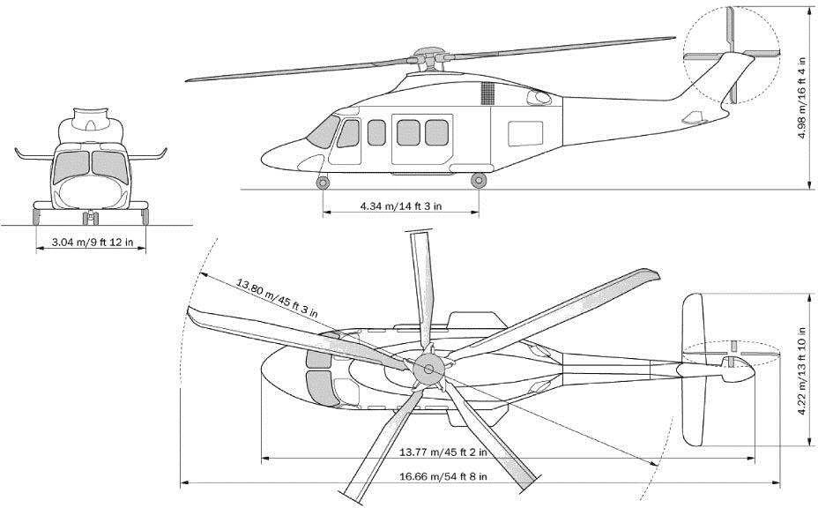

Source: [Heli Start’s AgustaWestland AW139 helicopter page](http://www.helistart.com/helicopters/AgustaWestland/AW139) <http://www.helistart.com/helicopters/AgustaWestland/AW139>

# Appendix 5: Image descriptions

## Figure 1: Layout of a generic heliport to meet design helicopter Category-A criteria (single flightpath track)

Illustration of a helicopter approaching a helipad, depicted as a red H on a white cross in a yellow circle (touchdown positioning circle), on a green square, which is on a tan square (safety area).Above and below the circle are double-headed arrows (flightpath alignment arrows).

### Generic HLS provisions

* Category-A helipad
* Single flightpath track
* Rotorcraft operating in Performance Class 1

### Helipad identification markings

* Red H on white cross
* Touchdown positioning circle

### Helipad markings

* FATO perimeter
* Flightpath alignment arrows
* Pilot reference lines
* D-value
* Maximum mass

### Obstacle accountability area (OAA)

* Inner edge: 37 m
* Lateral splay: 15 per cent
* Obstacle limitation surface within OAA
* Inner edge elevation to suit obstacle environment: 0% to 240m; 4.5% beyond 240m
* Nominal CTO segment: 240 m

### Safety area

* 37m x 37m

### FATO

* Single flightpath track: 23 m x 27 m
* Perpendicular flightpath tracks: 27 m x 27 m

### TLOF (within FATO)

* Surface level HLS: minimum 1xD
* Rooftop HLS: Coincident with FATO

## Figure 3: FOTA and aiming point marking requirements

A white H (heliport identification marking) within a triangle (aiming point marking), within a square with a white dashed line border (FATO perimeter marking).

Note:

* Aiming point and heliport identification markings are to be aligned along preferred flight path direction.
* The aiming point, heliport identification and FATO perimeter markings are white and ma be edged with a 10cm black border to improve contrast.

### Heliport identification marking (white H):

* 3 m x 1.8 m
* Width of H legs: 0.40 m
* Distance between bottom of H and aiming point marking stripe: 0.10 m

### Aiming point marking (triangle):

* 9 m x 9 m triangle with white stripe border
* Stripe width: 1 m

### FATO perimeter marking (square)

* White dashes:1.5 m long and 30 cm wide
* Spacing between dashes: 1.5 to 2.0 m

## Figure 4: Form and proportion of numbers an letters for surface markings

Source: ICAO Annex 14-II, Figure 5.4 – scaled for character height of 900 mm.

Numbers are made up of angular lines (horizontal, vertical and diagonal) rather than curved lines.

**Note:** All units are expressed in centimetres. Dimensions are expressed as ‘height x width’.

### Number 1

* Top of the character has a small serif with a bevelled edge
* Overall dimensions: 90 x 18
* Serif height: 18
* Bevel width: 6

### Number 2

* Small serif at top of the character
* Overall dimensions: 90 x 45
* Serif height: 24
* Top horizontal line dimensions: 15x 45
* Height of right-hand vertical line: 18
* Height of left-hand vertical line: 27 (this line is connected to the right-hand vertical line by a diagonal line)
* Bottom horizontal line: 15 x 45

### Number 3

* Overall dimensions: 90 x 45 (upper section 36 x 45; lower section 54 x 45)
* Top horizontal line dimensions: 15 x 45
* Upper vertical line height: 9
* Diagonal lines dimensions: 12 x 12
* Lower vertical line height: 27
* Bottom horizontal line dimensions: 15 x 45

### Number 4

* ‘Open’ 4 made up of three lines: one diagonal, one horizontal, one vertical. The vertical line bisects the horizontal line at 36 cm.
* Overall dimensions: 90 x 60
* Diagonal line: 27 cm higher than vertical line; overall dimensions are 72 x 36
* Vertical line: height is 66; starts 30 cm above the horizonal line; width is 12
* Horizontal line dimensions: 15 x 60.

### Number 5

* Overall dimensions: 90 x 45; height divided into three sections – 30 cm, 15cm and 45 cm
* Top horizontal line dimensions: 15 x 45
* Upper vertical line dimensions: 15 x 12
* Centre horizontal line dimensions: 15 x 45
* Lower vertical line dimensions: 30 x 12
* Bottom horizontal line dimensions: 15 x 45.

### Number 6

* Overall dimensions: 90 x 45
* Shape includes a diagonal line starting at the top and 33 cm into the width. This line meets the right-hand vertical line of the ‘6’
* Diagonal line dimensions: 36 x 21 with line width of 12
* Right-hand vertical line dimensions: 21 x 12
* Rectangle dimensions: 54 x 45; vertical lines have line widths of 12; centre rectangle has width of 21

### Number 7

* Horizontal top line and one diagonal line
* Overall dimensions: 60 x 54
* Top horizontal line dimensions: 15 x 54
* Diagonal line overall dimensions: 90 (including 15 height of top horizontal line) x 48)
* Diagonal line line width: 12

### Number 8

* Shape divided into upper section of 39 cm height and lower section of 51 cm height
* Overall dimensions: 9 x 45
* Top horizontal line: 15 x 45
* Vertical line widths: 12
* Distance between vertical lines: 21
* Diagonal line dimensions: 6 x 12 (combined height of 12)
* Bottom horizontal line: 15 x 45

### Number 9

* Shape is similar to an upside-down 6 (rectangle, small vertical line on right, diagonal line from right to left)
* Overall dimensions: 90 x 45
* Rectangle dimensions: 51 x 45; horizontal line width of 15 and vertical line width of 12
* Vertical line dimensions: 12 x 12
* Diagonal line dimensions: 33 x 33 with a line width of 12

### Number 10

* Distance between 1 and 0 is 30
* 0 is a rectangle with overall dimensions 90 x 54, horizontal line widths are 15 and vertical line widths are 12. Distance between the two vertical lines is 21
* Distance from the vertical line of the 1 to the end of the 0: 87

### Number 11

* Lowercase t is curved at the base (unlike the numbers previously described)
* Distance between outer edge of first 1’s vertical line and end of second 1: 87
* Distance between end of first 1 and beginning of second 1: 57
* Distance between end of second 1 and beginning of lowercase t: 69

### Lowercase t

* Overall dimensions of t: 72 x 27
* Vertical line dimensions: 72 x 12
* Upper horizontal line: begins 18 below top of vertical line; line width 12
* Slightly curved bottom horizontal line dimensions: 12 x 27 (distance between the two horizontal lines is 30)

## Figure 5: Form and proportion of ‘D’ character

* Outlined uppercase D (effectively an inner D and an outer D)
* Overall dimensions: 900 mm x 805 mm
* Height is divided into four sections: 140 mm, 310 mm, 310 mm and 140 mm
* Width is divided into four sections: 140 mm, 110 mm, 215 mm and 140 mm
* Line width: 140 mm
* Upper curve of inner D made of two arcs – first R 190; second R 465
* Lower curve of inner D made of two arcs – first R 465; second R 190
* Upper curve of outer D made up of two arcs – first R 330; second R 605
* Lower curve of outer D made up of two arcs – first R 605; second R 330
* Angle from height midpoint to upper curve of D: 25 degrees
* Angle from height midpoint to lower curve of D: 25 degrees

## Figure 8: Dimensions of the AB139 helicopter

The AB139 is a twin-engine helicopter with a five-blade main rotor and four-blade tail rotor.

* Overall length: 16.66 m or 54 ft 6 in
* Length: 13.77 m or 45 ft 2 in
* Height: 4.98 m or 16 ft 4 in
* Width: 2.08 m or 6 ft 10 in
* Width from wheel to wheel: 3.04 m or 9 ft 12 in
* Main rotor diameter: 13.80 m or 45 ft 3 in
* Tail rotor diameter: 2.68 m or 8 ft 8 in
* Tail width: 4.22 m or 13 ft 10 in



1. See the [Feasibility study page](http://www.capital.health.vic.gov.au/Planning_and_evaluation/Feasibility_study/) of the Capital Planning and Investment website <http://www.capital.health.vic.gov.au/Planning_and_evaluation/Feasibility_study>