|  |
| --- |
| 2023-24 Regional Health Infrastructure Fund  Frequently Asked Questions (FAQ) |

Contents

General 2

Eligibility 2

Project Types 3

Stream 1 Projects – Ready for Implementation 4

Stream 2 Projects - Previously Funded 4

Operational Funding 5

Further information 5

These Frequently Asked Questions relate to the Regional Health Infrastructure Fund (RHIF) 2023-24 round and should be read in conjunction with the RHIF 2023-24 Funding Guidelines available on the [Regional Health Infrastructure Fund page](https://www.vhba.vic.gov.au/health/regional-facilities/regional-health-infrastructure-fund) <https://www.vhba.vic.gov.au/health/regional-facilities/regional-health-infrastructure-fund>.

If you require further information or assistance in relation to the requirements of the RHIF 2023-24 please email [RHIF.Applications@health.vic.gov.au](mailto:RHIF.Applications@health.vic.gov.au).

# General

## When do submission open for RHIF 2023-24?

5:00pm, Monday July 17th 2023

## Is there an online webinar with further information?

Yes, the Victorian Health Building Authority (VHBA) will host an online briefing webinar for eligible Health Services / Agencies on 3rd August 2023, details will be provided in due course.

## When do submissions close for RHIF 2023-24?

5:00pm, Monday 11 September 2023 unless otherwise advised.

## How do I apply?

Submissions must be completed through the [SmartyGrants Portal.](https://dhhs.smartygrants.com.au/RHIF2023-24) https://dhhs.smartygrants.com.au/RHIF2023-24

The application form must be completed in its entirety. Further supporting information is to be provided as attachments. If the file size of the supporting documentation is over 25MB, please contact the RHIF team via the [RHIF.Applications@health.vic.gov.au](mailto:RHIF.Applications@health.vic.gov.au) to discuss how best to submit this additional information.

## Will hard copies be accepted?

No, all submissions must be submitted via the SmartyGrants portal.

## What is the minimum and maximum amount requestable per submission?

There is no minimum requirement and the maximum amount per submission is $10 million.

## What is the pool of funds available?

The Victorian Government announced funding of $300m over 4 years for the Regional Health Infrastructure Fund commencing 2022-23. This is the second year for this fund and RHIF 2023-24 is the second round from this fund.

# Eligibility

## My Health Service / Agency is not listed within the Funding Guidelines but believe it should be, can it be added?

If you believe that your Health Service /Agency should be listed as eligible, please send an email to [RHIF.Applications@health.vic.gov.au](mailto:RHIF.Applications@health.vic.gov.au)

## We have not applied for or received funding from previous RHIF rounds, are we still eligible?

Yes, the VHBA actively encourages all eligible Health Services / Agencies that have a compelling need for funding to submit an application.

# Project Types

## Will new building infrastructure be considered under the RHIF 2023-24?

Yes, provided other eligibility criteria are met then the submission will be evaluated for funding.

## Is master planning work eligible for funding?

No, under the Funding Guidelines master planning submissions will be deemed not eligible for evaluation and will be set-aside.

## Can I submit previously submitted projects that were not funded in previous RHIF rounds or other grant programs?

Yes, if you believe that your project demonstrates value against the key objectives of RHIF 2023-24, meets the eligibility and remains a priority for your Health Service / Agency. Any additional work or refinement of previously submitted projects is encouraged along with the submission.

## Can I apply for projects that may be eligible under other funding sources?

Yes. Health Services and Agencies can still apply but Health Services are required to identify in their applications that they have submitted proposals to other funding sources. Note that under the conditions of funding, funding is not available for projects previously funded or already approved for funding from another source.

## We currently have a project, funded through other sources, in progress, can we submit this for funding under RHIF 2023-24?

No, other than projects funded as a Stream 2 in RHIF 2022-23 there will be no evaluation of projects that have already commenced.

## Can we bundle multiple projects into a single submission?

No. Each project will require a separate submission. Health Services / agencies are required to rank the relative priority of each application on the second page of the application form. Bundled applications may not be considered.

If you are unsure on whether a submission would be considered bundled, please email [RHIF.Application@health.vic.gov.au](mailto:RHIF.Application@health.vic.gov.au) for guidance.

## When does my project need to be completed?

* Stream 1 projects need to be completed within 2 years of funding.
* Existing Stream 2 projects will be required to demonstrate adequate progress since previous funding rounds.
* VHBA expects that Stream 2 projects will continue to advance and complete two levels of design maturity in the first 9 – 12 months and achieve Stream 1 status.

Agencies successful in RHIF 2023-24 Stream 2 allocations are not guaranteed further project funding in successive funding applications.

Projects may not be funded in future rounds due to examples such as: scope creep, costs become prohibitive for RHIF to support, priority changes, strategic changes, other higher priorities have emerged, fund oversubscribed – and relevant assessments will be required to prioritise.

Specific timelines will be developed and proposed as part of any application. Applications should demonstrate the current status of planning and ‘readiness’, which will enable the project to meet the proposed timelines. Capital / construction projects will be formalised with a Project Agreement that includes milestones and payment schedules.

## Can funds be sought for projects to leased properties?

Projects that relate to capital works to property not owned or controlled by the Victorian Government will be considered. However, it is preferred that such property should not be mortgaged nor encumbered. In such circumstances the department will require a legally binding agreement with the mortgagee or charge of the property. Applications should clearly outline the lease term.

# Stream 1 Projects – Ready for Implementation

## A project meets most of the listed mandatory requirements, but work is underway on the other mandatory requirements, can we still submit this project?

No, to ensure fairness across the process only projects that meet the necessary mandatory requirements will be considered for evaluation purposes.

# Stream 2 Projects - Previously Funded

## We received Stream 2 funding in 2022-23 however the project has not progressed to a point that is ready for conversion to a Stream 1 project, should this still be submitted?

Stream 2 projects that are not ready to convert to Stream 1 will be required to provide an update on the project status including submission of all current documentation per the requirements as outlined in the guidelines.

If your currently funded project is no longer a priority, then this should be documented and the VHBA will review eligibility for ongoing funding.

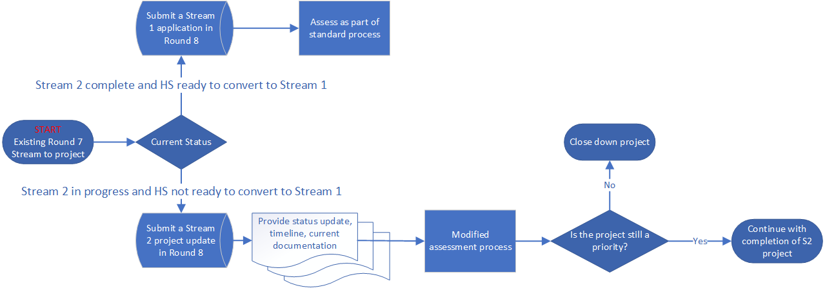

## We currently have two stream 2 projects that are not ready for conversion, however, will be in coming months and remain priorities. Is there an avenue for us to submit an additional project for consideration?

You are eligible to submit two new applications as part of the RHIF 23-24 application round.

Don’t forget to submit an update of your project status for any existing RHIF 22-23 Stream 2 projects. These need to be submitted as new application (refer question on page one of the application form) as part of the RHIF 23-24 application round.

## Is there guaranteed funding for Stream 2 projects that have been previously funded?

No, agencies successful in previous RHIF rounds for Stream 2 funding are not guaranteed further project funding in this, or successive round.

# Operational Funding

## Does the RHIF 2023-24 consider required uplift to operational funding to facilitate use of new infrastructure?

No, the funding under the RHIF 2023-24 is for capital improvement items only. Discussions should be had with Commissioning Systems and Improvement (CSI) prior to submission to ensure support for the project and potential operating funding uplift.

As outlined in the Funding Guidelines, all submissions require confirmation of operational funding uplift from your CSI representative prior to submission.

For Regional Aboriginal Community Controlled Health Organisations and organisations outside of CSI oversight, confirmation from their executive or board prior to submission will be required.

# Further information

## Can I make changes to my submission after it has been submitted?

If you need to alter your application after it has been submitted but before the application period closes, please contact us via RHIF.Applications@health.vic.gov.au. Once 2023-24 RHIF closes at 5.00pm Monday 11 September 2023, applications are unable to be altered.

## When will I know the outcome of my submission?

All applicants will receive written notification of the outcome of their submission following completion of the assessment process. It is expected that outcomes will be communicated by January 2024. Successful projects will be listed in due course on the Regional Health Infrastructure Fund webpage.

## Where can I get further information or assistance?

If you require further information or assistance in relation to the requirements of the 2023-24 RHIF please email RHIF.Applications@health.vic.gov.au.

Technical assistance regarding completion of the SmartyGrants online form can be obtained through reviewing the [SmartyGrants online guide](https://applicanthelp.smartygrants.com.au/help-guide-for-applicants/) <https://applicanthelp.smartygrants.com.au/help-guide-for-applicants/> or contacting SmartyGrants via [email](mailto:service@smartygrants.com.au) <service@smartygrants.com.au> or by calling (03) 9320 6888.

|  |
| --- |
| To receive this publication in an accessible format, email Regional Health Infrastructure Fund team at **<** RHIF.Applications@health.vic.gov.au >  Authorised and published by the Victorian Government, 1 Treasury Place, Melbourne.  © State of Victoria, Australia, Victorian Health Building Authority, July 2023.  Available at the [Regional Health Infrastructure Fund](https://www.vhba.vic.gov.au/health/regional-facilities/regional-health-infrastructure-fund) page on the Victorian Health Building Authority website <https://www.vhba.vic.gov.au/health/regional-facilities/regional-health-infrastructure-fund> |