|  |
| --- |
| HTA: Responding to flooding events - restoration for healthcare facilities  HTA-2024-002 |

To receive this publication in an accessible format, email the [Victorian Health Building Authority](mailto:vhba@health.vic.gov.au%3e) <vhba@health.vic.gov.au>

Authorised and published by the Victorian Government, 1 Treasury Place, Melbourne.

© State of Victoria, Australia, Victorian Health Building Authority, June 2025.

**ISBN** 978-0-7311-9362-2 **(pdf/online/MS word)**

Available on the Resources page of the [Victorian Health Building Authority website](https://www.vhba.vic.gov.au/resources/technical-guidelines) <https://www.vhba.vic.gov.au/resources/technical-guidelines>

Report number: HTA-2024-002

Report release date: 23rd October 2024

Contents

Executive summary 5

1. Introduction 6

1.1. Purpose 6

1.2. When to use this document 6

1.3. Remediation introduction and overview 6

2. Definitions 7

3. Initial impact assessment 10

3.1. Make safe 10

3.2. Remediation engagement 10

3.3. Qualified scientific consultant 10

3.4. Project manager 10

3.5. Expert panel 11

3.6. Response time 11

3.7. Initial assessment 12

3.8. Visual inspection 12

3.9. Moisture survey 12

3.10. Environmental conditions 13

3.11. Water classification 14

3.12. Identification of biological contaminates 14

3.13. Sampling 14

3.14. Pre-existing water ingress 16

4. Remediation 17

4.1. Introduction 17

4.2. Area isolation 17

4.3. Water removal 21

4.4. Area contents 22

4.5. Building structure 22

4.6. Building fixtures 22

4.7. Mould removal or disinfection cleaning 23

4.8. Heritage listed structures 25

4.9. Asbestos containing materials (ACM) 25

4.10. Heating, ventilation and air conditioning (HVAC) cleaning and recommissioning 25

4.11. Lift Shafts 26

4.12. Post-remediation verification 26

5. Contractor management 27

5.1. Health and safety 27

5.2. Personal protective equipment (PPE) 27

5.3. Donning and doffing 27

5.4. Thermal stress 27

5.5. Confined spaces 27

5.6. Contractor work clearance requirements 28

6. What is not covered by this document 29

7. References 30

Appendix A: Flowchart 31

Appendix B: Image descriptions 32

# Executive summary

This document offers specific guidance for restoration for healthcare facilities in response to flood or liquid escape incident (water ingress). It is intended to be used alongside *HTA-2024-001: Responding to flooding events - best practices* and the facility’s emergency response plan, providing instructions for hospital management and external contractors on conducting successful remediation within a healthcare setting.

The remediation process for water damage and potential microbial growth in healthcare facilities involves a comprehensive and systematic approach, spanning from initial assessment of biological contaminant identification to returning the building and its contents to its pre-event condition. Proper planning, sampling, stakeholder engagement, and expert oversight are essential for ensuring safety and successful mitigation of the damage.

1. Introduction
   1. Purpose

This document has been created to provide specific guidance on the best practices for healthcare facilities to undertake when responding to a flood or large escape of liquid event (henceforth referred to as water ingress). This document is to be used in conjunction with *HTA-2024-001: Responding to flooding events - best practices* and the facility’s internal emergency response plan. It is to be used to guide hospital management and external remediation contractors on how to conduct best practice remediation within a hospital setting.

In the event of water ingress, it is important for healthcare facilities to have a clear process to ensure a safe, effective and timely remediation. Also, one that minimises any impact to normal operations and reduces potential exposure risks to patients and hospital staff occupying the building. Healthcare settings create a number of complexities that are not otherwise encountered in more ‘standard’, residential, commercial or industrial settings.

* 1. When to use this document

If restoration services are required, this document is to be used.

* 1. Remediation introduction and overview

The goal of remediation is to return an internal environment to its pre-existing condition. In the hospital context, and assuming the facility had no pre-existing issues, this condition is one where patients can be safely treated in an environment free of potentially harmful pathogens.

Successful remediation involves not only the sterilisation, but also the physical removal of biological contamination. This is paramount in a healthcare setting as non-viable mould spores and fungal fragments may still pose a health risk via inhalation. Simply sterilising the environment is not enough to ensure the safety of staff and patients. As such, the removal of contaminated building materials, particularly porous ones such as plaster linings, carpet, and insulation, will be necessary for successful remediation in a healthcare setting.

A key goal of remediation is returning water impacted areas and building materials to an ‘acceptably dry’ state, otherwise known as a ‘dry standard’ in the shortest possible timeframe. The definition of ‘acceptably dry’ will depend on the specific building materials and their associated manufacturer’s guidelines. Especially in reducing moisture content to a level that no longer promotes the growth of pathogens.

Engineering controls incorporating physical containment barriers, air zone pressurisation and HVAC isolation, when done correctly, are the main prevention mechanisms, minimising the opportunity of microbial cross contamination to occur to adjoining areas and increase potential exposure risk to patients and staff.

1. Definitions

| Term | Definition |
| --- | --- |
| Aerosolisation | The production, disturbance or release of particles that are small and light enough to be carried on the air. |
| Air handling unit (AHU) | Collects outside air and room air, removes dust and other particles from the collected air, adjusts the temperature and humidity and then supplies air-conditioned air into the room through ducts. |
| Air filtration | Remediation strategy to remove or reduce the amount of airborne particulate or microbes. |
| Air sampling | The act of capturing particulate from the air, in this case fungal spores, for the purpose of quantification and identification. |
| ATP testing | A method of sampling for the presence of ATP (adenosine triphosphate) which is a chemical present in most living cells. |
| Categories of water | A four-level structure of water for the grading of contamination. |
| Condition 2 cleaning | Cleaning all surfaces within the remediation area utilising a procedure known as a ‘HEPA sandwich’. Involves HEPA vacuuming the surface, then wiping it with microfibre cloth and warm soapy water, before vacuuming again. |
| Confined space | A space that has limited or restricted means for entry or exit and is not designed for continuous occupancy. |
| Containment | An artificial barrier created to inhibit further contamination into otherwise unaffected areas. |
| Contamination | The introduction of an unwanted and possible hazardous substance into or onto a previously clean area. |
| Dehumidifier | Apparatus that takes moisture out of the air. |
| Dew point | The temperature the air needs to be cooled to (at constant pressure) in order to achieve a relative humidity of 100%. At this point the air cannot hold more water in its gaseous state. |
| Donning and doffing | The correct procedure for putting on and removing personal protective equipment. If carried out correctly, the wearer should, at no point, come in contact with any contaminants. |
| Dry standard | Returning water impacted areas and building materials to an ‘acceptably dry’ state. |
| Dwell time | Time spent in the same position or condition. In this case, the amount of time water has spent in a specific location. |
| Eight-fold technique | Similar to the four-fold technique, the eight-fold technique involves folding the cloth into eighths. This allows for even more clean sections to be used as you wipe, further minimising the potential for cross contamination. |
| Engineering controls | Control measure, physical in nature such as physical containment barriers, air zone pressurisation and HVAC isolation. |
| Escape of liquid | Categorised as internal water events and characterised by the volume and type of water that has escaped. |
| Experience | A proven track record of work undertaken in a particular field. |
| Flooding | Surface water rising from outside the building, which subsequently enters the internal spaces. |
| Four-Fold technique | In this technique, a cleaning cloth is folded into quarters. As you wipe a surface, you can unfold a clean section of the cloth for each new pass. This ensures that you’re consistently using a fresh part of the cloth, reducing the likelihood of transferring contaminants. |
| Hazard | A source or situation with the potential for harm in terms of human injury or ill-health, damage to property, damage to the environment, or a combination of these. |
| Heating, Ventilation and Air Conditioning (HVAC) | The system of plant, equipment and ducting used to control the temperature and air quality within an internal space. |
| HEPA filters | Apparatus that traps small, harmful particles, such as fungal spores, pollen, pet dander, smoke and dust mites by forcing air through a fine mesh. |
| Make safe | The process by which, following a major water ingress event, that the building, its structural materials and associated contents can be removed or stabilised in order that evaluation and remediation works can be arranged and undertaken safely. |
| Non-viable mould | A spore which is not capable of germinating and therefore reproducing, even if it exists in suitable conditions. |
| Non-viable sampling (Total count) | The collection of fungal particulate, be it from air or surface, be it viable or non-viable, for the purpose of quantification and identification. |
| Passive air sampling | The collection of microbial particulate from the air without the aid of a mechanical device. |
| Pathogens | An organism that can cause disease. |
| Personal protective equipment (PPE) | A range of clothing and equipment specifically designed to protect the wearer from a range of different hazards. |
| Post remediation verification (PRV) | An assessment conducted by an independent qualified scientific consultant (QSC) to assess the work conducted by the restoration contractor. |
| Pressurisation | Creating an air pressure differential between two spaces. |
| Qualified scientific consultant (QSC) | A scientific consultant or occupational hygienist who is experienced with an Australian Qualifications Framework (AQF) Level 7 or higher qualification in a relevant science field with a solid foundation on control strategies, including hazard elimination, engineering modifications, administrative controls and personal protective equipment. |
| Regular disposal of microfibre wipes | Microfibre wipes are often used for cleaning due to their effectiveness in trapping dirt and dust. However, they can also become saturated with contaminants after use. Regularly disposing of these wipes after use prevents the buildup of dirt and reduces the risk of spreading contaminants to other surfaces. |
| Relative humidity | Expressed as a percent, Relative humidity is the ratio of atmospheric moisture relative to the quantity present in saturated air. |
| Relevant science field | Scientific discipline relevant to the nature of the project. |
| Remediate | Return an internal environment to its pre-existing condition. |
| Specific humidity | The weight (quantity) of water vapour contained in a unit weight (quantity) of air, expressed as grams of water vapour per kilogram of air. |
| Surface sampling | The collection of biological particulate, be it viable or non-viable, from a surface. Typically, this is taken from a discrete location. |
| Thermal stress | Adverse health effects caused by the prolonged exposure to heat. |
| Three-Bucket system | This system utilises three buckets for three distinct purposes. The first for rinsing, second for washing with a cleaning solution, and the third for a final rinse. A cleaning cloth moves sequentially through these buckets, with the initial rinsing removing larger particles, the second bucket addressing dirt with cleaning solution, and the final rinse removing any remaining residue. This system achieves effective cleaning, especially in situations where machine laundering may not be feasible. |
| Water ingress | The potentially damaging introduction of water to the built environment. This can come in the form of large scale external flooding or a smaller scale pipe burst. |
| Wicking | The tendency of a liquid to travel through a material, regardless of, and sometimes in opposition to, external forces such as gravity. |
| Viable mould | A spore which is capable of germinating and therefore reproducing if it exists in suitable conditions. |
| Viable sampling, active | The collection of microbial particulate, via the use of a mechanical device, for the purposes of culturing, and thereby quantification and identification. |
| Viable sampling, passive | The collection of microbial particulate, without the aid of a mechanical device, for the purpose of culturing, and thereby qualification and identification. |

1. Initial impact assessment
   1. Make safe

The initial phase of the remediation process involves conducting a comprehensive assessment of the impacted areas. This assessment aims to ascertain the extent of the damage and the effects of the incident. This evaluation is crucial in determining the necessary actions for effective remediation.

However, before this assessment can begin, it is of the utmost importance to establish a safe environment into which contractors may enter. Although emergency services typically handle this task, there might be instances where the involvement of specialised professionals such as plumbers, electricians, or other trade experts become necessary. Their role is to guarantee the safety of the area for subsequent work. Various potential hazards must be evaluated and addressed to ensure a secure working environment. These hazards could encompass risks related to electrical systems (such as the possibility of electrocution), structural stability (including dangers from falling debris or precarious structures), and even inhalation hazards (like the risk of asphyxiation).

* 1. Remediation engagement

After the occurrence of water ingress, it becomes essential to enlist the services of an independent contractor who possesses the necessary qualifications and experience to carry out the required remedial actions. In the specific context of conducting remediation within a hospital setting, a contractor must meet the subsequent criteria:

1. Demonstrates adequate training, knowledge, and practical experience in executing tasks related to mould and water damage remediation;
2. Can proficiently assess the associated risks and establish appropriate control measures throughout the course of the remediation process; and
3. Possesses a comprehensive understanding of commercial building and construction practices, enabling an accurate assessment of the impact of water ingress on a building.

At the present time, Australia does not currently have nationally recognised qualifications for contractors engaged in remediation work. However, it is advisable for remediation technicians to have, at the very least, successfully completed the IICRC accreditations for Water Damage Restoration Technician (WRT) and the Applied Microbial Remediation Technician (AMRT) training courses. These courses are developed by the Institute of Inspection Cleaning and Restoration Certification (IICRC) and are delivered by independent training organisations across Australia. They align with the S500 Standard for Professional Water Damage Restoration and the S520 Standard for Professional Mold Remediation.

A Hospital must establish a contractual arrangement with at least one qualified, skilled, and experienced remediation subcontractor. This practice ensures prompt engagement during emergencies and minimises unnecessary administrative delays

* 1. Qualified scientific consultant

To counteract potential conflicts of interest or biases arising from the involvement of the remediation contractor, it is advisable to engage a qualified scientific consultant (QSC) with the requisite qualifications, expertise, and experience. This expert plays a pivotal role in delineating the boundaries of contamination, outlining the scope of works, and specifying the anticipated outcomes. In instances of unexpected complexities during the remediation process, the QSC will be able to offer guidance and support.

* 1. Project manager

Maintaining effective communication among all involved parties is imperative to ensure the remediation process progresses efficiently and within the designated timeframe. To facilitate seamless communication, the facility should designate an internal project manager.

The role of the project manager can be filled by a member of the management team, the facilities manager, or, in cases where internal resources are lacking, an external service provider can be engaged.

The responsibilities of the project manager encompass crucial aspects of the remediation process:

* Ensuring subcontractors adhere to stipulated schedules and budgets;
* Assessing and endorsing any alterations to the project scope, with approval obtained from pertinent internal stakeholders;
* Coordinating access to premises and essential services;
* Conducting reviews to manage and mitigate risks; and
* Conveying progress reports and outcomes to the relevant stakeholders.
  1. Expert panel

To support the prompt initiation of remediation activities and the engagement of proficient professionals, it is advisable for a facility to establish a pre-screened panel of remediation subcontractor experts, all of whom are under contract.

By pre-vetting and enlisting remediation contractors ahead of any water-related emergencies, the facility ensures their independence, impartiality, and lack of bias in decision-making during the remediation process. Furthermore, depending on the incident, specialist contractors may be in high demand locally, therefore quick access to a range of contractors is essential.

Maintaining a diverse pool of contractors offers the advantage of having at least one available contractor capable of responding swiftly when required. An adept panel for addressing water ingress should ideally comprise the following specialists:

* Remediator;
* QSC (Qualified Scientific Consultant or Occupational Hygienist);
* Builder;
* Plumber;
* Electrician; and
* HVAC specialist.
  1. Response time

Time holds significant importance following an episode of water ingress. The swiftness with which water ingress is addressed, or left unattended, can considerably impact the duration, cost, and severity of necessary remediation efforts.

The primary rationale for expedited action lies in the potential proliferation of fungal growth. In a healthcare environment, fungal growth is generally absent prior to water ingress. However, within as little as 48 hours after such an event, visible fungal growth may emerge. Consequently, the extraction of water and the swift drying of building materials within the initial 48 hour window become imperative. This urgency is not only to thwart the growth of fungi but also to prevent the dispersion of contaminants to unaffected areas. Once the 48 hour mark has passed, it should be assumed that fungal growth is present.

Time also influences the water’s Category classification. With the passage of time, Category 1 water (sourced from sanitary outlets) can degrade into Category 2 or 3 water, depending on its interaction with materials. This transformation is particularly likely if water lingers within non-inhabited sections of the building envelope, such as wall or ceiling cavities, or within lift shafts.

Under specific circumstances, especially subsequent to substantial water ingress events like floods, immediate water removal within the initial 48 hours might not be feasible. In such scenarios, it is reasonable to assume that the affected area will have already been contaminated by fungal growth.

* 1. Initial assessment

The initial assessment, typically overseen by a qualified scientific consultant (QSC), forms the basis for determining the necessary remediation actions (scope of works).

At a minimum, the initial assessment must involve gathering contextual data, conducting a visual inspection, and performing a moisture survey:

* **Contextual data**: This includes information about the impacted and suspected areas, the intended use of rooms or areas, and historical details like past renovations or incidents.
* **Visual inspection**: Initially, a visual examination of affected spaces is sufficient for delineating water ingress boundaries. This involves identifying signs of standing water, water staining, and indicators such as tide lines or debris accumulation. Given that porous building materials can absorb water, potentially wicking vertically, it is advisable for the remediation boundary to extend beyond visible evidence until moisture testing confirms the extent.
* **Moisture survey**: This includes the collection and recording of moisture content levels to buildings materials during a water ingress event. This allows for accurately delineating water ingress boundaries for the development of a scope of works.
  1. Visual inspection

Utilising a bright flashlight, even in well-lit environments, aids in distinguishing affected from unaffected materials. This can involve shining the light parallel to the surface while viewing it perpendicularly. This technique assists in identifying water-impacted (swollen) building materials and suspected microbial growth.

In situations where visual cues are inadequate, it may be beneficial to conduct a survey of any eyewitnesses (such as staff) or consult CCTV footage if available.

A floor plan illustrating affected areas, often obtained from the facilities manager, should be prepared.

In addition to visual observations, a thermal imaging camera can provide supplementary insights for guiding moisture sampling locations. Although it does not directly detect water, the camera identifies temperature variations.

Thorough documentation, including written notes and photographs, is essential. This encompasses both broad overview photos of affected zones and close-ups highlighting impacted, damaged areas, items, or pertinent specifics.

* 1. Moisture survey

Initial moisture measurements should be documented either in writing or through photos. Each entry should encompass the moisture meter used, the moisture content reading, the moisture scale applied, detailed location description, material particulars, material depth if relevant and the date and time of measurement.

Data can be logged digitally through photos, specialised mobile apps, or by manual notation.

Ensuring the technique and location employed for moisture assessments on each material is documented, especially for materials with low permeance, is vital. This practice guarantees a consistent and systematic approach to each moisture assessment, enabling accurate ongoing monitoring of the equivalent moisture content of the material.

This methodical approach also facilitates the documentation of drying rates over time.

**Table 1** details the specific information that should be recorded for each reading.

Table 1: Moisture level assessment data

| Location | Moisture Content | Material | Time | Date |
| --- | --- | --- | --- | --- |
| Patient room 34 – West wall – 600mm from floor height | 1.2% | Plaster board | 10:03 am | 01/01/2023 |
| Basement – North wall base plate adjacent generator | 42.3% | Timber | 10:06 am | 01/01/2023 |

Moisture readings should be included in the initial assessment report, outlining the scope of the damage. Additionally, it is valuable to visually represent moisture readings on a floor plan (**Figure 1**) to visually.

Figure 1: Moisture readings shown on a floor plan

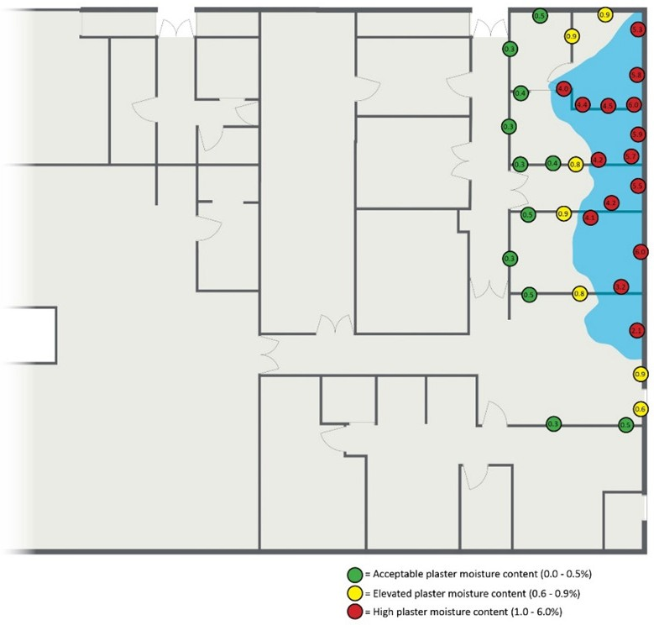

* 1. Environmental conditions

Following water ingress into a building envelope and subsequent evaporation of standing water, the moisture content of the internal air environment will increase resulting in elevated humidity levels. Therefore, it is important to monitor the temperature and humidity levels of the internal air environment and adjacent areas for the duration of the remediation project.

This increased available moisture content in conjunction with organic nutrient sources has the potential to create an indoor environment supportive of microbial growth. Air measurements should be recorded in a similar fashion to that described in **Moisture survey**, which will assist proactive management of drying works by the remediation contractor, with the aim to return the internal environment to sub 60% relative humidity (typically suggested by VHHSBA *Engineering guidelines for healthcare facilities*).

* 1. Water classification

Water classification should have been approximated during the internal response outlined in *HTA-2024-001: Responding to flooding events - best practices.* At this point in the assessment process, it is important to define the category of water in order to make informed decisions for the required remediation strategies (Scope of Works).

If, based on its source, the water has been classified as Category 3, such as sewage water or flood water, then there is no need to carry out testing to confirm the Water Category. If the water is suspected to be either Category 1 or 2, it is recommended that water testing be done to ensure that the water (Category 1) does not pose a risk if ingested or contain other contaminants that may potentially pose a health risk (Category 2).

As the category of water can change based on the progression of time, it is important to test the water periodically throughout the remediation process, particularly if it is suspected that the Category of water has changed.

In smaller, and often unclear, instances of water ingress, such as Category 1 and Category 2, it can be prudent to undertake confirmation sampling to identify water classification. For example, if a toilet is blocked, the toilet cistern is malfunctioning and keeps running, technically the source was a toilet, but the water will be so heavily diluted with potable water it is worth sampling to verify whether it is actually Category 3.

Another common situation involves ground water entry, where the primary route would have travelled from an outdoor area that was primarily a hard surface, such as concrete or pavers.

The intention of this check is to minimise the interruption to the hospital whilst still addressing the risk to the appropriate standard of care.

Hazardous materials may also be present within water, for example, the backflow from waste pipe designed to remove radioactive or cytotoxic waste from the hospital. Radioactive waste cleanup and disposal should occur in compliance with Victorian Radiation Act 2005 and the Department of Health disposal of radioactive material guidance, and is not specifically covered by this document.

* 1. Identification of biological contaminates

In the initial assessment phase, it is necessary to perform appropriate sampling to detect any biological contamination, especially pathogenic organisms that might be present. Since sampling can be both time- consuming and expensive, it is crucial to develop a sampling strategy, which includes data on moisture, temperature, and humidity, based on the results of the initial assessment. This strategy should adopt a risk-based approach and be designed to address a specific question. This question might be as broad as ‘Are there mould spores in the air?’ or more specific, like ‘Does this medical device have E. coli?’

Various sampling techniques are available for identifying and quantifying biological contamination. These techniques yield different levels of information. To comprehensively address biological contamination questions during an assessment, a combination of viable and non-viable sampling methods is likely needed. The advantages and disadvantages of these sampling techniques are detailed in **Sampling**. All collected samples must be clearly marked and transported following a chain of custody (COC) to a laboratory accredited by the National Association of Testing Authorities (NATA) for thorough analysis.

* 1. Sampling
     1. Air sampling

Air sampling can be utilised to confirm the presence or absence of biological particulate within the air. Air sampling involves the collection of a known volume of air onto a sample media where it can either be directly analysed, or organisms can be cultured (grown) or analysed for the genetic information.

* + - 1. Viable sampling

Viable air samples can be collected using either active or passive methods. Active air sampling for viable organisms is undertaken with a mechanical device designed to actively draw air into a sampler. Where air is aspirated through a perforated lid and impacted onto the surface of a specific growth media. The growth media is then sent to a laboratory for incubation. Incubation times and temperatures will depend on the growth media and target organisms.

Alternatively, passive air sampling utilises culture plates that involve exposing growth media to the surrounding air to passively collect airborne microorganisms. The growth media is then also incubated as the above.

While passive sampling is both cost effective and easy to undertake, it provides limited data, lengthier sample collection times, and may not be effective for certain airborne microorganisms, which remain suspended in the air for long periods. It also cannot provide an airborne concentration as the volume of air passing across the media plate is unknown.

Active air sampling is recommended as the gold standard within a healthcare environment, as infection from pathogenic microorganisms is of greatest concern to the occupants of a hospital.

Although it should be noted that viable sampling is a subset of all airborne microbial particulate, as non- viable biological particles are not detected, but can still present a health hazard.

* + - 1. Total count sampling (Including viable and non-viable)

Total count samples include both viable and non-viable fungal particulate. This non-discriminatory sampling method can provide a broad range of information about what is present in the air but is typically unable to identify microorganisms to a species level.

Similar to viable air sampling, non-viable air sampling uses a mechanical device designed to actively draw air through a sample cassette. Typically, these cassettes will have a microscope slide and a layer of gel. Air is drawn through the cassette (typically at a lower flow rate, for example 15 L/min) whereby any particles within a certain size or mass range are impacted into the gel. The cassette is then sent to a laboratory where direct microscopy techniques are utilised to count and identify particles present in the gel.

This sampling technique is most useful for identifying airborne fungal particulate, as both bacteria and viruses are typically too small to be identified via microscopy.

In most instances a combination of both viable and non-viable active air sampling will be utilised to effectively characterise the make up of present air.

Air samples should be taken in each affected air space and unaffected air spaces for potential comparison. Sampling should be undertaken in both habitable, and where possible, non-habitable areas. Examples of habitable spaces include, individual rooms, anterooms, bathrooms, hallways and open spaces. Examples of non-habitable spaces include wall cavities and lift shafts.

* + 1. Surface sampling

Surface sampling for biological particulate includes the collection of particulate present on the surface of building materials or items. This particulate may be settled dust, where the contents of the dust is unknown but is suspected of containing biological contamination. Alternatively, the particulate may be actively growing contamination (such as mould or bacteria) where confirmation, or identification is required.

Similarly with air sampling, there are different types of surface samples, each has pros and cons.

* + - 1. Viable sampling

Viable sampling is performed to identify specific species of bacteria or mould that may be present on a surface. Typically, it is done using a sterile swab, or less typically with a media press plate. A swab is rubbed along a surface, typically in a given area such as 100 cm2, placed into transport media, and sent to the laboratory for culturing and identification. While viable sampling is able to accurately identify which organisms are present, it is time consuming as organisms need to physically grow before they can be identified.

* + - 1. Non-viable sampling

Non-viable sampling looks at all particulate present on a surface that is recoverable by the surface sample, including active microbial growth. Typically, non-viable sampling media has an adhesive area which is pressed on the surface of interest. Any particles present on the surface adhere to the sticky surface. The sample is then transported to a laboratory for analysis by direct microscopy. This sampling is most suited for identifying fungal growth, or settled fungal particulate, and generally not used for identifying to species level, or for identifying bacteria.

* + 1. ATP testing

ATP (adenosine triphosphate) is a molecule used for energy storage in almost all living cells. Therefore, testing for ATP can give an indication of the cleanliness of a surface, based on biological contamination. This testing may already be carried out in a healthcare setting as part of routine infection control measures; however, it does have limitations when utilised in the context of remediation. For example, ATP testing was designed to be undertaken on smooth, non-porous surfaces, as such the testing of plaster, timber or concrete is not advised. Additionally, due to the hard cell walls of fungal spores, ATP testing can give false negatives when fungal spores are present. Therefore, ATP testing is not recommended during the initial assessment stage, however it may have its place in post-remediation verification (PRV) testing for specific material or surface types.

* 1. Pre-existing water ingress

In the initial assessment phase, it is important to identify and document any pre-existing water ingress or structural damage issues that may be present. Whilst unlikely, there may be areas of pre-existing water damage hidden within cavities that could be revealed once remediation works begin. Pre-existing damages should always be addressed once they are identified and exposed as it will always be the most opportune time to rectify any issues. The extent and severity of pre-existing damages should be documented and communicated to the project manager so repairs can be allowed for in the scope of works.

1. Remediation
   1. Introduction

Remediation tasks may present complexity and demand a significant investment of time; however, when executed properly, they ensure that future inhabitants of the space do not suffer negative effects. To attain the goals of restoration, it is generally necessary that the works be conducted in the sequence listed in this section.

As mentioned in *HTA-2024-001: Responding to flooding events - best practices*, at this stage in the process the appropriate level of PPE should have been determined and donned before completing any of the following works.

Before initiating the works detailed in this section, a staging zone must be designated, situated at a junction where the unaffected area adjoins the affected area. This staging zone is to be used for the remediator to start preparing their equipment and tools, prior to entering the affected area. This staging zone will generally become a part of the Buffer zone, also mentioned in this section, and is to be used as part of an entry-exit chamber. On occasion, the construction of this chamber may not be feasible or safe until certain initial steps have been completed.

* 1. Area isolation

Isolating affected areas is one of, if not, the most important step of the remediation process. The primary objectives of containment and isolation measures is to minimise the opportunity for cross- contamination of moisture and microbial contaminants in water damaged areas to impact non-affected areas of the building envelope, thereby reducing potential exposure risks and adverse health effects to immunocompromised patients and staff.

* + 1. Containment

Physical containment barriers, typically heavy, plastic, flame-retardant, polyethylene sheeting, with a minimum thickness of 200µm, are the primary tools used to isolate an area prior to undertaking any remediation activities. Containment barriers may be fitted to doorways, or temporary wall framing may need to be constructed from timber or other temporary structures. It is advised that these containment barriers are made as airtight as possible, with tape covering any perforations. Access to the remediation area should be via adhesive zips, attached to the containment barriers, with loose ‘curtains’ of plastic on either side of the ingress point. Passage should be closely controlled, with zips immediately closed once ingress or egress has occurred. Consideration should be given to the pressurisation of the containments to ensure seals are maintained and airborne contamination, including odours, are not being spread to unaffected areas. More information about pressurisation can be found in **Pressurisation**.

In the case of residential or commercial buildings, a single set of physical containment barriers are typically sufficient. However, in a healthcare setting, where the potential for severely compromised individuals may be present in adjacent areas, it is advised that a two-stage physical containment set up be installed where possible. **Figure 2** illustrates this method. Denoted in pink, the primary containment barrier must, at minimum, encompass the areas physically affected by water ingress. This zone is where all removal, drying, and cleaning activities are needed. A buffer zone, illustrated in green, is enclosed on one side by the primary containment barrier and the secondary containment barrier on the other. This zone will still require ongoing cleaning works, but should not require any removal or drying works. If contamination is identified on building materials in the buffer zone, a new buffer zone must surround it, and the newly discovered contaminated area be incorporated into the remediation zone.

Figure 2: Example of a water ingress and relevant recommended locations

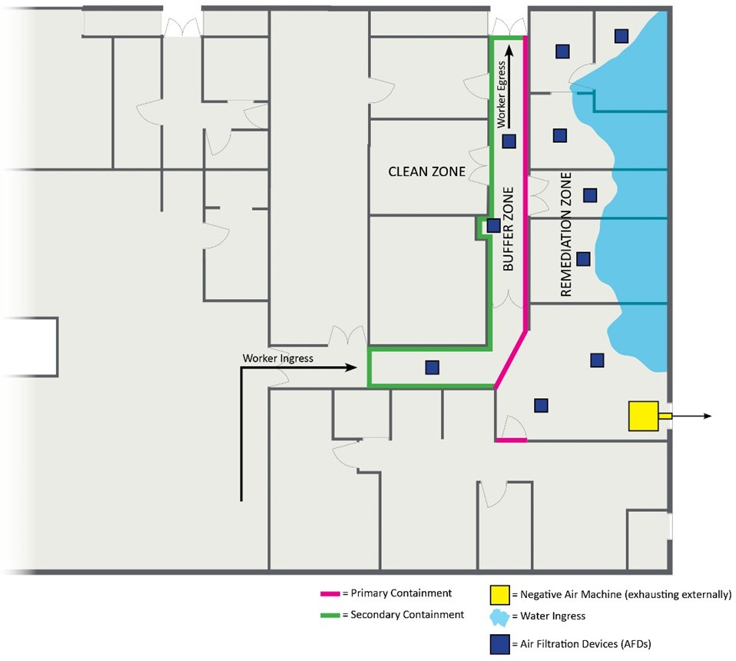

**Note**: Includes recommended locations for primary and secondary containments, NAM and AFD locations, and water ingress and egress points

The HVAC system’s assessment, previously referred to in this HTA, must be considered to make sure the containment is not bypassed or improperly pressurised.

All regions outside the secondary or ‘buffer’ zone are deemed clean and, in theory, suitable for standard hospital operations to proceed. Proper entry and exit of remediation staff must be accounted for when determining which areas can be returned to regular operation. Factors, such as noise resulting from the remediation process, must be taken into account when deciding what regions can resume normal functions.

The containment material for the buffer zone (green) should be opaque to prevent those in nearby areas from observing remediation activities. Conversely, the primary containment material (pink) should be transparent to enable oversight of the remediation tasks from the buffer zone.

Should the situation permit, it is advised that separate worker ingress and egress points are established. This facilitates the establishment of a ‘clean’ area for putting on PPE and a ‘dirty’ area for taking off PPE.

In circumstances where an entire level of a facility is affected, such as the flooding of a hospital basement, it is advised that containment be erected at the top of the leading staircase and the lift shaft doors to prevent aerosolised particulate from traveling to other levels.

Installation of containment barriers should be approximately 1m minimum from the top of stair cases to ensure trip hazards are not introduced within close proximity of a stair case.

* + 1. Pressurisation

4.2.2.1 Pressurisation refers to the creation of an air pressure differential between two areas. Restorers may choose between two methods for pressurising a space: Positive pressure or Negative pressure. Positive pressure involves the intentional introduction of air into a designated space, forcing the air within that space to flow outwards into adjoining areas. This controlled movement may transpire through various outlets such as vents, windows, or even the space beneath a door. Conversely, negative pressure is characterised by the deliberate extraction of air from surrounding areas into a specified space. This is realised by actively removing air from adjacent spaces through an external extraction point, leading to a controlled inward airflow towards the targeted region. A principal concern in remediation is aerosolised particles, especially pathogenic organisms. As such, the management of pressurised air flows is an essential concept that restorers must comprehend, observe, and employ.

As depicted in **Figure 2**, the usual recommendation for a remediation area is to establish negative pressure relative to both the buffer zone and the clean zone. This necessitates the active extraction of air from the remediation zone towards the external environment. A negative air machine (NAM), fitted with a HEPA filter, ensures the maximum practicable removal of particulate matter from the exhausted air before it reaches external areas, such as entrances, car parks, smoking zones and gardens.

The extraction of air from a remediation area results in a slight vacuum effect, leading to the draw of air from adjacent unaffected regions into the remediation zone. This is referred to as ‘make-up air.’ Care must be taken to ensure that make-up air originates only from preferred locations and not from undesirable ones. In the scenario illustrated by **Figure 2**, make-up air would ideally be sourced from the Buffer zone, subsequently drawing air from the clean zone. The movement of air between zones should occur through HEPA filters installed within containment barriers. Diligence is required to ensure that make-up air entering the remediation area does not come from non-habitable spaces like cavities, where there might be a risk of drawing in air tainted with pathogens.

Continuous monitoring and recording of pressure differentials are essential for ensuring the effectiveness of the pressurisation setup in maintaining airflow in the intended direction. A ‘manometer’ can measure and monitor pressure differentials, with a minimum differential of -5 to -7 pascals to be maintained, especially during the opening of zip doorways. The installation of automatic manometer devices with built-in alarms is advised, as they can notify stakeholders of pressure deviations outside prescribed limits. Pressure differential changes might occur due to:

* Broken or compromised containments;
* Power outages; and
* Machine failure.

The remediator must recognise the critical pressure differential equipment that must operate continually. Such equipment should be identified with a tag placed on the plug and the relevant circuit breaker, indicating that it is vital and must not be switched off. Any other general purpose outlets (GPOs) operating on the same circuit should be blocked from potential use.

In the remediation process, the threat of short circuits or overloads presents an ongoing concern. Such occurrences may trip safety switches, leading to catastrophic failure in the engineering controls. Efforts must, therefore, be made to mitigate this risk.

An operational or improperly contained HVAC system may affect pressure differentials, thereby impacting the intended airflow control within the remediation area.

* + 1. Air filtration

Air filtration serves as a significant remediation strategy for the elimination or reduction of airborne particulate within an area. air filtration devices (AFDs) must be fitted with high-efficiency particulate air (HEPA) filters, and their installation should occur promptly once mould is discovered or anticipated to be present.

The quantity of AFDs necessary is contingent on the size and throughput of the unit (or units), in addition to the volume of air requiring scrubbing. A minimum standard of four total air changes per hour (AC/h) is recommended to be sustained throughout remediation operations.

The number of devices (n) are calculated using the following equation:

Figure 3: Number of devices equation

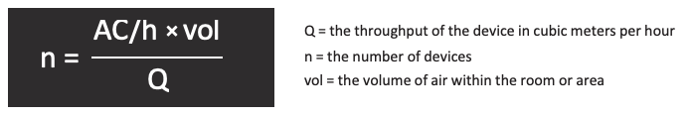

**Note**: Always round up the final result to the nearest whole number

For example, consider a device with a throughput of 840 cubic metres per hour (m3/hr). This specific throughput is generally model specific and is commonly around 840 m3/hr. Given a room with dimensions 7m x 4m x 2.4m and desired air changes required is five per hour (slightly above the minimum recommendation), one can calculate the number of devices necessary to effectively clean the air within this space.

Figure 4: Example calculation of number of devices

Example calculation of number of devices. Explained in text before this figure.
Number of devices is 5 times 7 times 4 times 2.4 divided by 840. This is 336 divided by 840. N equals 0.4.

In this scenario, to ensure the air is adequately cleaned, the total number of AFDs should be rounded up to one to achieve at least five air changes per hour.

Note: some AFDs may have their throughput stated in cubic feet/min, this can be easily converted to m3/min by dividing by 35.31 then multiplying by 60 to convert to m3/hr.

The HEPA filters in air filtration devices (AFDs) will require regular inspection and replacement, either as needed or on a predetermined schedule. The frequency of filter changes will hinge on factors such as:

* Work activity;
* Amount of dust created; and
* Filter capacity.

However, it is vital that new filters be installed before AFDs are introduced into a healthcare environment, and these filters should be disposed of upon the completion of the works.

* + 1. Drying

The methods utilised to dry affected areas will be dependent upon:

* The quantity of water;
* The areas affected;
* The dwell time; and
* The materials affected.

The selection and placement of equipment within the affected area are also pivotal to the efficiency and duration required to dry a location. Although the remediator will possess substantial experience in the appropriate drying practices for various scenarios, some general guidelines remain relevant.

The drying process consists of the following steps:

* Heating the material to encourage internal moisture to move to the external layer between the material and surrounding air;
* The mechanical movement of air across the surface to transfer water molecules from the surface into the air (evaporation);
* The condensation or absorption of water molecules in the air within a dehumidifier; and
* The transfer of water from the dehumidifier into a wastewater outlet.

When significantly wetted, highly porous materials, such as carpets, plaster wall linings, and ceiling tiles, should be removed and discarded rather than dried. Even if it is possible to salvage these materials, removal might still be necessary for the drying of other building materials located behind them.

In commercial structures, like healthcare facilities, semi-porous building materials like timber are seldom utilised. However, older buildings might contain timber framing or structures. In such instances, the timber should be returned to a ‘Dry standard’. This standard can be determined either by assessing the moisture content of timber from areas unaffected by water, or by aiming for a moisture content of less than 15% if the original moisture content is unknown.

The process of drying concrete may necessitate a substantial duration, contingent on the volume and dwell time of water. Subsequent to the removal of standing water, concrete has been found to respond favourably to a combination of dry air movement and direct heat application. This method fosters evaporation, allowing moisture-laden air to be extracted via dehumidifiers. The procedure for testing moisture within concrete should adhere to the ASTM F2170 Standard Test Method for Determining Relative Humidity in Concrete Floor Slabs Using in situ Probes. Should testing in accordance with ASTM F2170 not be feasible, it is advised to follow the methodology outlined in the ASTM F1869 Standard Test Method for Measuring Moisture Vapour Emission Rate of Concrete Subfloor Using Anhydrous Calcium Chloride (AS 1884:2021).

* 1. Water removal

One of the principal tasks associated to any remediation work is the removal of remaining water. Depending on the nature of the water ingress, immediate removal might not be feasible. Widespread flooding, for instance, might necessitate a waiting period for the water to recede. The elimination of water, contingent on the volume, affected areas, and accessibility, can be achieved through various methods. Water can typically be extracted from impacted regions by using commercial pumps for significant quantities or wet vacuums for lesser amounts. Wet vacuums should ideally be employed even after water pumping to ascertain that all standing water is eliminated. It is vital to ensure that the transfer of water from affected regions does not contaminate unaffected ones. This concern must be prioritised when routing hoses through unaffected parts of the healthcare facility, as contamination of the hoses can occur easily. If feasible and safe, it is advised that hoses be directed out of external openings rather than through unaffected parts of the facility. If this is not an option, the use of floor protection or the establishment of a cleaning protocol following each extraction session may be contemplated.

During water extraction, it is essential that measures are taken to minimise the aerosolisation of water droplets, and that splashing does not dampen otherwise dry materials or surfaces. This precaution serves to safeguard both remediation contractors and restorable building materials identified for retention and remediation.

Standing water, particularly if the source is sewage or flood, may also contain bulk material, such as soil or mud, faeces, wastepaper, organic matter and so on. It is important that these materials are also removed as part of this phase.

Extracted water and bulk materials must be disposed of in accordance with the applicable state based regulations, such as the Victorian Environment Protection Act 1970.

* 1. Area contents

In order to ascertain whether content items are to be disposed of, remediated or to prevent their contamination, it is essential that all content items are removed from the affected areas. This facilitates more comprehensive remediation by providing increased space for work and fewer surfaces to cleanse. Large, fixed assets, including MRI units, CT scanners, linear accelerators and so on, may be assessed for remediation suitability on site, but consultation with manufacturers is necessary to identify the appropriate remediation technique.

Reusable items, such as sheets and towels, which are typically laundered by the hospital, can be remediated via similar laundering techniques.

Similarly, reusable sterile items, including scissors and containers, may be reused subsequent to appropriate sterilisation in accordance with AS/NZS 5369:2023 Reprocessing of Reusable Medical Devices in Health Service Organisations.

The preceding points presuppose that the laundering and sterilisation infrastructure remains unaffected by the incident or has been restored to a suitable working condition. Nevertheless, external professional services may be required for laundering or sterilisation.

Items designated for single use, which have been affected by water or humidity, such as sterile needles, IV tubing, PPE, drapes, and dressings, must be removed and disposed of safely, in alignment with any relevant legislative or EPA requirements.

Items of a porous nature, composed of multiple materials, may prove challenging to remediate and thus may necessitate removal. The determination to dispose of such remaining items should be founded upon a cost-benefit analysis. Most non-porous, non-electrical items can be promptly and effortlessly restored. Electronic components impaired by water may occasionally be substituted, allowing for the majority of the item to be restored.

Items that are either irreparably damaged or not economically viable to remediate should be disposed of, adhering to any pertinent environmental protection guidelines.

As an organisational concern for the restorer, it is advised that items considered salvageable be stored offsite within a climate-controlled environment, facilitating proper remediation.

All equipment and contents with the affected areas are to be logged on an equipment register. This will assist Insurance Assessors and remediation teams to keep accurate asset record information for remediation and disposal purposes.

* 1. Building structure

Consideration for the removal of water or mould-damaged building materials will be necessary following water ingress.

Porous building materials, such as plaster linings, will require removal if they are impacted by Category 2 or 3 water or not dried within the initial 48 hour period. It is advised that plaster wall linings be removed to a point exceeding the visible impact. For instance, if water has reached a height of 200mm above the floor, removal of plaster wall linings to a minimum of 400mm is advised, as water may be absorbed by the porous material. Additionally, moisture readings of the material can also determine the removal height. If fungal growth is detected, the plaster lining may need removal beyond the water’s height, as humidity or condensation may have prompted fungal growth within a wall cavity.

In determining the suitable height for cutting, the extent of contamination is the principal deciding factor. Secondary consideration should encompass cost and timeframe.

Coordination with the remediator and plasterer is typically prudent in finalising the decision, as additional plaster removal may facilitate the remediator in executing their work more proficiently and comprehensively.

* 1. Building fixtures

As stipulated by the Australasian Health Facility Guidelines (AusHFG), patient facing areas are likely to possess vinyl wall coverings on the lower 1200mm of the walls (WLWA-025), while non-patient areas might only have vinyl skirting up to a height of 150mm (FLSK-010). Should the vinyl coverings remain in satisfactory condition, and water extracted promptly, removal of wall linings may not be necessary. Conversely, if the seams or ‘welds’ between the vinyl coverings are compromised, or there exists any indication that water may have seeped behind them, assessment of the materials behind will necessitate their removal.

In the event that adjacent rooms are not patient-facing, inspection openings can be created to facilitate the use of penetrative moisture meters on the reverse side of the patient-facing wall linings. This confirms whether the water-resistant properties of the vinyl effectively safeguarded the wall linings in patient- facing rooms. It is imperative to acknowledge that this process must be undertaken with appropriate containment and engineering controls in position, to account for any potential presence of fungal growth within the cavity.

Such openings might be utilised to dry the affected wall linings in circumstances where moisture has been absorbed.

In cases where floating or suspended ceilings are present, and ceiling tiles have become damp, it is strongly advised that they be removed and discarded, irrespective of the water category, given the highly porous nature of these materials.

The removal of wet insulation is mandatory, regardless of the category of water. This necessity arises not solely from a hygiene standpoint, but also because the insulation’s efficacy (R value) is likely to have been affected by the dampness.

In alignment with AusHFG, internal doors within a healthcare environment should be constructed with a solid core. As a result, these doors can be readily remediated, except in situations where they have been submerged in water for an extended duration, resulting in substantial swelling. Under such conditions, effective remediation of the doors is unattainable.

Carpets, carpet tiles, smooth edge, and underlay require removal and disposal if they have encountered Condition 2 or 3 water, or if visible fungal growth is present.

Independent of the types of building materials extracted, these materials must be contained in a way that precludes the dispersal of dust and debris into clean zones or the broader external environment. Removed materials should be accommodated in heavy-duty polyethylene bags (200 µm recommended), double-bagged and sealed with tape. Bags should then be wiped down and passed into the buffer zone. Bags should then be wiped down again in the buffer zone, prior to being transported through the clean zone. Alternatively, bags containing contaminated material may be transported directly outside if an external opening is accessible and safe to utilise. This process diminishes the risk of cross-contamination as well as significant labour costs or time. The bagged material should be placed into a commercial-grade skip for suitable disposal, following local and state disposal guidelines.

In an effort to limit dust, the execution of a basic clean to the remediation area is advocated at the conclusion of each shift during the removal procedure.

* 1. Mould removal or disinfection cleaning

Following removal of affected materials, and following the drying of all those remaining, the detailed process of ‘Condition 2 Cleaning’ can begin. Condition 2 cleaning consists of cleaning all remaining surfaces within the remediation area using a method commonly referred to as a ‘HEPA Sandwich’. This technique entails HEPA vacuuming the surface, followed by wiping with a microfibre cloth dampened with warm soapy water, and then HEPA vacuuming once more. Such a process ensures that the substantial majority of settled fungal spores are gathered by either the vacuum or the surfactant wipe.

During the wiping of surfaces, it is essential that the soapy water be refreshed regularly to maintain cleanliness and warmth. When wiping porous materials, such as plaster linings, care must be taken to prevent the material from absorbing moisture.

During wiping, adherence to a structured method that guarantees comprehensive coverage of the entire surface is imperative. It is vital to put into place measures that inhibit cross-contamination during the wiping process itself. This may be accomplished through regular disposal of microfiber wipes or by utilising methods, such as the four-fold or the eight-fold technique.

Establishment of essential protocols for the reuse of microfiber cloths for their thorough cleaning prior to subsequent use is vital. A comprehensive method entails the implementation of a system for gathering and laundering microfiber cloths that are eligible for reuse. As an alternative, a three-bucket system may be effectively employed.

In situations where substantial fungal growth is observed on semi-porous structural building elements, such as timber framing or concrete slabs, abrasive cleaning of the affected surfaces may be mandated. This necessity arises because fungal hyphae can infiltrate semi-porous building material to a depth beyond the reach of normal cleaning. Depending on the material and the extent of fungal growth, this process may range from as mild as scrubbing with a wire brush and warm soapy water to as intensive as grinding, sanding or dry ice or media blasting to remove a thin layer of the surface. Should this action be required, it is typically advisable to cleanse the surface to curtail aerosolisation. Preceding the abrasive phase with drying of the materials typically enhances effectiveness, especially for timbers, and is essential to prevent recurrence of growth.

Where bacterial contamination has been either identified or is suspected, surfaces will also require disinfection. The specific disinfectant utilised will be determined by the remediator, with the stipulation that all disinfectants must comply with the Australian Register of Therapeutic Goods (ARTG) for use as a disinfectant in Australian healthcare environments. It is also important that any disinfection products are approved by the facility specific infection prevention team.

In making their selections, the remediator must take into consideration the surfaces to which the disinfectant will be applied and the response of these surfaces to treatment, such as potential reactions between corrosive chemicals and metal.

Due consideration must be given to staff safety in light of potential inhalation risks that may emanate from the usage of chemicals in substantial quantities and within areas of inadequate ventilation. Factors to be assessed include:

* Flammability properties of the chemical;
* Properties of any residues; and
* The dwell time necessary for effective results.

Upon selecting the suitable chemical, adherence to the manufacturer’s application method and dwell time is necessary to ensure its effectiveness. While waiting for the required dwell time, air movers may be prepared but must not be activated until the dwell time has been completed.

After the passage of the requisite dwell time, generally ranging from 5 to 60 minutes, air movers may be activated to facilitate evaporation.

Should any moisture have been introduced into the internal environment during the cleaning phase, either through direct contact or increased humidity, continuation of drying works may be necessary at this stage. Utilisation of methods that minimise this factor is preferable.

It must be noted that antimicrobial disinfectants are not suitable for mould contamination removal and therefore must not be used as an alternative to proper removal methods that physically eliminate mould contamination.

Utilisation of encapsulation methods to cover mould damage is not advised unless the affected material is infeasible to remove or clean.

Employing fogging or gas or vapour phase biocides is not advised, as these methods do not remove particulate matter, which may continue to present health risks. Consideration must be given to the potential human exposure when utilising any aerosolised biocide within an environment.

* 1. Heritage listed structures

Victorian healthcare facilities include several heritage-listed structures. Specific caveats under these heritage listings may influence both the remediation strategies employed and the overall effectiveness of the remediation. For instance:

* Remediation may necessitate the preservation of original materials’ surfaces that would ordinarily be deemed non-salvageable if not heritage-listed. Gentler cleaning methods and chemicals may be required to avoid damage to surfaces or finishes; and
* Drying works might have to be performed without full exposure of all materials (in situ drying). For example, if wall linings cannot be removed but the timber framing behind is known to be wet, focused drying must be utilised to extract moisture through each layer of material.

The ideal selection of remediators will include those with experience in remediation of heritage-listed structures.

All remediation efforts should comply with the regulations set forth by the Department of Transport and Planning, especially Heritage Victoria. Further guidelines can be located in the Minimum Standards for Maintenance and Repair of Heritage Places, as stipulated in s19(2) of the Heritage Act 2017.

* 1. Asbestos containing materials (ACM)

Prior to commencing any removal works, remediators are obligated to review the site-specific asbestos register. Should no such register exist, bulk sample analysis of suspected materials might be required to confirm the presence of asbestos-containing materials (ACM). A remediator might engage a qualified site consultant (QSC) with experience in asbestos identification and assessment to obtain bulk samples or establish a site asbestos register.

Typically, non-friable ACM is non-porous and exhibits resistance to water damage, unlike other porous building linings. Consequently, they can be effectively remediated by manual cleaning. Under the National Model and Victorian State Health and Safety Regulations, abrasive methods such as high-pressure blasting or sanding must not be employed to clean ACM. The removal of all ACM must be performed in accordance with the stipulations of the National Model and Victorian State Health and Safety Regulations, and be carried out by a suitably licensed asbestos removalist.

Of particular note are common ACM vinyl floor tiles that will likely lift when exposed to high volumes of water, therefore remediation and removal of these products must be preformed in accordance with appropriate safety protocols.

* 1. Heating, ventilation and air conditioning (HVAC) cleaning and recommissioning

The existing HVAC system infrastructure may be impacted depending on the size and scale of water ingress. Since the HVAC system is vital to the safe operation of a healthcare facility, it is imperative that any remediation undertaken on this infrastructure is executed properly.

Should the facility remain partially occupied, the HVAC serving the affected areas must be isolated from the system to prevent potentially contaminated air from moving to unaffected areas. This also facilitates easier control of pressurisation in the remediation area. The system’s isolation, or parts of it, should be performed in consultation with the facilities manager or the nominated HVAC specialist.

All internal and external porous ductwork insulation, including sound attenuators, for the HVAC impacted by water must be removed, along with all associated air filters. Consideration should be given to remaining HVAC fixtures such as sensors, probes, humidifiers, variable air volume boxes, for either remediation or replacement, depending on severity of the impact, ease of remediation. Consultation with the facilities manager would be required. AIRAH *HVAC Hygiene Best Practice Guideline* is also a good reference.

The remaining solid ductwork must be cleaned using the Condition 2 cleaning methods described in **Mould removal or disinfection cleaning**. If the ductwork internals are inaccessible, removal is advised. Should neither access nor removal be possible, such as in multistorey riser shafts, remediation using high-pressure air whips and a high-powered HEPA vacuum is recommended. Specialised HVAC remediation contractors may need to be engaged for this work.

Plant rooms affected by water ingress will also necessitate specialised remediation. Air handling units (AHUs) might require dismantling and cleaning of internal components prior to recommissioning. Consultation with AHU manufacturers is necessary for specific cleaning and servicing requirements. Coils may need cleaning outside their scheduled maintenance period, typically employing high-pressure hot water and a surfactant or degreaser to remove particulate from the coil unit.

* 1. Lift Shafts

In addition to isolating lifts to assist in maintaining pressure regimes and minimise the potential spread of airborne contaminants, it is imperative to determine if any water entered the lift shaft well.

Lift contractors are to be contacted to determine the extent of water intrusion into the lift shaft well and appropriate pump out and drying solutions are to be deployed.

All equipment (mechanical and electrical) within the lift shaft is to be tested and validated for correct operation prior to lift car being returned into normal operation.

* 1. Post-remediation verification

After the completion of all remediation activities, a post-remediation verification (PRV) assessment is conducted to ascertain the effectiveness of the remediation that has been undertaken.

A PRV is an assessment carried out by a QSC to review the work performed by the restoration contractor. The PRV’s objective is to verify that all affected materials have been dried to an acceptable level and that no unacceptable levels of biological contamination remain. Suitable sampling methods, akin to those employed during the initial assessment, must be used by the QSC to examine the affected area. Utilising both viable and non-viable sampling methods is advised.

If the PRV assessment detects any unacceptable levels of moisture or microbial contamination, the QSC must furnish additional recommendations to rectify the specific issue (or issues) or areas of concern. After the completion of supplementary remediation works, a subsequent PRV assessment should be carried out to confirm the success of the works.

The PRV must include integration into the final internal hospital clean (clinical clean) and any pre-clinical operational requirements.

1. Contractor management
   1. Health and safety

The responsibility lies with hospital management to ensure that all subcontractors are operating in a manner that is safe and in compliance with any relevant health and safety management systems implemented by the facility.

It is advised that the project manager oversee the examination of all pertinent subcontractor safe work method statements (SWMS) and job safety analysis (JSA) documentation before work commences.

Specifically, the Project Manager must ensure that any personal protective equipment (PPE) requirements outlined within these documents are adhered to by all contractor employees.

* 1. Personal protective equipment (PPE)

**Clothing**: appropriate coveralls that prevent exposure of the skin or clothes to contamination. Typically, coveralls are disposable suits that cover the entire body and the head.

**Gloves**: gloves must be worn during mould remediation. It is highly advised that two pairs are worn, one pair of nitrile or latex gloves to prevent exposure, with another pair of ‘work’ gloves over the top to prevent abrasions.

**Eyewear**: eyewear must be worn when conducting remediation works. Depending on the stage of remediation, goggles may be required (if water is still present), or safety glasses may be sufficient (if removal works are occurring). Eye protection may be built into a respirator.

**Respirator**: as remediation will likely result in the aerosolisation of fungal spores, it is important that an appropriate respirator is worn. At minimum, a P2 mask must be worn within the remediation area, however a full-face mask can be worn as additional eye protection.

**Hearing** **protection**: dependent on the works being completed, hearing protection may be required. This is likely to be necessary when abrasive cleaning, coil cleaning or demolition works are occurring.

* 1. Donning and doffing

Clean PPE should be donned prior to entering the Buffer zone at the designated entrance. Used PPE should be removed and sealed in a polyethylene bag prior to leaving the Buffer zone at the designated exit area.

* 1. Thermal stress

Environmental conditions and workload may induce thermal stress in those undertaking remediation activities.

Prior to commencement of remediation activities a thermal stress risk assessment should be completed by the remediator to identify any unique conditions and controls required to effectively mitigate the risk of thermal stress, such as hourly or bi-hourly breaks.

* 1. Confined spaces

Some work locations may be considered a confined space, for example HVAC duct work and AHUs. The definition of a confined space is detailed within AS 2865:2009 Confined Spaces.

Entry and work within a designated confined space will be required to be undertaken under a Permit to Work System with appropriate controls commensurate with the risks associated with the Confined Space.

* 1. Contractor work clearance requirements

Remediators and any subcontractors must have the relevant work clearances to comply with the Public Health and Wellbeing Act 2008 and in addition may require Working with Children Check (WWCC) and specific immunisation requirements before entering the facility.

1. What is not covered by this document

* Pre-event checklist.
* Location of key infrastructure.
* How to determine which infrastructure is portable or immovable.
* Accounting for vulnerable stores (chemical, medicinal).
* Mapping vulnerable areas within the building (basements, lift shafts).
* Having an up to date, understood and clear evacuation plan.
* Having a clear mitigation strategy for dealing with lesser single room or lower level events.
* Understanding of the layout of the building, its vulnerabilities, and its strengths.
* Understanding methods and locations best suited to inhibit further damage.
* Post remediation verification (PRV) assessment.

1. References
2. I.I.C.R.C. 2021 S500 Standard for Professional Water Damage Restoration. Institute of Inspection Cleaning and Restoration Certification. Nevada, Unites States of America.
3. I.I.C.R.C. 2015 S520 Standard for Professional Mold Restoration. Institute of Inspection Cleaning and Restoration Certification. Nevada, Unites States of America.
4. Lee, T 2009 ‘Mold remediation in a hospital’ Toxicology and Industrial Health 25(9-10): 723 – 730
5. CDC: ‘Remediation and infection control considerations for reopening healthcare facilities closed due to extensive water and wind damage.’ In Natural Disaster and Severe Weather. https://www.cdc.gov/disasters/reopen_healthfacilities.html (Accessed 7/3/2023

# Appendix A: Flowchart

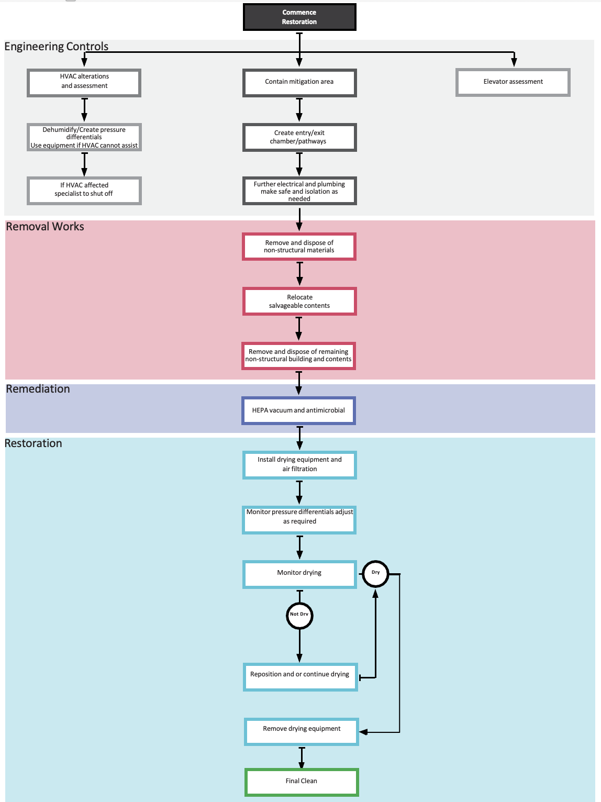

# Appendix B: Image descriptions

Figure 1: Moisture readings shown on a floor plan

Plaster moisture readings illustrated on a floor plan:

* Acceptable plaster moisture content: 0.0 to 0.5%
* Elevated plaster moisture content: 0.6 to 0.9%
* High plaster moisture content: 1.0 to 6.0%.

The floor plan shows a pool of water affecting 5 areas along the right wall. There are:

* 15 high readings against and near the right wall (all in a pool of water).
* 7 elevated readings around the water.
* 11 acceptable readings around the elevated readings.

Return to **Moisture survey**.

Figure 2: Example of a water ingress and relevant recommended locations

Example floor plan is the same one from Figure 1. The water ingress is shown as a pool of water affecting the 5 areas along the right wall.

The areas affected are labelled ‘remediation zone’. The border between this zone and the buffer zone is ‘primary containment’ (magenta line on floor plan).

The remediation zone shows:

* 7 air filtration devices
* 1 negative air machine (exhausting externally.

The buffer zone is a reversed ‘L’ shape. One end (top of floor plan) has a worker egress. The other end shows the worker ingress point. There are 3 air filtration devices in this zone.

Next to the buffer zone is the ‘clean zone’. The border between these two zones is ‘secondary containment’ (green line on floor plan).

Return to **Containment**.

Flowchart

### Start

Commence restoration.

### Engineering controls

**Step 1**: Contain mitigation area.

**Step 2**: Create entry, exit chamber, pathways.

**Step 3**: Further electrical and plumbing make safe and isolation as needed.

#### Parallel processes

##### Process 1

* **Step A**: HVAC alterations and assessment.
* **Step B**: Dehumidify, create pressure differentials. Use equipment if HVAC cannot assist.
* **Step C**: If HVAC affected specialist to shut off.

##### Process 2

* **Step A**: Elevator assessment.

### Removal works

**Step 4**: Remove and dispose of non-structural materials.

**Step 5**: Relocate salvageable contents.

**Step 6**: Remove and dispose of remaining non-structural building and contents.

### Remediation

**Step 7**: HEPA vacuum and antimicrobial.

### Restoration

**Step 8**: Install drying equipment and air filtration.

**Step 9**: Monitor pressure differentials, adjust as required.

**Step 10**: Monitor drying.

* If dry: Go to **Step 12**.
* If not dry: Go to **Step 11**.

**Step 11**: Reposition or continue drying.

* Once dry, go to **Step 12**.

**Step 12**: Remove drying equipment.

### End

Final clean.

Return to **Appendix A: Flowchart**.