

October 2025
Net Zero Building Handbook
Table of Contents
Acknowledgement of Country 2
Taking action 3
Targeted action 4
The role of VIDA Health 5
VIDA 7
Whole life carbon approach 8
Hospital whole life carbon 9
Hospital upfront carbon 10
Asset life cycle approach 11
Scalable approach 12
Phased targets 13
Embedded in our process 15
Recycled First Policy 17
Assurance framework 19
Digital engineering integration 20
Carbon management plans 21
Enabling infrastructure 23
Case studies 25
Glossary 29
References 31
Appendix A: Image descriptions 32

Acknowledgement of Country
VIDA Health acknowledges the traditional owners of the lands on which we operate, who have cared for and sustainably managed Victoria’s land and waterways for tens of thousands of years.
We recognise Aboriginal people as Australia’s first peoples and the Traditional Owners of this land. We thank them for their ongoing contribution to our projects through the sharing of their knowledge of their cultural heritage and pay our respects to elders past and present.

Taking action
The importance of taking action to address the urgent challenge of tackling climate change cannot be overstated.
As part of a global pledge to reduce carbon emissions and avoid the worst impacts of climate change, the Victorian Government has committed to being net zero by 2045.
Backed by legislated targets, Victoria’s transition is underway with significant investment in renewable energy, new transmission lines and energy efficiency initiatives. However, we know that all sectors of our economy must adapt; VIDA Health has a responsibility to demonstrate strong action to decarbonise the health infrastructure we deliver.
Expansion of our health system is both a source of our emissions and an opportunity to put in place measures to reduce carbon emissions over the life cycle of our assets. By acting now, we can leave a lasting legacy, helping Victoria transition to a net zero economy, supporting job creation and enabling new industries.
VIDA Health’s net zero building handbook sets out our commitment to measure and manage the whole life carbon impact of the health infrastructure we deliver. The handbook is in addition to our existing design guidelines and requirements. Our focus will centre on driving efficiency, value engineering and seeking to reduce emissions through informed decision making. We will support innovation in our industry, driving down the emissions associated with health infrastructure.
We recognise that we do not act alone. To be successful will require collaboration and coordination from government, health agencies, the construction industry and our supply chains. Work has already begun. Through this handbook, we have now identified clear and deliberate actions and set targets to support Victoria’s journey to net zero.

Targeted action
In 2023, the Victorian Government brought forward the commitment to achieve net zero from 2050 to 2045.
Victoria exceeded its first interim target – to reduce emissions 15 to 20% below 2005 levels by 2020 – with a cut of almost 30%. Building on this success, the Victorian Government has set targets that provide a clear path to net zero emissions – most recently with the 2035 interim target of 75 to 80% reduction compared to 2005 levels.
These targets place Victoria alongside international climate leaders and will bring real benefits for Victorians, including:
- new jobs
- energy bill savings
- improved health
- environmental outcomes.
They represent Victoria playing its part in global efforts to limit warming to 1.5°C by the end of the century and to avoid the worst impacts of climate change. It will be difficult to eliminate all carbon emissions from health infrastructure. Relying on carbon offsets alone is not a viable or value-for-money solution.
Significant progress is expected across sectors of the economy responsible for the majority of Victoria’s emissions, including energy, transport users, agriculture and land use. However, to achieve the state’s net zero ambitions, the response must be whole-of-economy. The health sector will play an important role.
Figure 1: Climate Change Act (Vic) targets and progress
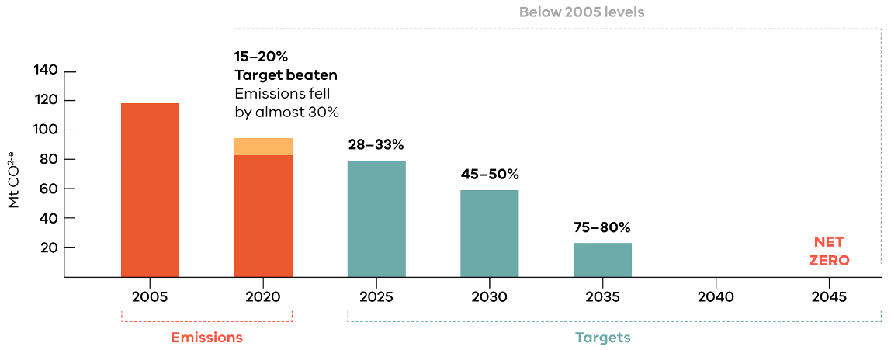

Leading the way on climate change action
To tackle the extraordinary challenge of climate change, Victoria was one of the first jurisdictions in the world to legislate a net zero emissions target.

The role of VIDA Health
VIDA Health is responsible for the planning and delivery of the Victorian Government’s multibillion-dollar health infrastructure program.
VIDA Health is responsible for health infrastructure projects, from business case development through to procurement and delivery. We deliver these projects for the Department of Health under a client-based model.
Projects delivered by VIDA Health are then handed over to health agencies, who are responsible for asset operation and maintenance. VIDA Health has a relatively small carbon footprint from its corporate activities; however, the carbon emissions of the health infrastructure we deliver are significant.
The whole life carbon emissions of health infrastructure are determined by 2 key factors:
- the volume of projects delivered
- the whole life carbon intensity of the projects we deliver.
The significant increase in the number, size and complexity of health infrastructure projects being undertaken in Victoria over the last decade has come with an increased carbon footprint.
Figure 2: Artist impression of New Melton Hospital
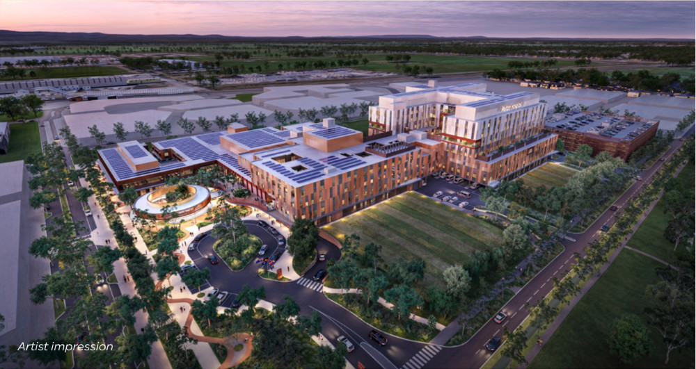

Figure 3: New Footscray Hospital
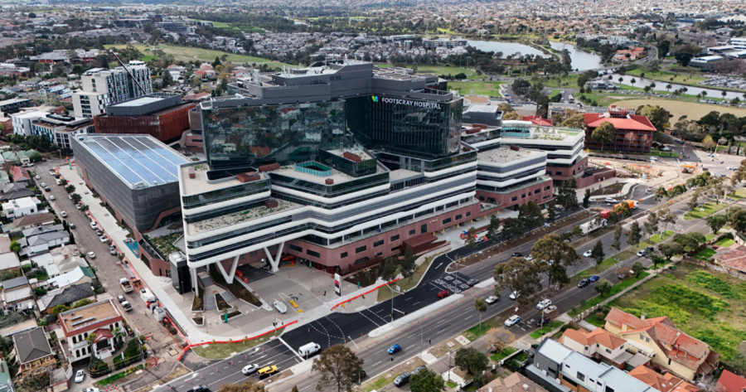

VIDA
The Victorian Infrastructure Delivery Authority (VIDA) was established in 2024 and brings together the Major Transport Infrastructure Authority (MTIA) and the Victorian Health Building Authority.
VIDA was established to oversee Victoria’s unprecedented level of investment in transport and health infrastructure.
VIDA released its transport infrastructure decarbonisation strategy in 2024. The strategy focusses on reducing carbon emissions from the delivery of transport infrastructure projects, aligning with the state’s broader net zero commitment. The strategy also includes decarbonisation actions for corporate activities that apply to all project offices within VIDA.
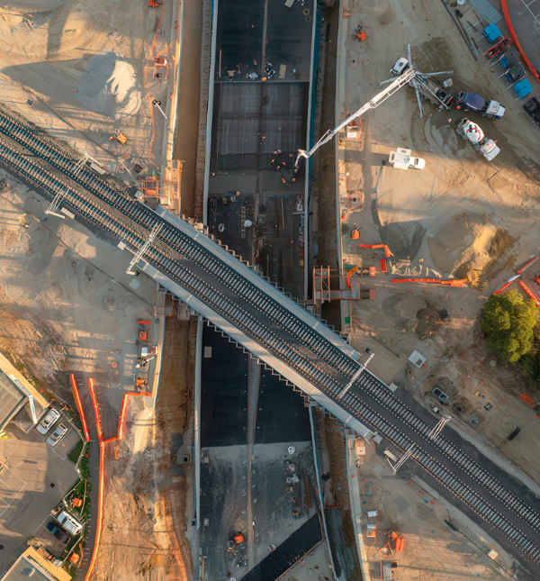

Whole life carbon approach
Health infrastructure emits carbon over its whole life cycle, from construction, through its operational stage and at the end of its life.
Figure 4: Whole life carbon cycle (based on EN 15978)
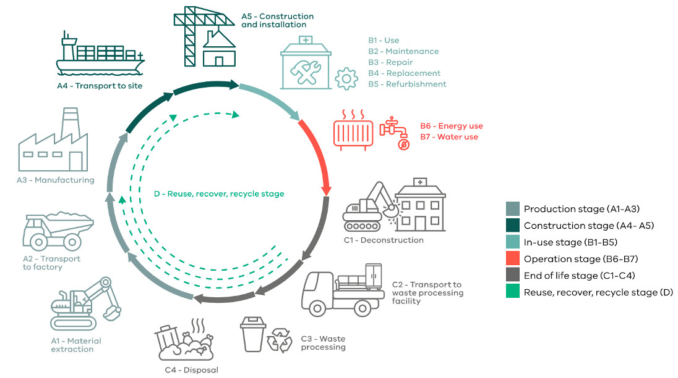
Whole life carbon describes the greenhouse gas emissions over the asset life cycle. Whole life carbon consists of operational carbon plus embodied carbon.
Operational carbon emissions are due to energy and water use. These operational emissions have traditionally been the focus for decarbonising health infrastructure through:
- energy and water efficiency
- use of reclaimed water
- onsite renewable energy
- procurement of renewable electricity.
Embodied carbon refers to the greenhouse gas emissions associated with materials and construction over the infrastructure life cycle.
Upfront carbon is the embodied carbon emitted during the material production and construction stage (stages A1 to A5 – see Figure 4).
The reuse, recover, recycle stage measures how materials can reduce the embodied carbon impact of future projects. This is outside the asset life cycle, so is reported separately.
Whole life carbon describes the emissions of the asset only. Broader health services carbon emissions (due to supply of medical equipment and products, transportation, operational waste and so on) are not the focus of this handbook. They are being targeted by the Department of Health and health agencies through operational and procurement strategies. This handbook does cover the subject of enabling infrastructure, such as charging infrastructure to enable the transition to electric vehicles.

Hospital whole life carbon
The whole life carbon profile of a hospital is important to understand when determining the focus for decarbonising health infrastructure.
Figure 5: Hospital whole life carbon
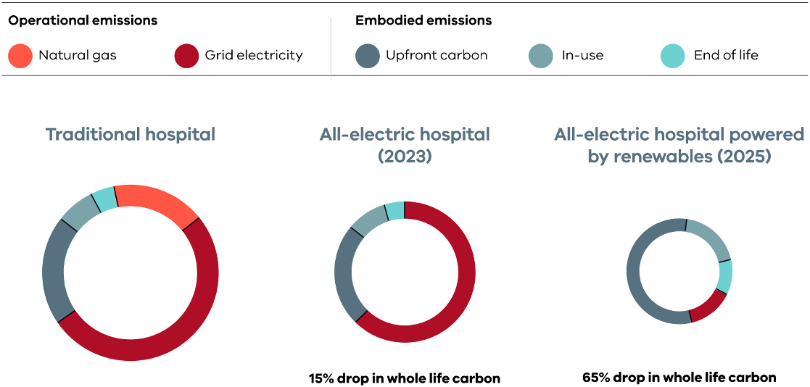

Traditional hospital
Historically, hospitals have used a fuel mix of fossil gas and grid electricity. In this scenario, most of the whole life carbon emissions are due to energy use. This is why energy efficiency and onsite renewable energy has been VIDA Health’s primary focus for decarbonising health infrastructure.

All-electric hospital (2023)
In 2023, it was announced that all new public health infrastructure will be all-electric.
This avoids the use of fossil gas onsite and reduces whole life carbon impact by 15% compared to a traditional dual-fuel hospital, benefitting from continual decarbonisation of the Victorian electricity grid as it switches to renewables.

All-electric hospital powered by renewables (2025)
From July 2025, all hospitals that use over 40 megawatt-hours of electricity a year will be supplied with 100% renewable electricity by the State Electricity Commission (SEC).
This reduces life cycle carbon emissions by 65% compared to a traditional dual-fuel hospital and means embodied carbon becomes most of a hospital’s whole life carbon emissions.
The analysis presented illustrates why embodied carbon is a key focus for VIDA Health moving forward, with upfront carbon emitted during construction accounting for over half of a hospital’s whole life carbon impact.
Energy efficiency and onsite renewables will continue to be priorities due to their impact on reducing operating costs and improving operational resilience – every dollar saved on energy use is a dollar for frontline health services.

Hospital upfront carbon
Reducing upfront carbon is an immediate challenge for VIDA Health and the construction industry.
Upfront carbon is emitted before a building is occupied. It is due to:
- production of construction materials
- transportation of these materials to site
- construction site activities.
For an all-electric hospital powered by renewable electricity, upfront carbon represents more than half of the building’s whole life carbon emissions.
Reducing upfront carbon is an immediate priority for VIDA Health and the construction industry, as these carbon emissions are released before a facility is operational. For a typical hospital, over half of the upfront carbon impact is due to the building structure. These elements typically use high embodied carbon materials such as concrete and steel.
The façade is the next biggest contributor, followed by engineering services and the internal fitout. The transportation of materials to site and construction site processes (such as diesel and electricity use) make up the rest of the project upfront carbon emission profile.
Until now, measuring and managing upfront carbon has not been consistently applied through VIDA Health’s sustainability approach.
Figure 6: Hospital upfront carbon
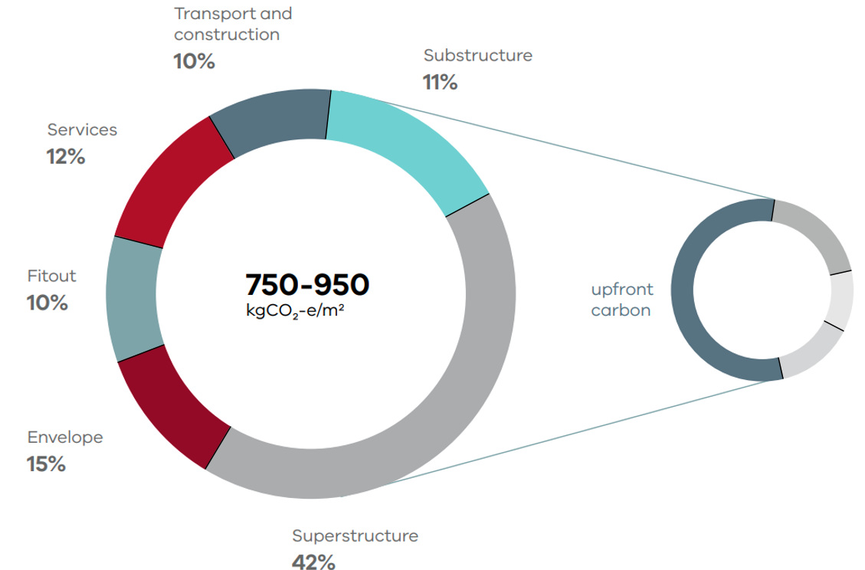

Asset life cycle approach
Whole life carbon should be considered at every stage of the asset life cycle, with early action the most impactful.
Figure 7: Asset life cycle approach
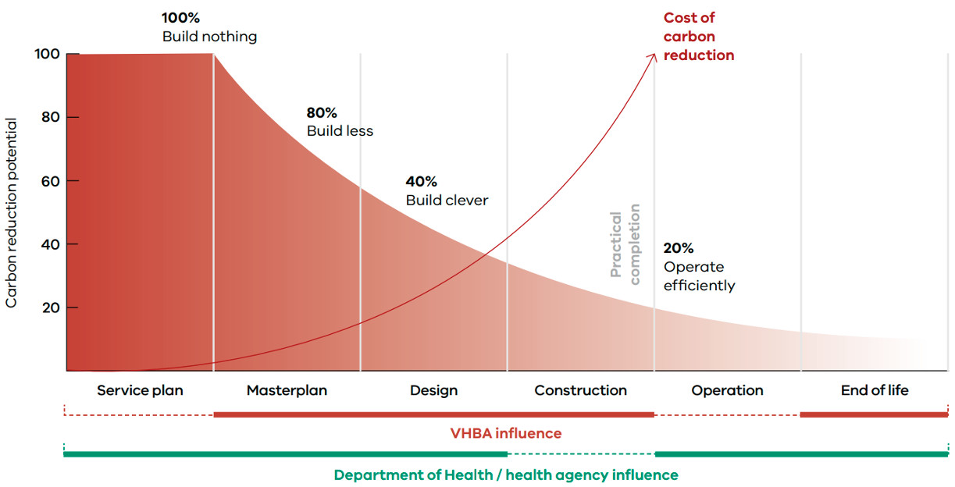
Opportunities to influence carbon emissions decrease in impact and increase in cost through the planning and delivery phases.
When whole life carbon thinking is embedded from the early planning stages and through the whole asset life cycle, opportunities to reduce carbon emissions can be achieved for the lowest possible cost.
A build nothing approach provides the greatest carbon savings. However, in an expanding health system, modern infrastructure is required to deliver a world-class health system that leads to better health outcomes for all Victorians.
A build less approach means delivering more efficiently-designed buildings and better space utilisation, as well as adaptive reuse of existing buildings.
Once these opportunities have been explored, a build clever approach delivers resource-efficient facilities built with reduced impact materials and modern methods of construction to further reduce whole life carbon emissions.
To operate efficiently, asset performance needs to be monitored and tuned, with carbon conscious refurbishment works and end-of-life treatment.

Scalable approach
VIDA Health delivers projects ranging from small refurbishments to major acute hospitals, therefore our approach needs to be scalable.
As project scale increases, so does whole life carbon impact.

Small (under $20M): No mandated requirements
Small projects are typically fit out of existing spaces or small buildings and are often funded by grant programs. These projects must:
- meet the requirements of our guidelines for sustainability in capital works.
In line with our guidelines, projects with over $5M construction cost have a dedicated sustainability budget. Project teams are encouraged to consider the use of reduced carbon materials funded by the project sustainability budget.

Medium ($20M to $50M): Baseline requirements
Medium projects are major fit out of existing spaces or medium-scaled buildings (such as aged care or medical centres). These projects must:
- meet the requirements for small projects
- meet operational energy and water targets (see Phased targets)
- apply the Recycled First Policy (see Recycled First Policy)
- allocate a portion of the sustainability budget to reduce upfront carbon and report on any upfront carbon savings achieved.

Large ($50M to $250M): Increased requirements
Large projects are typically new buildings or adaptative reuse of existing buildings. These projects must:
- meet the requirements for medium projects
- meet upfront carbon targets (see Phased targets) and undertake associated iterative design activities and construction phase assurance (see Assurance framework) to verify achievement of targets
- apply a carbon value to all business cases for projects over $100M.

Major ($250M and over): Additional requirements
Major projects are typically new acute hospitals and have the highest whole life carbon impact. These projects must:
- meet the requirements for large projects
- integrate with our Digital engineering (DE) framework, using building information modelling (BIM) for sustainability analysis and reporting (see Digital engineering integration)
- develop a carbon management plan (see Carbon management plans).
The scale of the project will be determined by the total construction cost unless otherwise stated in project briefing documents. In some cases, VIDA Health may define project scale above their construction value.

Phased targets
VIDA Health’s decarbonisation targets ramp up over time to accelerate action towards the 2045 state government net zero commitment.
Table 1: Decarbonisation targets
Element | 2025 | 2028 | 2030
VIDA Health governance | Develop and test embodied carbon benchmarks (see Assurance framework)  Develop supporting resources  Confirm proposed 2028 and 2030 targets | Review achievements | Review achievements  Set targets for 2035 to 2045
Upfront carbon | 15% reduction compared to a reference building | - 20% reduction, or  - Equivalent NABERS rating | - 30% reduction, or  - Equivalent NABERS rating
Energy demand | Meet requirements of our guidelines for sustainability in capital works.  15% energy demand reduction compared to a reference building | Review guideline requirements  20% energy reduction | Review guideline requirements  25% energy reduction
Key project requirements | All-electric engineering services (2023)  Powered by renewables for sites over 40 MWh/yr (2025)  Medium projects ($20M):  - Energy demand target  - Iterative energy analysis during design  - Structural concrete and steel environmental product declarations  - Recycled First Policy  - Renewable electricity for construction  Large projects ($50M):  - Upfront carbon targets  - Iterative carbon analysis during design  - Reduced impact construction phase  - Enhanced commissioning (ICA)  Major projects ($250M):  - Carbon value cost benefit analysis  - Digital engineering integration (see Digital engineering integration)  - Carbon management plan (see Carbon management plans) | Designed for future refrigerants  Primary façade and fitout materials supplied with environmental product declarations (EPDs) | 60% rooftop solar coverage  Ultra-low GWP refrigerants  Medium projects:  - Previous large project requirements  Large projects:  - Carbon value cost benefit analysis  - Carbon management plan

Embedded in our process
To successfully decarbonise health infrastructure, carbon emissions need to be considered at every stage of the project life cycle.

Plan and design

- Masterplan and feasibility
- Business case
- Design
Masterplans will compare the upfront carbon impact of design options and prioritise adaptive reuse where feasible.
Business cases will include a focus on whole life carbon, with large and major projects required to estimate upfront carbon impact. Major projects will use carbon values in business case cost benefit analysis.
An enhanced design phase will use early-stage iterative modelling of energy and upfront carbon to drive down carbon emissions.
Standardisation, design for deconstruction, and design for future flexibility will be key design drivers.

Procure and deliver

- Engage the market
- Construction
- Handover
Where there are early contractor engagement activities, we will have a decarbonisation focus.
Medium projects and above will be required to submit a Recycled First plan at tender.
Construction phase carbon emissions will be measured, reported and reduced. Materials used onsite will be verified against project commitments. Enhanced commissioning oversight will improve operational efficiency.
At handover, a close out report will be submitted by the contractor including a NABERS embodied carbon assessment and a carbon management plan for eligible projects.

Operate and sustain

- Energy and water
- Refresh and refurbish
- End of life
VIDA Health will deliver a building that can operate efficiently so that the health agency and the Department of Health can measure and manage resource consumption through proactive maintenance and annual performance benchmarking.
When deconstruction is required, materials will be used at their highest possible value on future projects.
Adaptive reuse of the asset will be considered as part of the masterplan.

Recycled First Policy
Following its success in transport infrastructure, the Recycled First Policy has been expanded to health.
VIDA Health is embracing the Victorian Government’s commitment to transition our state to a circular economy, implementing systemic changes to cut waste and boost recycling and reuse of materials that often go to landfill. A part of this goal is to increase the use of recycled materials in the state’s construction projects.
From 1 July 2025, all health projects with a capital works value of $20M or more will adopt the Recycled First Policy.
The Recycled First Policy seeks to:
- promote the use of recycled and reused materials
- drive innovation
- gather data to assess supply chains
- support sustainable, circular economy outcomes for future infrastructure projects.
As well as reducing waste to landfill, expansion of the Recycle First Policy has the potential to develop new local industries by creating strong end-markets for new products that use recycled materials.
The Recycle First Policy has 2 key requirements:
- optimise the use of recycled materials in construction
- report on the materials and volumes used during construction.
This means that companies who bid on our tenders for health construction projects of $20M or more in value must demonstrate in their submissions how they will optimise the use of recycled and reused materials, while complying with relevant standards and specifications.
Figure 8: Recycled construction materials
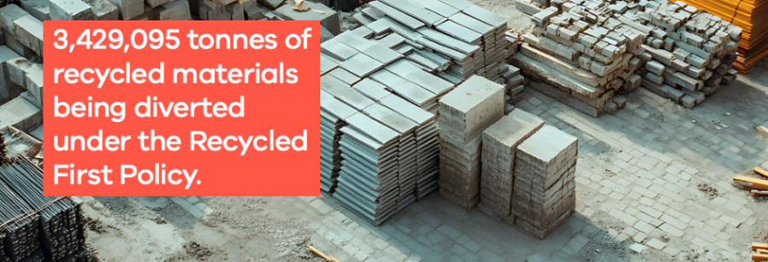

ecologiQ
VIDA created a new body, ecologiQ, to support the implementation of the Recycled First Policy by:
- offering technical leadership
- offering education and resources
- connecting contractors with suppliers
- supporting research and innovation.
For more information, see Victoria’s Big Build’s ecologiQ web page.

Assurance framework
A robust assurance process ensures that our projects deliver expected carbon savings.
Figure 9: Frankston Hospital Redevelopment
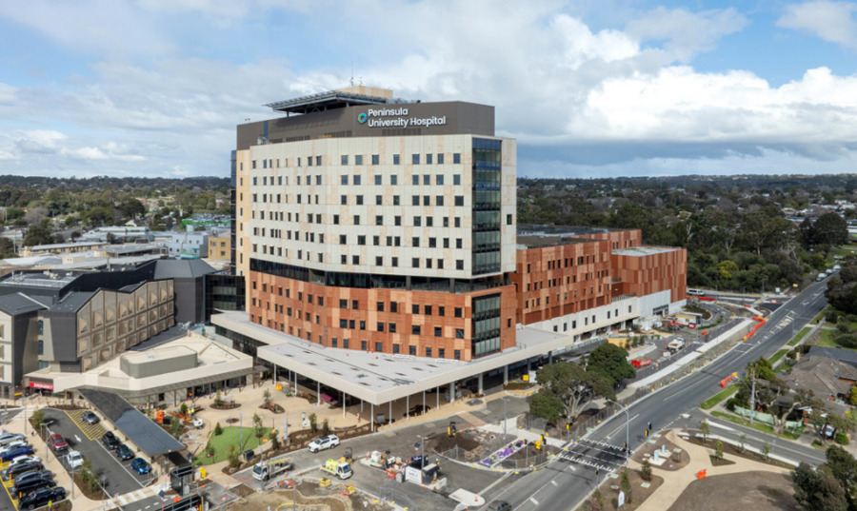
The National Australian Built Environment Rating System (NABERS) has been used to rate the energy and water performance of public hospitals in Victoria since 2015. In 2024, Victoria was the first jurisdiction to publicly disclose heath portfolio performance.
VIDA Health collaborated with NABERS and other health jurisdictions across Australia to develop star rating benchmarks of 1 to 6 stars for energy and water performance.
NABERS has developed an embodied carbon tool to measure and rate the upfront carbon impact of new buildings and partial rebuilds compared with other similar buildings. At the time of release of this handbook, star ratings are not developed for public hospitals. However, any eligible building may be assessed and receive a kgCO2/m2 upfront carbon intensity.
The benefits of adopting the NABERS embodied carbon tool are:
- it is a well-defined, industry-understood methodology
- it aligns with local and global standards
- it provides a rigorous third-party assurance process so that VIDA Health is assured that projects deliver expected carbon savings.
NABERS
VIDA Health will utilise the NABERS tool for all large and major projects. VIDA Health will continue to collaborate with other health jurisdictions to develop a consistent approach to upfront carbon.

Digital engineering integration
Digital engineering can enable whole life carbon savings through a model-based workflow over the asset life cycle.

What we do now
As described in our digital engineering framework project information requirements, BIM can enable sustainability analysis, with the following opportunities available for projects now…

Model export
BIM geometry can be exported to energy modelling software to improve workflow efficiency and complete energy modelling in a timely manner to drive better design decisions.

Material quantities
BIM can be used to output material quantities for embodied carbon analysis and reporting through the project design and construction phases.

Material attributes
To improve workflows, reduce post-processing and generate project-specific reporting, material attributes can be included in the BIM environment that describe embodied carbon, recycled content (Recycled First Policy) and other relevant sustainability information.

What we plan to do
As digital engineering is integrated across the health system, there are opportunities to expand its influence on enabling decarbonisation…

Enhanced asset attributes
Whole of life carbon data could be structured, traceable and flow from the project information model (used during design and construction) to the asset information model (used during operation). In the future, carbon could be treated in the same way as any critical asset data, which may include future integration of carbon data into asset management platforms.

Common data environment
Carbon data could be exchanged, stored and validated at project and portfolio levels. This could include the carbon intensity of operating assets under normal operating conditions.

Digital twin
Whole life carbon tracking, material passports and predictive analytics offer strong digital twin use cases that can assist with measuring and managing asset life cycle carbon emissions.

Carbon management plans
The carbon management plan (CMP) drives decision making through the project life cycle to reduce whole life carbon emissions of the facility.
Figure 10: Example PAS 2080 CMP
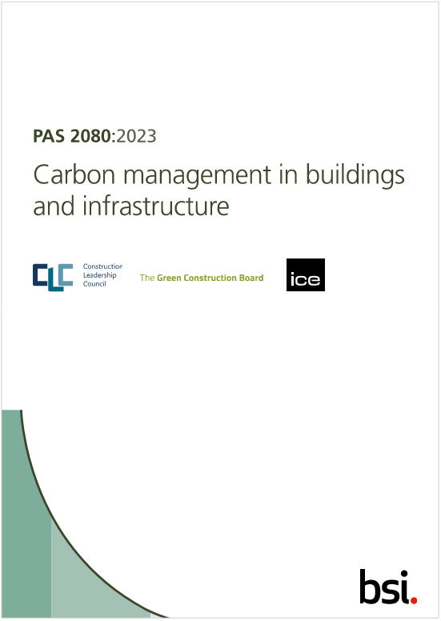
A carbon management plan provides a framework to reduce carbon emissions over the life cycle of a health facility, ensuring key decisions consider carbon impact and document this process in detail.
A CMP is a live document that is created at project inception and follows the project through each phase of its life cycle, nominating the relevant stakeholders that are required to manage the process.
Developed in the UK by the British Standards Institution, PAS 2080 is currently the global best practice standard for managing carbon emissions for infrastructure and buildings.
Although VIDA Health projects are not currently seeking PAS 2080 certification, our major projects will develop CMPs that are generally in line with the PAS 2080 standard so that we can better measure and manage whole life carbon.

Figure 11: Example VIDA Health CMP
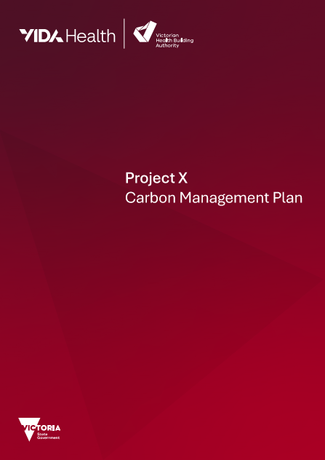
VIDA Health has developed a CMP framework for use by project teams that are required to develop a CMP.
The CMP must clearly outline stakeholder roles and responsibilities. It must be integrated with broader project governance systems.
The CMP will outline the decarbonisation strategy for each phase of the project and record process and decision making that impacts whole life carbon.
The CMP framework is built on the PAS 2080 principles of:
- managing whole life carbon under control and influence
- aligning with the net zero carbon transition
- managing whole life emissions by applying the carbon reduction hierarchy
- considering interconnected sustainability themes
- implementing appropriate governance.
The CMP will be provided to the health agency at handover of the facility.

Enabling infrastructure
Whole life carbon describes the emissions of a building but does not include emissions from service delivery. VIDA Health projects provide enabling infrastructure to support broader health service decarbonisation.

Operational waste
The baseline requirements for material handling and storage are outlined in our guidelines for sustainability in capital works and include:
- minimum waste streams (including futureproofing)
- loading dock and point-of- disposal spatial allowances
- cardboard balers
- compactors for larger facilities.
Waste must be mapped by suitably qualified professional to identify additional opportunities.
VIDA Health can support specialist waste stream treatment (such as onsite organics processing) under the sustainability budget.

Health service transport
Since the adoption of the 2022 building code, 20% of health facility carparks need to be future proofed for electric vehicle (EV) charging.
Our guidelines for sustainability in capital works also require futureproofing for EVs. The sustainability budget may be allocated for fleet vehicle and ambulance charging stations.
Refer to HTA-2024-004 Embedding sustainability in health facility carparks for further details.

Furniture, fixtures and equipment
VIDA Health does not select these items; however, key considerations should be to:
- select suppliers with environmental credentials
- use energy and water efficient equipment
- use local manufacturers where possible
- target suppliers with take back schemes that promote the circular economy.

Anaesthetic gasses
Nitrous oxide (N2O) is an anaesthetic gas with high global warming potential.
Traditionally, N2O has been reticulated from a central gas store to point of use. It has been found that significant leakage may occur in the reticulation system.
Projects should consider mobile cylinders instead of reticulation. When reticulation is a clinical requirement, distance should be minimised and leak monitoring provided.
Once administered, N2O may be captured by a scavenger system and broken down into nitrogen and oxygen by a N2O destruction unit. The sustainability budget may support these units or provisions for future installation.

Staff and patient travel
Our guidelines for sustainability in capital works require:
- connectivity and wayfinding to transport nodes
- bicycle facilities exceeding statutory requirements
- an investigation of charging points for e-bikes
- 25% of car parking for small cars or motorcycles
- encouraging adoption of telemedicine facilities.

Consumables
VIDA Health does not procure consumables. However, consideration should be given to infrastructure impacts. For example, if reusable items are used instead of single use, additional CSSD and storage capacity may be required. We need to collaborate with health agencies during design to explore these circular economy opportunities.

Case studies

Masterplanning

As part of our masterplanning process VIDA Health undertake upfront carbon analysis, providing early estimates of upfront carbon for each design option. The analysis explores alternative design and material options and associated costs to support reduced carbon outcomes.
Key insights included:
- the high upfront carbon impact of basement parking
- masterplan options that maximised adaptive reuse of existing structures were the lowest upfront carbon impact
- new buildings on existing sites may incur upfront carbon penalties due to specific structural requirements (for example, cantilevering over an existing structure).

Challenges
- There is limited benchmark data for hospital upfront carbon.
- Due to the early planning stage, the analysis could not capture the full masterplan scope.

Successes
- The findings inform masterplan decision making by highlighting the upfront carbon impact of different design options.
- The analysis provides practical guidance and high-level costs on design strategies and material options to reduce upfront carbon.

Lessons learned
- Early estimation of upfront carbon can provide a metric to drive design decisions.
- Embodied carbon data limitations require balanced consideration, with assumptions refined as the design evolves.

New Melton Hospital
Figure 12: New Melton Hospital
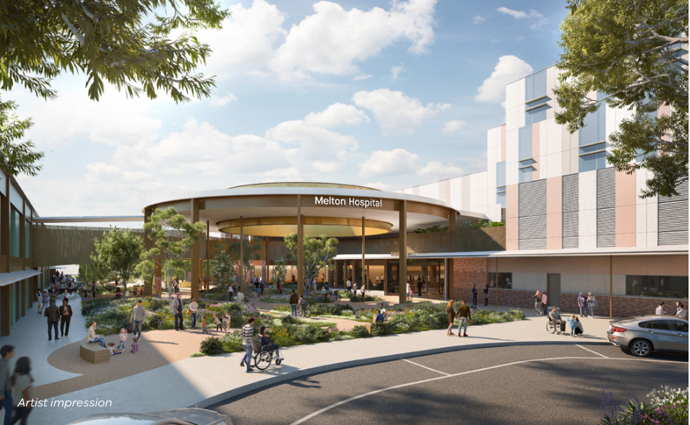
The new Melton Hospital will be Victoria’s first all-electric hospital. The facility will include a 24-hour emergency department, an intensive care unit, maternity and neonatal services, mental health services, radiology services and ambulatory care. Once completed, it will be capable of treating 130,000 patients each year.
As briefed, the hospital has committed to a 20% reduction in upfront carbon compared to a reference building, in line with the Green Star Credit Achievement requirements. This involves measuring and reducing carbon emissions associated with the future construction of the building.

Challenges
- Applying Green Star’s upfront carbon reduction benchmarks at the early stages requires clear alignment between sustainability and design scope.
- Achieving embodied carbon reductions can be impacted by supply chain limitations.

Successes
- Embedding a defined target in the project brief ensures sustainability remains central to design decisions.
- By following a recognised framework and certification, a consistent methodology can be applied including third-party verification of the as-built outcome.

Lessons learned
- Early target setting and inclusion in project brief drives accountability and gives the project team clear direction.
- Net zero carbon operation must be supported by embodied carbon reduction strategies as materials play an important role in achieving whole life carbon reductions.

PSRACS Numurkah
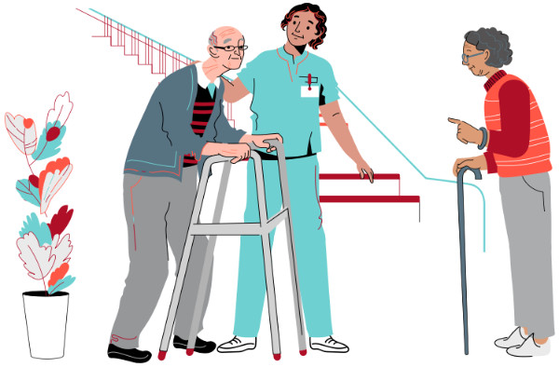
The new Numurkah aged care facility is part of the Victorian Government’s Regional and Rural Public Sector Residential Aged Care Services Revitalisation Strategy (PSRACS).
The strategy phases out outdated public sector facilities, replacing them with purpose-built facilities that better meet community expectations and enable contemporary models of aged care.
The project has been tendered with reduced carbon concrete for the extensive ground slab, a sustainability initiative that will significantly reduce the upfront carbon impact of the project. There is also a focus on reducing operational carbon, with the building envelope designed to exceed building code insulation and air tightness requirements.

Challenges
- Balancing upfront carbon reduction with other project sustainability aspirations.
- Ensuring regional supply chains can deliver reduced carbon materials.

Successes
- The largest PSRACS project to include reduced carbon concrete in the tendered design.
- The project demonstrated that low carbon design choices can be adopted without compromising functionality or construction program.

Lessons learned
- If upfront carbon targets are known from the outset, these can be designed for and built into the budget early.
- Even when introduced at a later stage, targeted material choices can still have a meaningful impact.

Northern Hospital Redevelopment Ambulatory Care Centre
Figure 13: Northern Hospital Redevelopment Ambulatory Care Centre (artist’s impression)
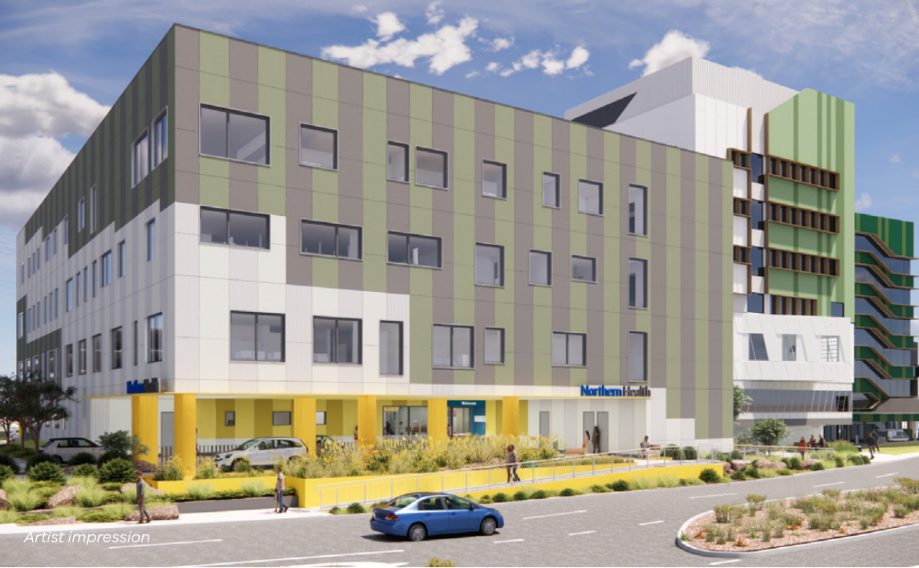
The Northern Hospital Redevelopment is being delivered in 2 stages, with Stage 1 focused on the construction of the Ambulatory Care Centre. The building will be a hub for outpatient ambulatory services, clinical and outpatient health services, and administration.
The project made 2 key design decisions that target reduced embodied carbon during the construction phase. Firstly, the structural elements use low-carbon concrete, lowering its emissions profile. Secondly, the inclusion of a lightweight, air-tight façade system supports both carbon reduction and enhanced energy efficiency.

Challenges
- Implementing low-carbon design solutions that are not yet industry standard can mean additional effort across procurement.
- Opportunities to influence major material choices are limited when carbon considerations begin during the construction phase.

Successes
- The project demonstrated that low carbon design choices can be adopted without compromising the functionality or construction program.
- The lightweight, airtight façade system delivered carbon savings and operational efficiency, providing dual benefits.

Lessons learned
- Even when introduced at a later stage, targeted material choices can still have a meaningful impact.
- Tracking of design decisions should occur to confirm final carbon values and alignment with project targets.

Glossary
Term | Abbreviation | Definition
Adaptive reuse | - | The repurposing of existing buildings or structures for new use.
Asset life cycle | - | The series of stages that an asset goes through during its lifetime, from planning through to end of life.
Building information modelling | BIM | The use of a shared digital representation of a built asset to facilitate design, construction and operation processes.
Business case | - | A document that provides justification for a project or initiative.
Carbon footprint | - | The total emissions volume of greenhouse gases associated with all the activities of a person or entity.
Carbon management plan | CMP | A framework to reduce carbon emissions over the life of an asset.
Circular economy | - | A model of production and consumption that aims to eliminate waste and promote reuse and resource efficiency.
Common data environment | CDE | A common data environment (CDE) is a centralised, cloud-based digital platform where all project information—including BIM models, documents, contracts, and schedules—is collected, managed, and shared among project stakeholders.
Decarbonisation | - | Refers to the removal or reduction of greenhouse gas emissions to the atmosphere.
Deconstruction | - | An alternative to demolition of buildings, where they are carefully dismantled rather than demolished. Deconstruction prioritises the recovery of materials.
Digital engineering framework | DE | A document that outlines the structured approach to using emerging technologies to improve the design and construction of our health infrastructure.
Digital twin | - | A digital twin of a building is a dynamic, data-driven virtual replica that mirrors a physical building’s systems, equipment, and even occupants, using real-time data from sensors to monitor, analyse, and optimize performance throughout the building’s lifecycle.
ecologiQ | - | An organisation set up by VIDA to deliver and support the implementation of the Recycle First Policy.
Embodied carbon | - | Refers to greenhouse gas emissions relating to manufacturing, transportation, installation, maintenance and disposal of a building’s materials and construction process over the asset’s life.
Emissions profile | - | Identifies the greenhouse gas emissions that are generated by a business of or entity through its operations.
End of life | - | Refers to the demolition or deconstruction stage of a building that is at the end of its use.
Energy efficiency | - | Reducing the amount of energy used to do the same amount of work or provide the same amount of output from a service.
Environmental product declaration | EPD | A form of environmental declaration that quantifies the environmental impact of a product.
Electric vehicle | EV | Refers to cars or other vehicles with motors that are powered by electricity.
(Future) Refrigerants | - | Refers to refrigerants used in heating and cooling systems that are designed to have a lower global warming potential (GWP).
Global warming potential | GWP | A standardised measure describing the relative potency, molecule for molecule, of a greenhouse gas.
Green Star | - | An internationally recognised rating system to evaluate environmental design and performance of buildings, developed by Green Building Council Australia.
Green Star credit achievement | - | Greenstar rating criteria that outline the best practises that buildings must meet for recognition.
Guidelines for sustainability in capital works | - | A framework for creating sustainable and resilient healthcare facilities, focusing on environmental and health outcomes.
Handover | - | The final part of the design and construction process where a project, along with all information and resources for operation, is handed to its owner.
Health technical advice | HTA | Technical guidelines and information provided to assist health services, consultant and contractors manage Victoria’s public health facilities.
Masterplan | - | Refers to a planning framework describing the long-term development of a project, sit or area.
National Australian Built Environment Rating System | NABERS | Rating system that measures the environmental performance of buildings in Australia.
Net zero | - | Refers to a balance of greenhouse gas emissions that are produced and removed from the atmosphere.
Nitrous oxide | N₂O | An anaesthetic gas with high global warming potential commonly used in medical industries.
Offset credits | - | Carbon offset credits are exchanged for investment in the reduction or removal of greenhouse gas emissions.
Operational carbon | - | The carbon emissions emitted in the day-to-day activities of a building and are due to energy use and water.
PAS 2080 | - | The global standard that specifies the requirements for the management of whole life carbon in buildings and infrastructure.
Recycle First Policy | - | A procurement policy that applies to all Victorian Government construction projects with a value of $20 million or more. It requires bidders to demonstrate how they will optimise the use of recycled and reused materials within allowable limits under existing specifications.
Scavenger system | - | A medical device that collects and removes anaesthetic gases that are emitted to the surrounding areas after patient use.
Upfront carbon | - | Refer to the greenhouse gas emissions associated with the initial stages of a building’s lifecycle; those that occur before the asset is operational.
VIDA Health |  | VIDA Health leads the planning, delivery and oversight of public  health, mental health and aged care infrastructure.
Victorian Health Building Authority | VHBA | Before August 2025, the Victorian Health Building Authority was the organisational name for VIDA Health.
Victorian Infrastructure Delivery Authority | VIDA | VIDA delivers the state’s transport and health infrastructure programs. VIDA Health is a project office under VIDA.
Whole life carbon | - | Describes the greenhouse gas emissions over the whole asset life cycle, consisting of both operational and embodied carbon.

References

VIDA Health technical guidelines
These resources are available on our technical guidelines web page.
- Guidelines for sustainability in capital works
- Engineering guidelines for healthcare facilities
- Building sealing (HTA-2024-001)
- Recycled materials in healthcare design and construction (HTA-2024-002)
- Embedding sustainability in health facility carparks (HTA-2024-004)

VIDA decarbonisation resources
These are available from Victoria’s Big Build’s Transport infrastructure decarbonisation strategy web page.
- Transport infrastructure decarbonisation guide
- Lower carbon materials visual guide

Appendix A: Image descriptions

Figure 1: Climate Change Act (Vic) targets and progress
Table 2: Targets
Year | Target
2005 | 2005 is the baseline future targets are measure against
2020 | 15% to 20%. Actual emissions fell by almost 30%.
2025 | 28% to 33%
2030 | 45 to 50%
2035 | 75% to 80%
2045 | Net zero
Return to Targeted action.

Figure 4: Whole life carbon cycle (based on EN 15978)
Table 3: Stages and phases of the whole life carbon cycle
Stage | Phases
Production | - A1: Material extraction  - A2: Transport to factory  - A3: Manufacturing
Construction | - A4: Transport to site  - A5: Construction and installation
In-use | - B1: Use  - B2: Maintenance  - B3: Repair  - B4: Replacement  - B5: Refurbishment
Operation | - B6: Energy use  - B7: Water use
End of life | - C1: Deconstruction  - C2: Transport to waste processing facility  - C3: Waste processing  - C4: Disposal
Reuse, recover, recycle | - D: Reuse, recover, recycle  In the figure, this stage is shown as 3 dotted arrows that start at C2 (transport to waste processing facility):  - first arrow stops at the end of A2  - second arrow stops at the end of A4  - third arrow stops at the end of A5.
Return to Whole life carbon approach.

Figure 5: Hospital whole life carbon
Note: The percentages in this description are rough estimates to convey the general proportion of emissions only.
Figure 5 has 3 donut charts showing the breakdown of emissions (operational and embodied) for:
- Traditional hospital
- All-electric hospital (2023)
- All-electric hospital powered by renewables (2025).
Operational emissions include:
- natural gas
- grid electricity.
Embodied emissions include:
- upfront carbon
- in-use
- end of life.
The traditional hospital profile, from most to least:
- grid electricity (about 50%)
- upfront carbon (around 20%)
- natural gas (around 17%)
- in-use (around 10%)
- end of life (around 5%).
The all-electric hospital profile, from most to least:
- grid electricity (about 63%)
- upfront carbon (around 20%)
- in-use (around 10%)
- end of life (around 5%).
There is a 15% drop in whole life carbon.
The all-electric hospital powered by renewables profile, from most to least:
- upfront carbon (around 55%)
- in-use (around 20%)
- grid electricity (about 14%)
- end of life (around 10%).
There is a 65% drop in whole life carbon.
Return to Hospital whole life carbon.

Figure 6: Hospital upfront carbon
Figure 6 is a donut chart showing the split of upfront carbon across the elements of a hospital.
The 750 to 950 kgCO2-e/m² of upfront carbon comes from:
- superstructure – 42%
- envelope – 15%
- services – 12%
- substructure – 11%
- fitout – 10%
- transport and construction – 10%.
Return to Hospital upfront carbon.

Figure 7: Asset life cycle approach
Figure 7 shows the increasing cost of carbon reduction versus the decreasing impact potential of carbon savings over the project life cycle. The cost of carbon reduction rises almost exponentially from the service plan stage to the end of the construction stage.
The chart shows high impact, cost effective interventions typically happen early in the project planning stage.
The figure also shows the influence that VIDA Health, the Department of Health and the relevant health agency have over the project life cycle:
- VIDA Health’s influence is higher during design, construction and end of life stages
- Department of Health and health agency influence is higher in the service planning, operation and end of life stages.
Table 4: Carbon reduction potential and influence over project life cycle
Life cycle stage | Carbon reduction potential | VIDA Health influence | Department of Health, health agency influence
Service plan | 100% - build nothing | - | Higher influence
Masterplan | 80% - build less | Higher influence | Higher influence
Design | 40% - build clever | Higher influence | Higher influence
Construction | Note: practical completion at end of this stage | Higher influence | -
Operation | 20% - operate efficiently | - | Higher influence
End of life | - | Higher influence | Higher influence
Return to Asset life cycle approach.

To receive this publication in an accessible format, email vhba@vida.vic.gov.au
Authorised and published by the Victorian Government, 1 Treasury Place, Melbourne.
© State of Victoria, Australia, Victorian Health Building Authority, November 2025.
Except where otherwise indicated, the images in this publication show models and illustrative settings only, and do not necessarily depict actual services, facilities or recipients of services.
ISBN 978-0-7311-9374-5 (online)
Available at VHBA’s Environmental sustainability web page <https://www.vhba.vic.gov.au/resources/environmental-sustainability>

In August 2025, VIDA Health became the organisational name for the business formerly known as the Victorian Health Building Authority (VHBA).
2028 and 2030 targets and project requirements are provisional only
Excludes the contribution of carbon offsets or certified carbon neutral product or services
Excludes the contribution of onsite renewable energy generation
https://bigbuild.vic.gov.au/about/ecologiq
https://www.nabers.gov.au/ratings/our-ratings/nabers-embodied-carbon
https://www.vhba.vic.gov.au/resources/technical-guidelines
https://bigbuild.vic.gov.au/library/victorias-big-build/decarbonisation-strategy

