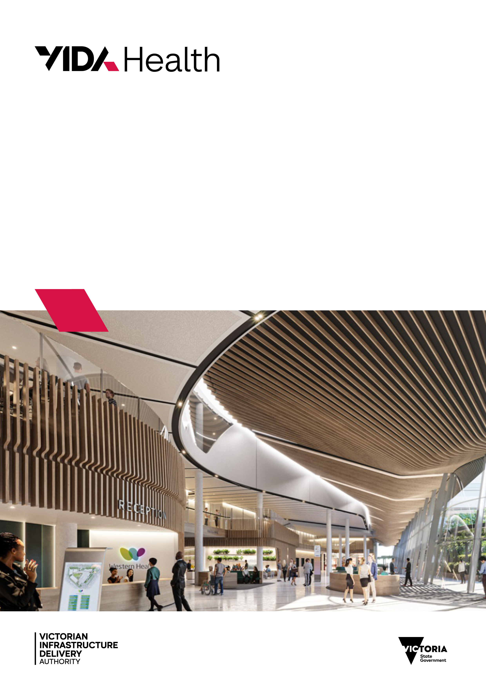

HTA: Energy modelling
HTA-2026-001

To receive this publication in an accessible format, email the Victorian Health Building Authority <vhba@vida.vic.gov.au>
Authorised and published by the Victorian Government, 1 Treasury Place, Melbourne.
© State of Victoria, Australia, Victorian Health Building Authority, August 2026.
ISBN 978-0-7311-9303-2 (pdf/online/MS word)
Available on the Resources page of the Victorian Health Building Authority website <https://www.vhba.vic.gov.au/resources/technical-guidelines>
Report number: HTA-2026-001
Report release date: 31st August 2026

Contents
Summary 3
Purpose 3
Context 3
Project design targets 3
Modelling and reporting approach 4
Energy demand reduction 4
NABERS Energy 5
Modelling process 5
Masterplan 5
Schematic design 5
Schematic design modelling approach and outputs 5
Design development 6
Design development modelling approach and outputs 6
Commissioning and building tuning 6
Allocation of sustainability budget 6
Climate resilience 7
NABERS 7
Overview 7
NABERS design target 7
NABERS reverse calculator 7
Predictive modelling for NABERS 8
Modelling requirements 8
Off-axis scenarios 8
Renewable energy 9
Value management 9
Reporting 9
Load diversity 13
ICT loads 13
Cooking equipment 13
Supplementary air-conditioning systems 13
Lifts…… 13
Medical air, suction plant, and pneumatic tube system 13
Exclusions from NABERS boundary 13
Resources 14
General 14
NABERS 14
Contacts 14

Summary

Purpose
This Health Technical Advice (HTA) provides guidance on predictive energy modelling for health care capital works during the design and delivery phases.
This HTA has been developed in response to frequently asked questions and to ensure a more consistent approach to energy modelling and reporting across the health capital works pipeline.
This HTA is to be read in conjunction with the Guidelines for sustainability in health care capital works (‘the Guidelines’) and the VIDA Health Net Zero Building Handbook (‘the Handbook’).

Context
Reducing operational energy consumption of health infrastructure is a key priority for VIDA Health and Victorian health agencies to minimise operational costs – every dollar saved on energy use is a dollar for frontline health services.
All capital works projects are expected to outperform the minimum energy efficiency standards set by the applicable edition of the National Construction Code of Australia (NCC) Section J – Energy Efficiency. This expectation applies to new constructions, extensions, and refurbishments of existing facilities.
Energy modelling is a powerful tool that can be used throughout an asset’s life cycle to optimise the design, commissioning, and operation for energy efficient performance. If commenced early in the design process, energy modelling can support design decisions and demonstrate achievement of design targets.
As the design develops, energy modelling is refined to include detailed system parameters and operational profiles to provide predictive energy targets that can be used to track operational performance and identify out of range energy consumption at system and equipment level. This approach is particularly effective when coupled with a robust submetering and monitoring strategy that facilitates building performance analytics.

Project design targets
In the 2021 edition of the Guidelines, ‘eligible’ projects are required to demonstrate through energy modelling that they are capable of achieving operational energy performance equivalent to a 5 Star NABERS Public Hospitals energy benchmark. Eligibility is applicable to both new builds and refurbishment projects and is dependent on if the project includes in-patient beds or residential aged care beds.
Since the NABERS Public Hospitals energy design targets were introduced to the Guidelines, they have provided a useful benchmarking process for project teams delivering health infrastructure. However, due to the NABERS Public Hospitals energy rating scheme being for the entire hospital site, the energy benchmarks are often not appropriate for individual buildings. For this reason, VIDA Health’s approach to project design targets has been redefined as follows, with NABERS Public Hospitals energy targets only applying to new ’greenfield’ hospitals.

Table 1 Energy design targets
Project Type | Requirement | Design Target
New building or major refurbishment at an existing campus | New buildings or major refurbishments that are $20M Total Estimated Investment (TEI) or more are required to meet the energy demand reduction set out in the Handbook. | 15%* reduction compared to a reference building (excluding the contribution of onsite renewables)
New ‘greenfield’ hospital | In addition, new hospitals are also required to meet the 5 Star NABERS Energy benchmark set out in the Guidelines. | 15%* reduction compared to a reference building (excluding the contribution of onsite renewables)  AND  5 Star* NABERS Public Hospitals energy equivalent
* Design targets may be increased in stringency over time – please refer to the latest version of the referenced documents for applicable targets.
Refer to the NABERS section of this HTA for further details on the NABERS scheme, how to set the project energy benchmark for new ‘greenfield’ hospitals, and details on predictive NABERS energy modelling requirements.
The VIDA Health Sustainability team is available to provide advice on what targets and requirements are applicable to a particular project.

Modelling and reporting approach

Energy demand reduction
Energy demand reduction is modelled against a theoretical reference project to determined compliance with the project design target.
The reference project represents a building code compliant project constructed using industry standard practice methods at the time of the project design.
The modelling methodology adopted should be a local industry-standard approach such as National Construction Code (NCC) J1V3 or other recognised approaches widely used for the built environment. Note that regardless of which modelling methodology is selected, onsite renewable energy generation may not contribute to achievement of the energy demand reduction target, however, renewable energy generation must still be modelled and reported separately if included in the project delivery scope. See Appendix 1 for the energy boundary used for energy demand reduction calculations.
At each project milestone, the sustainability consultant must provide an energy modelling report as an appendix to the sustainability report. Reporting must clearly present modelling inputs for the reference proposed and proposed project model.

NABERS Energy
For a new ‘greenfield’ hospital with a 5-Star NABERS Public Hospitals energy design target, modelling must be caried out in accordance with the relevant NABERS protocols and include all project energy uses within the NABERS Public Hospitals energy boundary. See the NABERS section of this HTA for further information.
At each project milestone, the sustainability consultant must provide a completed NABERS Public Hospitals reverse calculator as an appendix to the sustainability report. Reporting must clearly present modelling inputs.

Modelling process
The following section sets out the expected energy modelling process for capital works projects. By commencing iterative energy modelling early, insights from the modelling can influence the design before design elements are fixed.

Masterplan
Energy modelling at the masterplan phase can be used to test and optimise building massing. If the modelling scope is expanded to include additional building performance parameters such as indoor daylight performance and external daylight access, this may form a parametric modelling approach that balances competing sustainable design metrics.

Masterplan modelling approach and outputs
- Test building massing and orientation options for energy and daylight performance
- Identify facades that may require external solar shading
- Test roof areas for solar access and overshadowing in relation to the requirement in the Guidelines for 60% of roof area to be designed for solar panels
- Test outdoor spaces (e.g. courtyards) for daylight access.
Note that if masterplan phase modelling is required, this will be included in the project brief.

Schematic design
If massing options are being considered at schematic design, undertake analysis as per the masterplan approach outlined above.
During schematic design, the extent of design iterations can be high and fast paced, which means detailed whole building energy modelling is often not practical. In this case, building massing modelling outputs may be supported by sample space modelling to test various elements and optimise the design response.
Sample spaces should be a selection of rooms or areas that capture a diverse range of solar exposure or experience shading impact from an adjacent obstruction. The selection should also include any “extreme” or “worst-case scenario” areas, such as corner rooms.

Schematic design modelling approach and outputs
- Test building massing and orientation options for energy and daylight performance (where applicable)
- Test using representative sample spaces where appropriate to optimise the design and test the impact of the following:
- Window size
- Glazing performance
- External solar shading design
- Insulation levels
- Improved building sealing (airtightness)
- High-level mechanical system options testing (e.g. constant air volume versus variable air volume, or variable refrigerant volume versus central hydronic heat pumps)
- Preliminary compliance assessment against relevant project design targets including energy demand reduction compared a reference building and 5 Star NABERS Public Hospitals energy for new hospitals
- Provide high-level return of investment (ROI) calculations for energy efficiency measures with capital costs provided by the Quantity Surveyor (QS) and Services Engineer to support allocation of project sustainability budget
- Potential for parametric modelling of energy, daylight and thermal comfort (optional/additional scope – project team to provide a value proposition if appropriate for the project).

Design development
During the design development phase, a whole building energy model will be prepared including detailed operational profiles and building system modelling.
During this phase, building system and equipment options may be tested in more detail.
By the end of the design development phase, reporting will demonstrate compliance with project performance targets and provide estimated energy end uses that may be used for commissioning, building tuning and estimation of operational energy bills.
For new hospitals required to undertake predictive NABERS Public Hospitals energy modelling, this will be provided at the end of the Design Development phase.

Design development modelling approach and outputs
- Develop a whole building model
- Test plant and equipment efficiency upgrades against baseline requirements
- Demonstrate relevant project design targets are met including energy demand reduction compared a reference building and 5 Star NABERS Public Hospitals energy for new hospitals
- Provide predicted energy end uses
- Provide ROI calculations with capital costs provided by QS and Services Engineer
- Provide high-level ROI calculations for energy efficiency measures with capital costs provided by the QS and Services Engineer to support allocation of sustainability budget

Commissioning and building tuning
Energy end use outputs from the design phase modelling may be used during commissioning and embedded into the energy management system to track actual performance against predicted performance, allowing identification of out-of-range energy consumption.

Allocation of sustainability budget
As required in the Guidelines, operational energy efficiency initiatives funded by the project 2.5% sustainability budget should provide estimated energy reductions. The project 2.5% sustainability budget may be utilised to fund energy efficient initiatives that exceed the baseline requirements set by the NCC and the business-as-usual (BAU) requirements in the Guidelines.
Where appropriate, the energy model should be utilised to provide this assessment so that an ROI calculation can be conducted to demonstrate life cycle value. Energy tariffs for ROI calculations should be requested from VIDA Health during the design phase.

Climate resilience
Predictive modelling can be used to test climate risk strategies, such as increased mechanical system capacity for cooling during heatwaves as ‘off-axis scenarios’.

NABERS

Overview
NABERS is a national six-star sustainability rating system used to measure and understand the environmental performance of buildings across sectors including public hospitals, offices, hotels, shopping centres, and apartments.
The following NABERS tools are available for measuring the operational performance of public hospitals:
- NABERS Public Hospitals energy
- NABERS Public Hospitals water
- NABERS Public Hospitals waste

NABERS design target
New hospitals have a design target of 5-star NABERS Public Hospitals energy. Projects can determine their target energy budget to achieve the 5-star target using the NABERS Reverse Calculator.
A predictive energy modelling report is required for new hospitals that demonstrates how the design may achieve the operational energy budget. This should be included as an appendix to the sustainability report at the design development phase.

NABERS reverse calculator
The NABERS reverse calculator provides benchmark figures (i.e., the maximum amounts of energy and water a building can use) for the hospital to meet the specified star target. The calculator is updated periodically, so the latest version available at the time of the project design must be used.

The calculator requires information on the hospital to determine the design target, which can be either obtained from VIDA Health sustainability team or the health agency:
- Hospital postcode
- Peer group
- Occupied bed days (OBD): total number of bed days of all admitted patients accommodated (refer formula below)
- Separations: the administrative process by which a hospital records the cessation of treatment/care/accommodation of a patient (refer formula below)
- Commonwealth funded aged care beds (equates to the number of aged care beds)
- Commonwealth funded aged care bed days (excluded from the OBD count)
- Percentage breakdown of energy consumption
- 100% of energy use is electricity (diesel use of backup generators may be excluded)
The following calculations below may be used to determine OBD and separations during the design phase:
OBD = (no. of inpatient + aged care beds) x 365 x 0.95*
Separations = OBD / average patient length of stay in days**
* a factor of 0.95 is used to estimate average bed utilisation ** the default average length of stay is 2 days unless otherwise advised by the project team or health agency

Predictive modelling for NABERS

Modelling requirements
Energy modelling for estimating the hospital NABERS performance must be compliant with the principles set out in the latest versions of the Handbook for Estimating NABERS ratings and The Rules Energy and Water for Hospitals.
Operating profiles should be referenced from a local industry-standard modelling protocol as a starting point and confirmed with the health agency during the design phase. Additional health sector specific modelling guidance is provided in the Appendix of this HTA.

Off-axis scenarios
In accordance with the NABERS validation protocol for computer simulation requirements, modelling must include off-axis scenarios to evaluate the sensitivity of various factors in relation to achievement of the project NABERS Energy target.
Examples of off-axis scenarios are:
- energy consumption without solar panels
- extreme heat/cold scenario based on climate risk information
- reduced building occupancy and equipment loads
- uncalibrated temperature sensors
- reduced OBDs
Within the modelling report, information on NABERS modelling inputs, energy end use and simulation results must demonstrate the results for the base case, and all selected off-axis scenarios.

Renewable energy
If the project includes a solar PV system, annual energy generation should be modelled using an appropriate tool that accounts for any system overshadowing.
For projects targeting a 15% reduction in energy demand, the contribution of onsite solar PV does not contribute to the achievement of the target, which must be achieved through energy efficiency strategies. In this case, the modelled annual solar PV generation is reported separately to the design target.
For new hospitals targeting a 5 Star NABERS Public Hospitals energy benchmark, solar PV energy consumed onsite (i.e. excluding electricity exported to the grid) contributes to achievement of the design target.
If other sources of renewable energy or energy storage are proposed for the project, the modelling approach must be discussed and confirmed with the VIDA Health Sustainability team during the design phase.

Value management
If a project is subject to a value management process that impacts the energy performance (e.g. deletion of roof top solar PV), the modelling must be updated to reflect these changes and provide feedback to the project team on the potential energy performance impacts of the value management.

Reporting
The NABERS report must include the following information:
- Input data, including assumptions and source documentation
- Analysis of the impact of changing emissions factors (using NABERS prediction tool)
- NABERS model inputs summary for base case and off-axis models
- NABERS energy end-use summary for base case and off-axis models
- Predicted NABERS rating for base case, off-axis scenarios and results based on changing emissions factors
- Metering requirements including meter technical requirements and system configuration
- Risk assessment of any factors that may prevent the project from achieving its estimated rating
- The project should identify if it cannot meet the 5-star NABERS Public Hospitals energy target and provide evidence of testing and justification for not meeting the target.

Appendix 1: Energy modelling boundary
Category | End Use | Energy Demand Reduction | NABERS Energy Modelling
Air-conditioning | Heating | ✔ | ✔
Air-conditioning | Cooling | ✔ | ✔
Air-conditioning | Heat rejection | ✔ | ✔
Air-conditioning | Air-conditioning pumping | ✔ | ✔
Air-conditioning | Air-conditioning fans | ✔ | ✔
Air-conditioning | Supplementary air-conditioning | ✔ | ✔
Ventilation | Outdoor air systems | ✔ | ✔
Ventilation | Exhaust systems | ✔ | ✔
Ventilation | Car park ventilation | ✔ | ✔
Ventilation | General ventilation fans | ✔ | ✔
Domestic water | Domestic hot water generation | ✔ | ✔
Domestic water | Domestic water pumps | ✔ | ✔
Lighting | Internal lighting | ✔ | ✔
Lighting | External lighting | ✔ | ✔
Vertical transport | Lifts | ✔ | ✔
Building systems | Wet fire |  | ✔
Building systems | Dry fire |  | ✔
Building systems | Date and communications |  | ✔
Building systems | Security |  | ✔
Building systems | Controls |  | ✔
Equipment | General equipment |  | ✔
Equipment | Major medical equipment |  | ✔
Equipment | Refrigeration |  | ✔
Equipment | Cooking equipment |  | ✔
Specialist healthcare systems | Medical gas plant |  | ✔
Specialist healthcare systems | Vacuum systems |  | ✔
Renewable energy | Solar PV | ✔* | ✔
* Excluded from energy demand reduction calculation but modelled and reported separately if included in the project scope.

Appendix 2: Health equipment loads
Type | Peak Equipment Load  (W/m²)
Administration | 12
Ambulatory Care | 15
Birthing Suites | 15
CSSD | 40
Discharge Lounge | 15
Education and Research Hub | 20
Emergency Department | 30
Equipment precinct | 15
ICU | 40
Inpatient Medical Imaging | 25
IPU | 15
Main entry | 5
Mortuary | 15
Pathology | 25
Patient community support services | 15
Perioperative services | 40
Pharmacy | 30

Appendix 3: Medical imaging equipment energy use
Type | Benchmark Consumption  (kWh/day/unit)
Magnetic Resonance Imaging (MRI) | 166
Computed Tomography (CT) scanner | 72
Ultrasound | 2
X-ray | 10

Appendix 4: Additional modelling guidance

Load diversity
For predictive NABERS Public Hospitals energy modelling apply a 60% diversity factor to peak equipment and occupancy loads.

ICT loads
Where fan coil units serve ICT spaces (e.g. server rooms, campus distributor rooms, floor distributions rooms, and other ICT rooms), a 10% diversity factor should be applied to ICT equipment energy consumption and heat loads.

Cooking equipment
Energy associated with cooking each meal should be calculated in line with guidance included in section A.9.6 in the Handbook for estimating NABERS ratings for energy consumption per meal, based on the assumption of three cooked meals per day and the project occupied bed days.

Supplementary air-conditioning systems
Where fan coil units are provided for spaces with additional heat loads or occupancies (e.g. meeting rooms, staff rooms, training rooms), the units should be assumed to operate for 20% of the respective department’s annual operating hours, with a 25% diversity factor applied to heat loads.

Lifts
Lift energy calculations should be based the ISO 25745-2 with operating days and usage category confirmed with project team during the design phase.

Medical air, suction plant, and pneumatic tube system
Energy must be linked to the occupant / clinical utilisation, with a 10% diversity factor applied to peak equipment loads.

Exclusions from NABERS boundary
The following energy uses are excluded from the NABERS Energy predictive modelling:
- Electric vehicle (EV) charging
- Tenancies that do not to serve staff or patients
- Externally operated buildings (e.g. a Child Care Centre)
- Future fit out of shell spaces
- Bushire or pandemic mode operation.

Resources

General
- VHBA sustainability guidelines for health capital works <https://www.vhba.vic.gov.au/sites/default/files/2021-10/Sustainability-guidelines-for-capital-works-VHBA-Revised-October-2021.pdf>
- VIDA Health Net Zero Building Handbook < https://www.vhba.vic.gov.au/sites/default/files/2025-12/VHBA-2025-10-Net-Zero-Building-Handbook.pdf>
- Victoria’s future climate tool <https://vicfutureclimatetool.indraweb.io/cmip6/>

NABERS
- NABERS Public Hospitals Fact Sheet <https://www.nabers.gov.au/sites/default/files/2022-12/Fact Sheet - Public Hospitals.pdf>
- Estimating NABERS ratings handbook <https://www.nabers.gov.au/sites/default/files/2022-11/Handbook%20for%20estimating%20NABERS%20ratings.pdf>
- The Rules: Energy and Water for Hospitals <https://www.nabers.gov.au/sites/default/files/2022-12/Energy and Water for Hospitals Rules.pdf>
- Reverse Calculator <https://www.nabers.gov.au/rating-tools/our-calculators/setting-targets-using-reverse-calculators>

Contacts
For any queries, please email VIDA-Health-TDAPSTechnicalAdvisoryServices@vida.vic.gov.au

This also applies to NABERS Public Hospitals water targets.
New hospitals also have a 5-Star NABERS Public Hospitals water design target however this is not covered in this HTA.
Refer page 43, Energy and Water for Public Hospitals Rules V.2.: <https://www.nabers.gov.au/sites/default/files/2022-12/Energy%20and%20Water%20for%20Hospitals%20Rules.pdf>
If these areas are excluded from the NABERS boundary any associated OBDs and separations must also be excluded.

